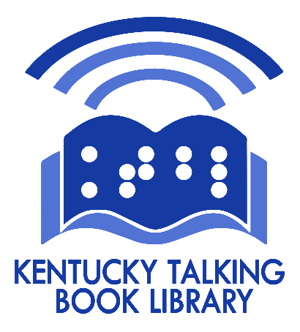
Kentucky Talking
Book Library
Newsletter
April 2024

Welcome Evan!
The Kentucky Talking Book Library is happy to introduce Evan Hatter—our new Information Officer who started February 1. Evan will be responsible for marketing KTBL to advertise our service and recruit new patrons. He will reach out to agencies and organizations who serve people who have visual, physical, or reading disabilities and are therefore eligible for Talking Books. He will travel around the state to meet with them and attend events to promote our library.
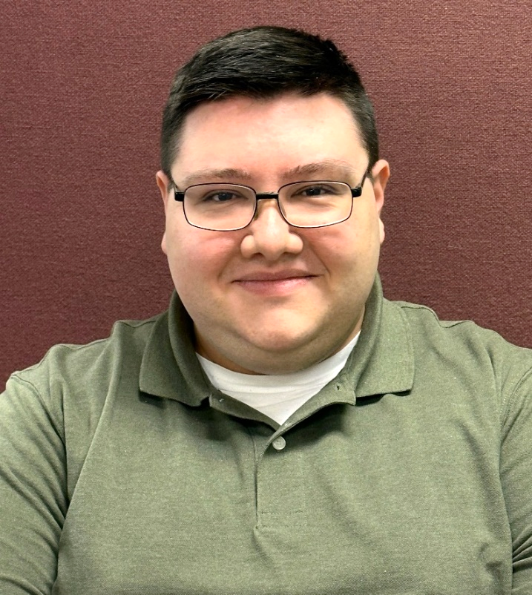
Evan has ties to various parts of the Commonwealth. He is a Frankfort native, but attended Western Kentucky University in Bowling Green, earning a degree in meteorology and a minor in broadcasting. He joined our team following a stint at WYMT-TV in Hazard. In his free time, Evan enjoys unwinding by watching his favorite sports teams—which include the Reds, the Bengals, and his beloved Hilltoppers.

Photo caption: a head and shoulders photo of KTBL Information Officer Evan Hatter. Evan is a young man with short, dark hair and black wire-rimmed glasses, wearing a sage green polo-type shirt.

In a related note, we said goodbye to our recording studio manager, Brian Bertucci in February. After nine years at KTBL, Brian has moved back to his home state of Florida to be near his family. Brian was our first studio manager, and during his time here he made great improvements in the quality of our recorded Kentucky books. We will miss him. Meanwhile, we are in the process of hiring someone to follow in his footsteps.

Accessible Newspapers
Would you like a newspaper with your morning cup of coffee? NFB-NEWSLINE® is a service from the National Federation of the Blind that allows users access to well over 500 publications, including 10 Kentucky newspapers and magazines. There are various ways to access the latest news: touchtone telephone, the internet, your iOS (Apple) smartphone or tablet, your Amazon Alexa Smart Speaker, your Victor Reader Stream, or even an NLS braille eReader.

Each day, you can use your phone or other device to choose which paper, section, or article to hear. You can even change the speed and voice settings, spell out words, or search for a particular word or subject.

KTBL has a partnership with NFB Newsline®, so contact us at 800-372-2968, 502-564-5791, or ktbl.mail@ky.gov to get set up.

NLS News
Want to know the latest about new NLS equipment, programs, and initiatives? If so, you may subscribe to the NLS Patron Announce listserv. To receive email updates, email NLSPES@loc.gov and ask to be added. This is an announcement-only list, so you will not get messages from others or be able to ask questions.

Another resource is the NLS public website at https://www.loc.gov/nls/ . It contains useful information, including user guides for all our reading devices, the NLS online catalog, Ask a Librarian, curated book lists, and reminders about patron events. The website also hosts resource guides on everything from independent living to braille education to travelling with a disability. Patrons can use the Suggest a Title feature on the NLS Catalog page, which brings books to the attention of the NLS Collection Development team for possible inclusion in the NLS collection.

Search for KY books on BARD
Did you know you can easily browse our locally-produced Kentucky books on BARD and BARD Mobile? The key is knowing our unique library code—KY1A. On the BARD website, simply type KY1A in the search box. You can then sort the list by author, title, or date. For BARD Mobile, open the BARD mobile app, navigate to Get Books, and select Search. Make sure your search is set to Keyword (the default), then enter KY1A in the search bar. Finally, press Go or Search. Twenty-five books will be displayed first, but as you scroll down the list will refresh to 50, 75, 100, etc. Again, you can sort result by Author, Title, or Latest. For assistance with BARD, or any other topic, contact ktbl.mail@ky.gov, 800-372-2968, or 502-564-5791.

2024 Kentucky Talking Book Library Patron Survey

Please take a few moments to complete our annual survey. Your feedback helps us make decisions about materials, services, and procedures to help us better serve you. We also use results in state and federal reports to justify our funding. When finished, fold the survey so our address shows, and tape it closed. No postage is necessary.

You may take the survey over the phone by calling 1-800-372-2968 or 1-502-564-5791. You may also take it online at https://www.surveymonkey.com/r/2024ktblsurvey
This survey is anonymous; however, if you include requests or issues regarding your account, we must have your name in order to help you.

- Approximately how long have you received service from the Kentucky Talking Book Library?
  - One year or less
  - 2-5 years
  - 6-10 years
  - 11-20 years
  - More than 20 years

- How did you learn about the Kentucky Talking Book Library? (Choose one.)
  - Friend or family member
  - Doctor’s office
  - Government agency, such as Blind Services or Veterans Administration
  - Social worker or therapist
  - Public library
  - School
  - Internet, TV, or radio ad
  - Other (please describe) ______________________________________

- On average, how much time do you spend reading braille or talking books?
  - Less than 1 hour per week
  - Between 1 and 2 hours per week
  - Between 3 and 6 hours per week
  - Between 1 and 2 hours per day
  - Between 3 and 6 hours per day
  - More than 6 hours per day

- Would you have access to braille or audio books if you did not get them from the Kentucky Talking Book Library and/or BARD?
  - Yes
  - No
  - I’m not sure

- The State Library has a collection of large print books that it circulates to public libraries. If we could expand this program to provide large print books to Talking Book users by mail, would you be interested in using them?
  - No
  - Yes
  - Maybe—I need more information.

- KTBL has a book club that currently meets during the day. Would you be interested in attending our book club discussions if we had a second, evening meeting? You can join by telephone, computer, smartphone, or tablet. You do not have to participate in the discussion but may simply listen to the conversation about the book.
  - No
  - Yes
  - Maybe—I need more information.

- Do you have the ability to receive text messages?
  - No
  - Yes
  - I am not sure

- Are you on social media? Please check all that you use.
  - I do not use social media
  - Facebook
  - Twitter (now called X)
  - Instagram
  - Threads
  - Other (please list)____________________________________________

- In what areas do you benefit from using braille or talking book library service? (Select all that apply.)
  - Pleasure reading or entertainment
  - Companionship
  - Education
  - Work
  - Religion
  - Health
  - Staying informed and connected with others
  - Other (please describe) _______________________________________

- Do you feel that braille or talking books are important to your mental health?
  - Yes, very important
  - Yes, somewhat important
  - No, not important
  - I don’t know

- In what areas has using braille or talking books benefitted your mental health? (Select all that apply.)
  - Provides mental stimulation
  - Improves concentration or memory
  - Eases loneliness or boredom
  - Lessens depression or anxiety
  - Distracts from problems or pain
  - Increases confidence or independence
  - Helps me come to terms with vision loss or physical disability
  - Other (please describe)__________________________________________

- Please rate the overall quality of service you have received from KTBL.

  - Excellent
  - Very good
  - Fair
  - Poor

Thank you for taking the time to compete our survey. Call KTBL at 800-372-2968 or 502-564-5791, or email KTBL.Mail@ky.gov if you have specific issues about your service. If you write them here, please include your name.

Comments:

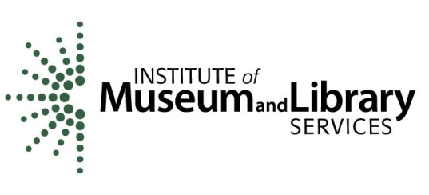
This project was made possible in part by the Institute of Museum and Library Services.

Free Matter for the Blind and
Physically Handicapped
DMM 703.5

Kentucky Talking Book Library
PO Bos 537
Frankfort KY 40602

KTBL Book Club

Join our monthly book club meetings to share how you liked (or did not like) that month’s book selection. We meet at 3:30 Eastern Time on the third Tuesday of each month. You do not have to talk—you can simply listen to the discussion. You may even prefer to read the books and skip the meetings altogether. Let us know if you wish to be added to our list for email reminders announcing upcoming book selections and meeting information.

May 21, 2024
DB 104764, BR 24116
A Psalm for the Wild-Built by Becky Chambers
Centuries ago, the robots of Panga gained self-awareness and disappeared into the wilderness. When Sibling Dex, a tea monk, meets Splendid Speckled Mosscap, a robot, they are the first person to encounter a robot in years. Dex and Mosscap travel through the woods together, engaging in philosophical conversation. Unrated. Commercial audiobook. 2021.

June 18, 2024
DB 110243, BR 24544
Other Birds: A Novel by Sarah Addison Allen
When Zoey Hennessey comes to claim her deceased mother's apartment in coastal South Carolina, she meets her quirky, enigmatic neighbors: a girl on the run, a grieving chef whose comfort food does not comfort him, two estranged middle-aged sisters, and three ghosts. Each with their own story. Each with their own longings. Each whose ending isn't yet written. When one of her new neighbors dies under odd circumstances, Zoey is thrust into a mystery which involves missing pages from a legendary writer whose work might be hidden there. Some strong language.

Audio Magazines
For years, NLS audio magazines were copied and distributed by a company in Maryland. They served all Talking Book libraries in the Eastern US, so there could be delays in processing magazine orders. Starting in May, KTBL will begin to distribute your NLS audio magazines right here in our Frankfort office, just like how your talking books are handled. There may be some hiccups as we all grow used to the new system, but there will be advantages: we can handle any issues right here at our library, and we will be able to provide back issues upon request.

Automatic Email Notifications
In our last issue, we told you about a new feature that would allow you to automatically receive an email whenever materials were sent to you or returned from you to our library. Unfortunately, it is not yet working correctly. Please be patient while the developers correct this; we will notify you once it is available.

Kentucky Talking Book Library
Free Matter for the Blind and
Physically Handicapped
DMM703.5
PO Box 537
Frankfort KY 40602

