Hosting a Lock In for Teens
Below are some online resources that you might use in hosting a lock-in for teens at your library.

Group Games and Activities for Teens
http://www.cplrmh.com/teenactivities.html

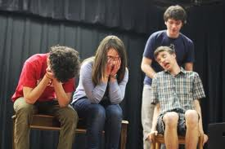
- Whose Line is It Anyway?
Games: http://www.oocities.org/hollywood/2549/wlgamesframe.html
http://learnimprov.com/
You can also use the 101 Improv Games for Children and Adults by Bob Bedore book from the kit.

- Survive Jeopardy and Feel Like a Millionaire
http://www.cplrmh.com/gameshow.html
You can do trivia with the Smarty Pants Trivia game from the kit, or go to one of the following sites for Powerpoint games:
http://jc-schools.net/tutorials/ppt-games/
http://projects.coe.uga.edu/lrieber/wwild/search/PPT-search-results.asp
http://www.hardin.k12.ky.us/res_techn/countyjeopardygames.htm

- Mystery Games
Use the “Panic at the Prom” mystery game from the kit or borrow another mystery game from KDLA’s collection. You can find more information about mystery games here:
http://www.whodunnitmysteries.com/
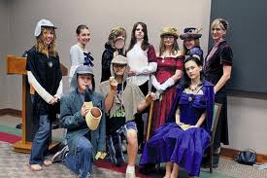
- Reader’s Theater or Silly Skits
Use the The Nuttiest, Wackiest, Funniest Skits Ever book from the kit or try here:
http://www.aaronshep.com/rt/index.html

- Play Live Clue
http://www.cplrmh.com/clue.html

- Library Scavenger Hunt
http://www.cplrmh.com/survivor.html
http://www.cplrmh.com/scavenger.html

Other Ideas for Lock-In Activities:
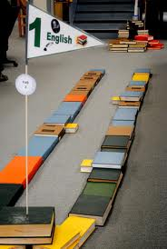
- In A Year of Programs for Teens, Amy Alessio suggests setting up a mini-golf course in the library. Use the golf set included in the kit to hold a mini-golf tournament. Teens can design the course and then play.

- Use the 500 Smoothies & Juices book by Christine Watson and a couple of blenders to inspire a smoothie-off contest.

- Have the board games around to alleviate boredom or host a board game tournament.

- Use the Mad Libs for fun or see who can go the longest without laughing while listening to them.

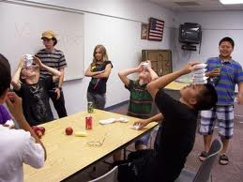
- Play Minute to Win It. This game show on NBC features contestants performing 60-second tasks that involve everyday objects. For example, one task called Dizzy Mummy challenges players to unwind a single roll of toilet paper by spinning their body repeatedly in a 360–without tearing the paper. NBC provides the rules, set-up, and how-to videos for the more than 60 challenges on their site and encourages people to send in videos of themselves trying the tasks.

You can find videos and examples of possible challenges here:
http://www.nbc.com/minute-to-win-it/how-to/
nd here:
http://en.wikipedia.org/wiki/List_of_Minute_to_Win_It_challenges

\
- Viral Video Movie Fest: Gather links to some of the most hilarious and mind boggling You Tube Videos out there. Provide popcorn and drinks and hold a mini-movie fest. You can find some video suggestions here:
  - http://mashable.com/follow/topics/viral-video
  - http://www.viralthis.com/
  - http://www.ugo.com/the-goods/the-50-awesomest-viral-videos-under-30-seconds-long-1

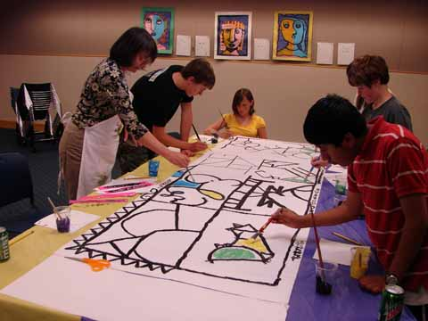
- Group Art Project: Make a huge abstract line drawing on bulletin board paper. Spread the paper over a table and provide art supplies. Let teens drop by during the night to add to the creation.

- Face Painting: Not just for the little ones. Below are examples of some designs teens might appreciate.

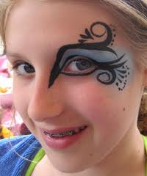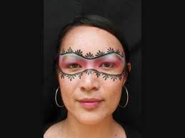

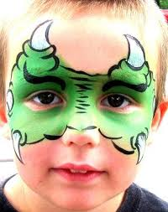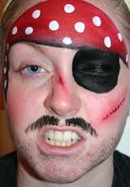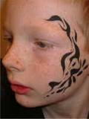

Find more face painting ideas here:

http://www.buddingstars.com/index.html

http://www.snazaroo.com/your-face-painting-pictures/

Resources

A checklist for planning a lock-in:
http://www.creativeyouthideas.com/blog/youth_ministry/lockin_checklist.html

Interview with 2 librarians who hosted a teen lock-in at their library:
http://librarygarden.net/2009/11/10/teenlockin/

