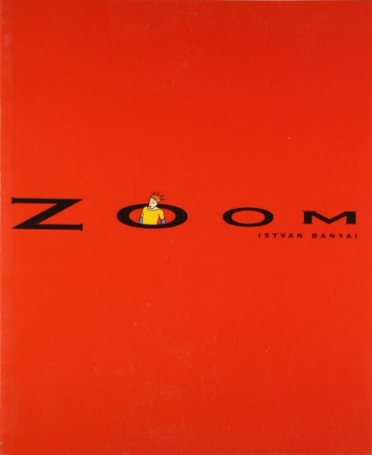
Critical Thinking
Family
The books and activities in this kit are designed to encourage, teach and enhance critical thinking skills.

Zoom by Istvan Banyai
Supporting Books:
Flotsam by David Wiesner
Duck! Rabbit! by Amy Krouse Rosenthal and Tom Lichtenheld
They All Saw a Cat by Brendan Wenzel
The Most Amazing Creature in the Sea by Brenda Z. Guiberson

Explore
Questions:
Copy pages of the book and laminate them. Working together, families have to figure out the order of the pages. Then “read” the book, encouraging participants to write their own text for each page – make their own story for the images they are seeing.

Manipulatives:
- Magnifying glasses
- Mirrors
- Prisms
- Binoculars
- Tuff scope
Not Supplied:
- Random Objects such as rocks, leaves, toys, pom poms, things with texture and details, pages from magazines…
How do these objects change your perspective? Let the children explore ways they can change the way things appear using these objects. How can a mirror distort instead of reflect? What does a prism do? Why do you have to adjust the spy glass or change the position of the magnifying glass to make things clear?

Create
Create a picture from a different perspective – as an ant, a giant, from the window of a plane….
Supplies:
- Paper
- Markers
- Crayons
- Construction Paper
- Scissors
- Glue sticks

Share
Talk about their choices. Why does it look like that? If you spent a day as _____________ what would that be like?

