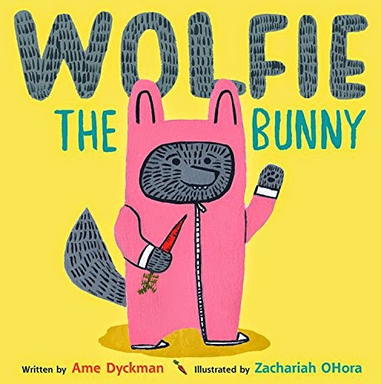

Critical Thinking
Ages 2-3
The books and activities in this kit are designed to encourage, teach and enhance critical thinking skills.

Informational Guide

Critical Thinking
Ages 2-3
The books and activities in this kit are designed to encourage, teach and enhance critical thinking skills.

Wolfie the Bunny by Ame Dyckman

Supporting Books:
Ball by Mary Sullivan
Morris Mole by Dan Yaccarino
Go, Dog, Go! By P.D. Eastman
Demolition by Sally Sutton

Explore
Questions:
Before you read the story, ask the children what they know about wolves and bunnies. Then start the story.
- Why does Dot think Wolfie is going to eat them?
- Do Dot’s parents listen to her? Why?
- Why doesn’t Dot sleep?
- Do things sometimes keep you awake?
- Why do Dot and her friends leave to play at another house?
- Why does Wolfie cry?
- Do you think Wolfie is following Dot because he wants to eat her?
- At the carrot patch, what does Dot think Wolfie is going to do? What do you think he is going to do?
- Why does Dot go after the bear?
- After Dot scares away the bear, why do you think Wolfie Pounces? Is he finally going to eat her?
- What did Dot figure out?

Manipulatives:
- Balls
- Blocks
- Jars

Not Provided:
- Boxes
- Solo cups

What fits in what? The children have a variety of objects of various sizes. Let them explore what fits inside what. Ask why does that fit there? Or not?
Pick an object, but do not show the children what it is. Give them clues and have them guess what it might be. Talk about how we can sometimes be misled by what we think we know.

Create
Working with your parent or caregiver, think of your favorite toy. How would you get someone to guess what it is by giving them clues? Draw a picture of your toy, but don’t show it to anyone.

Supplies:
- Paper
- Crayons
- Markers

Share
See if you can get the others to guess what you have drawn by giving them clues.

