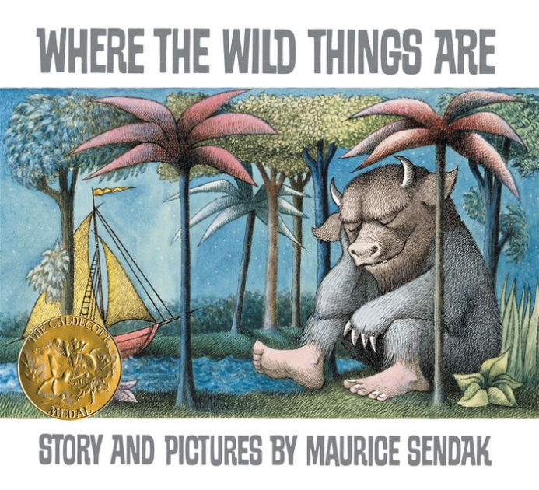
Critical Thinking
Family
The books and activities in this kit are designed to encourage, teach and enhance critical thinking skills.

Where the Wild Things Are by Maurice Sendak
Supporting Books:
The Dark by Lemony Snicket
Bedtime for Frances by Russell Hoban
The Whisper by Pamela Zagarenski
Where Once There Was a Wood by Denise Fleming

Explore
Questions:
- Why did Max get sent to his room?
- What happened then?
- What do you think is happening when the forest appears?
- How does Max become King?
- Do you ever feel like a wild thing?

Manipulatives:
- Magnet tiles
Not Supplied:
Other building materials – blocks, tinker toys, legos…
Build a setting for your own wild rumpus! What is a wild rumpus?
What makes a good wild place?

Create
Paper bag Masks – visit link for inspiration https://www.redtedart.com/where-the-wild-things-are-craft/

Supplies:
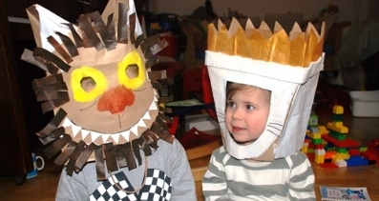
- Brown paper bags
- Paint, crayons or markers (or all 3)
- Construction paper
- Scissors
- glue

Share
What happens when you put on a mask? Does it make you someone else? Is it easier to be silly with a mask on? Why? Do you have times when you need a wild rumpus? Put on your mask and let it begin!

