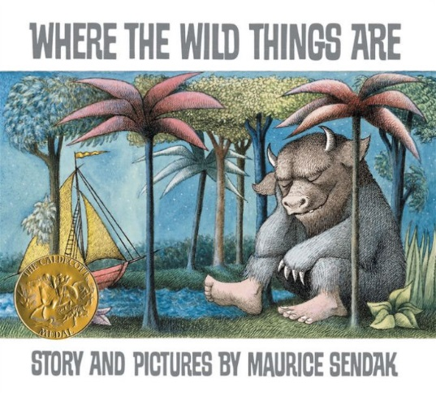

Critical Thinking
Family
The books and activities in this kit are designed to encourage, teach and enhance critical thinking skills.

Informational Guide

Critical Thinking
Family
The books and activities in this kit are designed to encourage, teach and enhance critical thinking skills.

Where the Wild Things Are by Maurice Sendak

Supporting Books:
The Dark by Lemony Snicket
Bedtime for Frances by Russell Hoban
The Whisper by Pamela Zagarenski
Where Once There Was a Wood by Denise Fleming

Explore
Questions:
- Why did Max get sent to his room?
- What happened then?
- What do you think is happening when the forest appears?
- How does Max become King?
- Do you ever feel like a wild thing?

Manipulatives:
- Magnet tiles

Not Supplied:
Other building materials – blocks, tinker toys, legos…

Build a setting for your own wild rumpus! What is a wild rumpus?
What makes a good wild place?

Create
Paper bag Masks – visit link for inspiration https://www.redtedart.com/where-the-wild-things-are-craft/

Supplies:
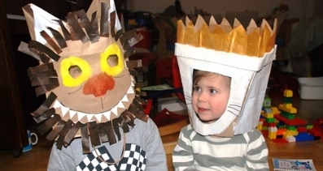
- Brown paper bags
- Paint, crayons or markers (or all 3)
- Construction paper
- Scissors
- glue

Share
What happens when you put on a mask? Does it make you someone else? Is it easier to be silly with a mask on? Why? Do you have times when you need a wild rumpus? Put on your mask and let it begin!

