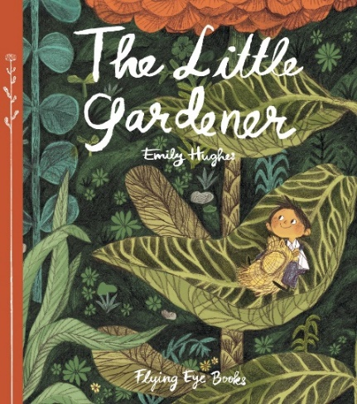

Linking Cause and Effect
Ages 4-5
The books and activities in this kit are designed to explore why things happen, the causes and their reactions.

Informational Guide

Linking Cause and Effect
Ages 4-5
The books and activities in this kit are designed to explore why things happen, the causes and their reactions.

The Little Gardener by Emily Hughes

Supporting Books:
Alexander and the Terrible, Horrible, No Good, Really Bad Day by Judith Viorst
Strega Nona by Tomie dePaola
The Rain Came Down by David Shannon
The Tree Lady: The True Story of How One Tree-Loving Woman Changed a City Forever by H. Joseph Hopkins

Explore
Questions:
- Why doesn’t this garden look like much? What do you notice about it?
- What do you notice about the gardener?
- As the pages are turned, give the children time to see the problems with the garden. Ask about what they are seeing.
- Have you ever worked hard at something? What was the result?
- What was his result? Why?
- Why did the flower give him hope? What makes you want to keep going when things aren’t working out the way you want them to?
- What would happen if the garden died?
- He wished for help. Sometimes we all need a little help. How do you ask for help?
- Did the gardener get help? Why? What happened next?
- At the end it says HE means everything to the garden. How is that different from how the story started?

Manipulatives:
- Boom whackers
- Maracas

Not Provided:
- Pots
- Wooden Spoons
- Oatmeal boxes
- buckets

Allow the children to explore the instruments. How do you they make sounds? What causes the sounds? What if you hit a pot with a boom whacker? A box?

Create

Supplies:
- Seeds
- small flower pots
- planting soil
- paper
- crayons

(Put the seeds out without the package that tells what kind of plant it will be. Have a few different varieties)
Pick a seed. Draw what you think the plant will look like when it grows. Plant your seed in the pot.

Share
Talk about how to care for a plant. Talk about why they think their plant will look that way. The conversation will continue at home as the plant grows. Encourage parents to talk about the cause and effect of caring for the plant – watering, etc – and to ask how the plant that grew resembles or does not resemble the plant they drew.

