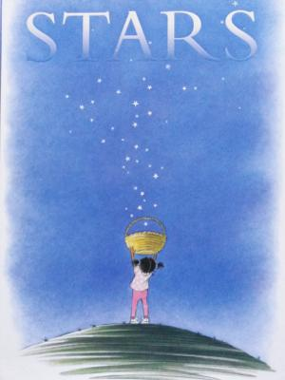
Seeing Patterns and Making Predictions
Ages 4-5
The books and activities in this kit are designed to explore the nature of patterns and how we use patterns to predict what comes next.
Stars by Mary Lyn Ray
Supporting books:
The Tortoise and the Hare by Jerry Pinkney
One Duck Stuck by Phyllis Root
Green Eggs and Ham by Dr Seuss
Zoo in the Sky by Jacqueline Mitton

Explore
Questions: (Ask the questions as you read the story, giving time for answers and thought)
- What do you think is happening on the cover?
- Why do you know it’s almost night when you see a star?
- Why can’t you see stars during the day?
- Can you always see stars at night? Why or Why not?
- If you can’t see them, how do you know they are still there?
- If you had a star, what would you do with it?
- How can you predict when you can see stars?
- Where else do you see stars?
(Discuss the relationship between patterns and predictions – as in stars coming out at night (pattern) means you can predict….)

Manipulatives:
- Buttons
- Beads
- String

Lay out a basic pattern and ask what comes next? Predictions…
Talk about patterns. What makes a pattern? Why do patterns help us make predictions? How things are different, how they are the same….

Allow the children to explore their own patterns. Have them work together to predict what comes next in each other’s patterns.

Create
Make a pattern with pictures!
Select one or more pictures and cut them into triangles. Assemble the triangles to make a pattern. (If you want to make your pattern more complex, take some construction paper and cut it into squares. Add the squares to your pattern!) When you have an arrangement you like, glue it down on a piece of construction paper.
Supplies: (Make an example to get things started. Talk about your choices, your pattern…)
- Pictures from magazines
- Construction paper
- Scissors
- Glue sticks.
(Depending on how many parents, caregivers or helpers you have, you may want to precut the pictures and construction paper)

Share
Talk about your pattern. Why did you choose those pictures? What did you like about them? What kind of pattern are you making? Why triangles and squares? How do they fit together?

