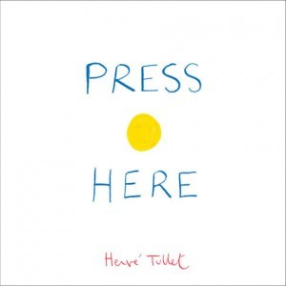
Linking Cause and Effect
Family
The books and activities in this kit are designed to explore why things happen, the causes and their reactions.

Press Here by Herve Tullet
Supporting Books:
The Book With No Pictures by B.J. Novak
The Stray Dog by Mark Simont
There Was an Old Lady Who Swallowed a Fly by Simms Taback
Parrots Over Puerto Rico by Susan L. Roth

Explore
Questions:
- What is the author asking you to do on the cover?
- Why does the first page ask if you are ready?
- As you follow the instructions on each page, ask what they think will happen?
- How did you make the dots bigger? Smaller?
- What other things do you think you could do to affect what happens to the dots?
- At the end of the book, look at the end pages. Is there a pattern to the dots? What is it?

Manipulatives:
- Dominos
- Balls
Not Provided:
- Boxes
- Solo cups
- Marbles
- Paper towel rolls

Help the children explore cause and effect with a few well-placed suggestions as they explore the materials. For example, how can they make a track for the marbles with the cups and the towel rolls? How can you set up a chain reaction with the dominos? What other elements can you add to your chain? How does that affect what happens?

Create
Make a Clever Lever (see attached instructions)
Make six more and link them. Together or singly, set off your Stixplosions.
Supplies:
- ½” Wood Cubes
- Craft sticks
- Rubber bands

Share
Talk about what happened. How far did the sticks fly? Try different configurations. How does that effect the result? What other things do you think you could add to change the outcome?

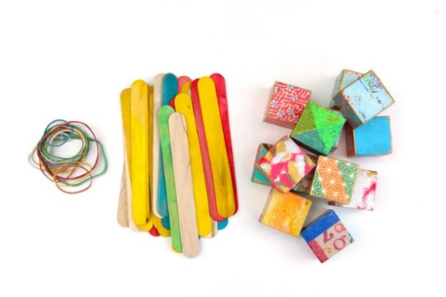
Stixplosions!

Materials
- Jumbo Craft Sticks
- ½ Wood Cubes
- Rubber Bands

Step 1
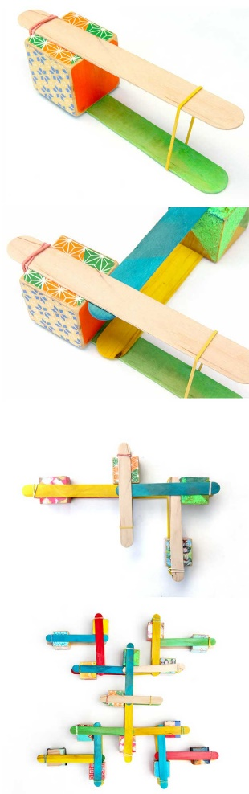
Make your first Clever Lever. Place two popsicle sticks on either side of one block. The block should be near the end of the sticks. Place a rubber band around the end of the sticks NEAR the block. Now place a second rubber band around the other end of the sticks to hold the lever together. This 2nd rubber band is your DETONATION POINT. Place the clever lever on a table or floor in an open area.

Step Two
Build a second clever lever, omitting the second rubber band. Place the open end of the lever between the sticks in the first clever lever, right next to the block.

Step Three
Repeat Step Two five more times. You can build a quick chain reaction with just a few clever levers but the more levers you add the more power you will get.

Step Four
To detonate your stixplosion remove the rubber band at the DETONATION POINT while pressing down on the free end of the sticks.
Now let go!

