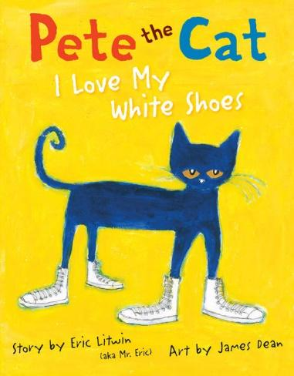
Seeing Patterns and Making Predictions
Ages 4-5
The books and activities in this kit are designed to explore the nature of patterns and how we use patterns to predict what comes next.

Pete the Cat: I Love My White Shoes by Eric Litwin
Supporting Books:
I Want My Hat Back by Jon Klassen
Goodnight Moon by Margaret Wise Brown
Bear Has a Story to Tell by Philip C Stead
Bring on the Birds by Susan Stockdale

Explore
Questions:
Encourage the kids to sing Pete’s sing about his shoes.
- What do you do when you get new shoes?
- What song would you sing about your shoes? Or what dance would you do?
- What happens to Pete’s shoes?
- Does he get upset? (Encourage them to say “Goodness NO!” every time the book asks if Pete cries.)
- Why do you think Pete doesn’t get upset?
- What do you do if you get your new shoes dirty? Or you drop something on your new shirt or rip your new pants?
- How does Pete’s song change? How does it stay the same?
- What other things could Pete step in? What color would it change Pete’s shoes?
(Pete’s story follows a very predictable pattern. What other patterns can you see in the story?)

Manipulatives:
- Buttons
- Beads
- Gems

Not provided: Solo Cups
Place the materials on the table and let children examine them. Break them into groups. Give each group 4-6 cups and have them sort the objects into the cups. How will you sort them? By color? Texture? Size?....?

Create
Word patterns – patterns are more than color or shape sequences. Patterns can be behavior – the way Pete reacts each time to his shoes getting dirty. Patterns can also be with words – words that start with the same letter, have the same number of letters, same sounds, rhyme…
Make a pattern with the words on your paper.
Supplies:
- Construction paper
- Pages full of words printed in a variety of bold fonts

Share
What is your pattern? Why did you choose that pattern? What other patterns do you see in the world around you?

