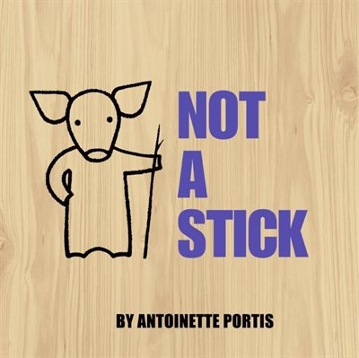
Wondering and Asking Questions
Ages 2-3
The books and activities in this kit are designed to inspire wonder, curiosity and juicy questions.

Not a Stick by Antoinette Portis

Supporting Books:
If Rocks Could Sing by Leslie McGuirk
The Color Monster by Anna Llenas
We’re Going on a Bear Hunt by Michael Rosen
Birds by Kevin Henkes

Explore
Questions:
(Remember, with this age, you may not get answers, but still ask the questions, then talk through the answers with them)
- Why do they keep telling him to be careful with the stick?
- What does he know that they do not?
- How is he making the stick Not a Stick?
- Do you like to use your imagination?

Manipulatives:
- Sorting discovery stones

Not Provided: (collect sticks and stones from your backyard, park or woods and get boxes from a local store)
- Sticks
- Stones
- Boxes
Let children explore the materials. Yes, these are sticks and stones and boxes, but what else can they be. Build, wonder and imagine with the children.

Create
What else can a stick be? Take a stick and make it into something else – a magic wand, a hobby horse, a sword….?
Supplies:
- Sticks of all sizes and lengths
- Ribbons
- Paint
- Brushes
- Boxes (broken down to use for the cardboard)
- Yarn

Share
What is your Not a Stick? Make up a story about you and your stick

