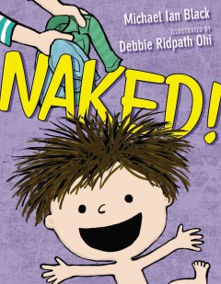

Linking Cause and Effect
Ages 2-3
The books and activities in this kit are designed to explore why things happen, the causes and their reactions.

Informational Guide

Linking Cause and Effect
Ages 2-3
The books and activities in this kit are designed to explore why things happen, the causes and their reactions.

Naked! by Michael Ian Black

Supporting Books:
Two Bad Ants by Chris Van Allsburg
No, David! By David Shannon
Oops, Pounce, Quick, Run! By Mike Twohy
Weeds Find a Way by Cindy Jenson-Elliott

Explore
Questions:
- Why is he naked?
- Why don’t you take a bath with your clothes on? You wash your clothes in the washing machine? Why is that different?
- What do clothes do for you?
- After all his naked adventures, he gets cold. Why is he cold? How do clothes keep you warm?
- Why did he keep his cape on?
(Remember, with this age, you may not get answers, but still ask the questions, then talk through the answers with them)

Manipulatives:
- Bubble wands
- Bubble soap
- Pinwheels

Both these are dependent on the movement of air. As the children are exploring, talk about how air is what makes them work. The pinwheel only turns if air is blowing on it, the bubble only happens if you blow on the wand. Why is that?

Create
Painting with air.
Place puddles of paint on the paper. Move the paint on the paper by blowing through the straws.

Supplies:
- Watercolor paper
- Straws
- Watercolors

Share
What happens when you blow gently? Harder? How does air move the paint?

