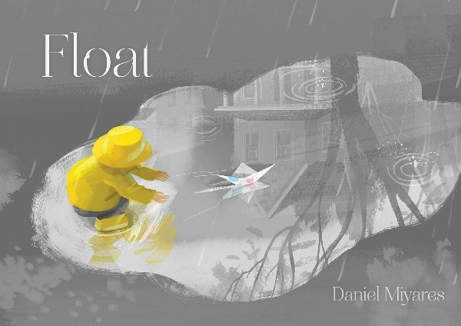

Investigation and Problem Solving

Ages 2-3
The books and activities in this kit are designed to encourage investigation and teach and enhance problem solving skills.

Informational Guide

Investigation and Problem Solving
Ages 2-3
The books and activities in this kit are designed to encourage investigation and teach and enhance problem solving skills.

Float by Daniel Miyares

Supporting Books:
Knuffle Bunny by Mo Willems
Harry the Dirty Dog by Gene Zion
Giraffes Can’t Dance by Giles Andreae
A Chicken Followed Me Home by Robin Page

Explore
Questions:
Since this book has no words, your questions will drive the story. Give the children time to answer before turning the page.
- Whose hands do you see on the first page? What are they doing?
- What is the boy holding? Is that what they made? Where do you think he is going? What is he wearing? Why?
- What is happening? Why is he putting his boat inside his coat?
- WOW! It’s raining hard. Can you find the boy in the rain?
- What is he doing here? Do you like to play in puddles? What do you do in a puddle?
- What happens when you jump in a puddle?
- What is he standing on? The water in the gutter is like a river? Have you ever seen that happen? He let his boat go in the water? What do you think will happen?
- What is the expression on his face? Amazed? Excited?
- Now what is it? Worried? Why is he running? Where is the boat?
- He can’t find the boat. Can you find it? What would happen if a car hit the boat?
- He sees the boat, but where is it going? Why are the boy’s arms up? What do you think he is yelling?
- OH NO! Where did his boat go?
- What is happening here? Where is the boy and his boat?
- Can you find the boat in this picture? What happened to it? What is the boy doing with the stick? How do you think he is feeling now?
- How is his walk home different from when he first left his house? Can you see his shadow?
- Who opens the door for him?
- What is happening here? Have you ever been out in the rain? How do you get dry?
- What do you think is in the pot? Do you like a hot drink when you are wet and cold? Why does it make you feel better? Are they folding a piece of newspaper again? Are they going to make another boat?
- What is the boy holding? Why do you think they made a plane?
- He is off to fly his plane! Have you ever made a paper airplane?
(Remember, with this age, you may not get answers, but still ask the questions, then talk through the answers with them)

Manipulatives:
- Tubs
- Shimmer shapes

Not Provided:
- Heavy and light objects
- Balloons

Fill the tubs with water. Fill some of the balloons with water, blow up some and leave a few uninflated. Collect some random objects that can be safely placed in water with at least one object made of paper. Let the children put the objects in the water. What sinks? What floats? How does the water effect the objects?

Create
Newspaper boats and airplanes. Follow the links for how-tos.
Boat: http://www.wikihow.com/Make-a-Paper-Ship
Plane: http://www.diynetwork.com/made-and-remade/learn-it/5-basic-paper-airplanes

Supplies:
- Paper
- Markers
- Crayons

Share
What did you make? What will you do with your boat? Plane? What adventures will you have? What else can you make with newspaper?

