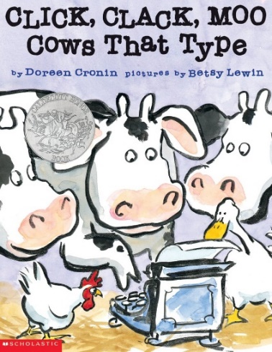
Critical Thinking
Ages 4-5
The books and activities in this kit are designed to encourage, teach and enhance critical thinking skills.

Click, Clack, Moo Cows that Type by Doreen Cronin
Supporting Books:
Children Make Terrible Pets by Peter Brown
The Little Hummingbird by Michael Nicoll Yahgulanaas
George and His Shadow by Davide Cali
I Face the Wind by Vicki Cobb

Explore
Questions:
- What did the cows want?
- Why did they want electric blankets?
- What are they willing to do to get what they want?
- Why is Farmer Brown angry with the cows?
- What effect does actions have on Farmer Brown?
- What effect do the cows demands have on the rest of the animals?
Talk about how one thing caused another – the cold caused the cows to want the blankets which caused…..

Manipulatives:
- Magnet set
- Keva Planks
- Jars
Not Provided:
- Random small metal objects
- Paper towel rolls
- Toilet paper rolls
- Wrapping paper rolls
Let the children explore the magnets. Working together or in small groups, have them build ramps and pathways with the rolls and Keva planks. Place jars at the end of the course created. Using the magnets, manipulate the metal objects through the course and into the jars. Which objects work best? Which magnets work best? What happens when you use the magnet marbles with the magnets?
Create
Write a letter to your parents making the case for why you should have your favorite treat for dinner. Try to imagine what they will say and think of ways around it. What do you have to trade for what you want? How can you use that?

Supplies:
- Paper
- Pencils

Share
Talk about your strategies. Why do you think they will work? Or not work? Try it out when you get home. How close did you come to answering what they actually said?

