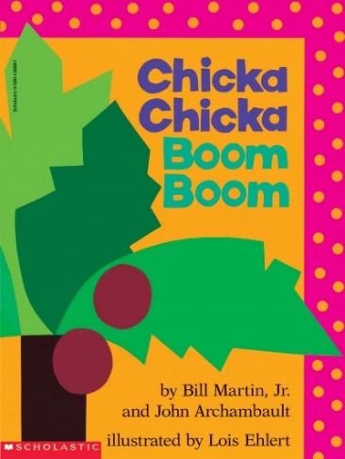

Imagining and Making Models
Ages 2-3
The books and activities in this kit are designed to explore the part our imagination plays in the things we create.

Informational Guide

Imagining and Making Models
Ages 2-3
The books and activities in this kit are designed to explore the part our imagination plays in the things we create.

Chicka Chicka Boom Boom by Bill Martin, Jr. and
John Archambault

Supporting Books:
Chick Chicka 123 by Bill Martin Jr and John Archambault
If by Sarah Perry
Fraidyzoo by Thyra Heder
Alphablock by Christoher Franceschelli

Explore
Questions:
- Why do you think they wanted to climb the coconut tree?
- Do you think they will fit?
- How do letters climb?
- Did they fit?
- What happened?
- How could you make it so they would all fit?
- Who came running? Why?
- Skinned knees, bumps, owies…what happens when you get them? Who helps you? Does it make it better?
- Do you try it again even though you got hurt?
- What do the letters do?
(Remember, with this age, you may not get answers, but still ask the questions, then talk through the answers with them)

Manipulatives:
- Blocks
- Bean bag shapes

Not Provided:
- Other building sets – tinker toys, Legos, etc. as desired or needed

Allow the children to explore the blocks and bean bags. Can they build a tree? Balance the bean bags on it? What happens? What else can they build?

Create
Make an animal out of the first letter of your name. Where is the head? The tail? The mouth?...?

Supplies:
- Construction paper cut into all kinds of shapes
- Cardboard letters to trace and cut out
- Scissors
- Ribbons
- Googly eyes…

Share
Talk about your animal, tell stories about it, describe its adventures, family…

