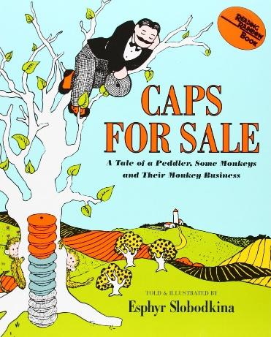
Seeing Patterns and Making Predictions
Family
The books and activities in this kit are designed to explore the nature of patterns and how we use patterns to predict what comes next.

Caps for Sale by Esphyr Slobodkina
Supporting books:
The Rose in My Garden by Arnold Lobel
Today is Monday by Eric Carle
Should I Share My Ice Cream? Mo Willems
Sorting at the Market by Tracey Steffora

Explore
Questions:
- How did the man arrange his caps?
- Why do you think he did it that way?
- What do you think will happen when he falls asleep?
- How do you think he can get his caps back?
- How did he get his caps back?
- Was it an accident?
- Do you think he could have predicted throwing his cap down would get his caps back? Why?
- How can you predict what will happen next?
(There are patterns in how the caps are arranged, patterns in the way the peddler goes about his business, patterns in the behavior of the monkeys. Because of these patterns, you can predict what happens next.)
Extras: Have a sign with Stop! on one side and Go! on the other. Use the sign to stop the story and invite predictions of what happens next.

Manipulatives:
- Hats
- 3 ties
- Fabric squares

Suggested additions (solid colors and patterns): Caps, Scarves, Ties, Socks
Ask the children to sort the objects.
How would you sort these?
Why did you sort them that way?
Talk about patterns in objects and patterns in behavior – what clues tell you what comes next?

Create
Newspaper hats – this craft requires helping hands (See attached directions)
Supplies:
- Newspaper
- Staples
- Masking tape
- Paint
- Feathers
- Plastic gems
- Construction paper
- Glue
- Chenille stems
- other decorative items

Share
Model your hats – maybe have a parade to show them off…
What kind of hat is it? Why did you design it that way?

Newspaper Hat

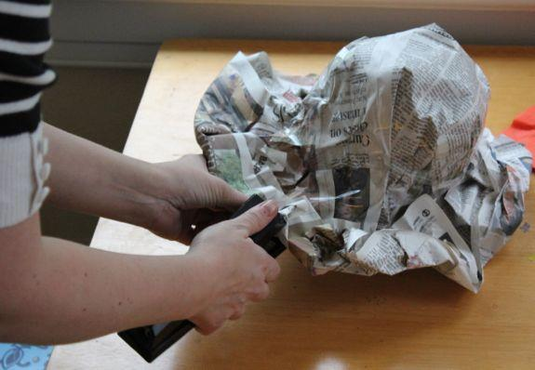
Supplies:
3-4 Full newspaper sheets
Masking Tape
Stapler

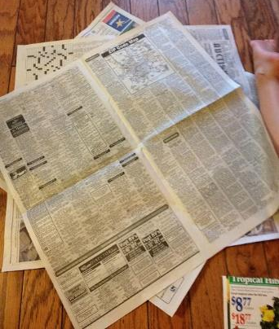

Instructions:
1. Lay out 3-4 sheets of newspaper.
Arrange them at different angles.

2. Size the hat:

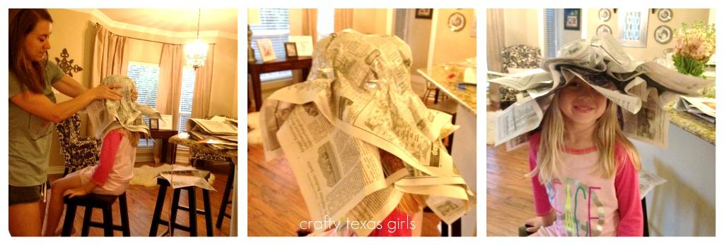
Center the papers on the head. Then wrap tape around the newspaper, just above the eyes.

3. Shape the brim:
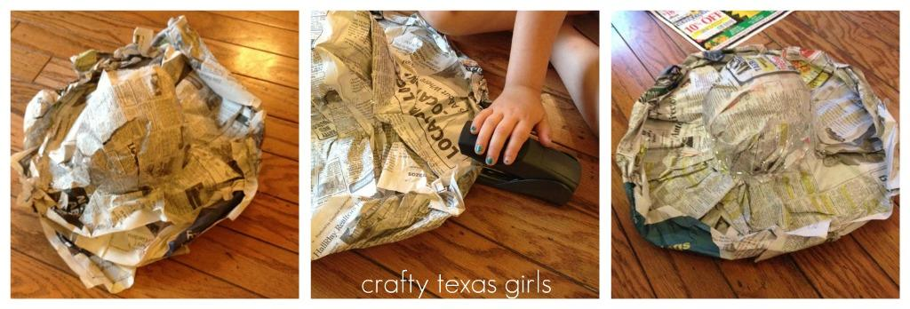

Take off the hat and fold the brim into the shape you want. This shows 'Kentucky Derby' style hat. But you could make cowboy hat, a sun hat, a bowler hat, a safari hat etc. We rolled up the edges of the newspaper and stapled them into place. Then we worked all the way around the hat until it was just right.

4. Decorate your hat! Be creative!

