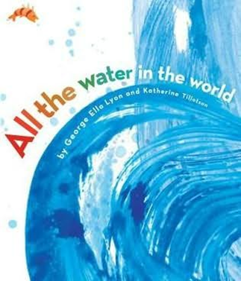

Seeing Patterns and Making Predictions

Family
The books and activities in this kit are designed to explore the nature of patterns and how we use patterns to predict what comes next.

Informational Guide

Seeing Patterns and Making Predictions

Family
The books and activities in this kit are designed to explore the nature of patterns and how we use patterns to predict what comes next.

All the Water in the World by George Ella Lyon

Supporting Books:
On Bird Hill by Jane Yolen
Do You Know Which Ones Will Grow? By Susan A. Shea
Have You Seen My Cat by Eric Carle
Little Treasures: Endearments from Around the World by Jacqueline Ogburn

Explore
Questions:
- How does the author talk about water?
- Is there a pattern in the words he chose?
- What pattern can you see in where water comes from and where it goes?
- Why is water so important?
- Does everything need water?
- Are all clouds rain clouds?
- How can you predict when it will rain?
- Notice the illustrations? Do you see a pattern? What is it?

Manipulatives:
- Tubs
- Plastic gems
- Balls

Not provided: random heavy and light objects, 2 small containers (one empty, one full)

Fill tubs with water. Place an assortment of objects on the tables near the tubs and allow children to see what will float and what will sink. Have them make predictions of what will happen before they place an object in the water. Ask: “Were you surprised by what happened? Why? Or Why not?”
Ask: “Is there a pattern to what float and what sinks?”
“Knowing the pattern, how can you use it to predict what will happen?”

Create
How would you describe water? With A picture? With words? Create a picture of water. Write a poem or short story about your picture. Make patterns with the words you choose.

Supplies:
- Construction paper, including several shades of blue
- Blue and silver glitter glue
- Tissue paper
- Scissors
- Pieces of fabric
- Ribbons
- Crayons
- Markers

Share
Talk about your water picture and poem or story. Why did you choose those materials? Those words? Do you see a pattern in what you made? Explain it.

