Investigation and Problem Solving
Family
The books and activities in this kit are designed to encourage investigation and teach and enhance problem solving skills.

A Chair For My Mother by Vera B. Williams
Supporting Books:
Those Shoes by Maribeth Boelts
The Invisible Boy by Trudy Ludwig
Bats at the Library by Brian Lies
A Splash of Red by Jen Bryant

Explore
Questions:
- What do you think the story is about? What is the problem? How are they solving it?
- How much do you think they will need for the chair? Have you ever saved for something? What did you save for? How did you get the money and how long did it take?
- Have a jar of coins. Let the children count them and exchange them for play paper money. Talk about the relationship between the mother and the daughter. She is saving for something for her mom, not herself. What does that say about their relationship?
- Design something for someone you love. What are you designing? How will it look? What need does it fill for that person?

Manipulatives:
- Sample designs (see attached)
Not Provided:
- Paper
- Pencils
- Rulers
- Compasses
Divide children into groups. Have them use the dry erase boards to design a piece of furniture for someone else – it can be a chair, a desk, a table or? but it must be for someone else. Why do they need this? What is it they need it to do for them?

Create
Using the materials provided, build a model of your design. (See design reference images)
Supplies:
- Paper
- Crayons
- Craft sticks
- Masking tape
- Felt
- Fabric
- Ribbon
- Scissors
- Glue

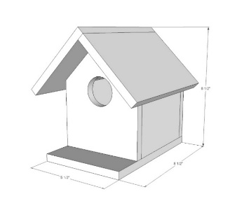
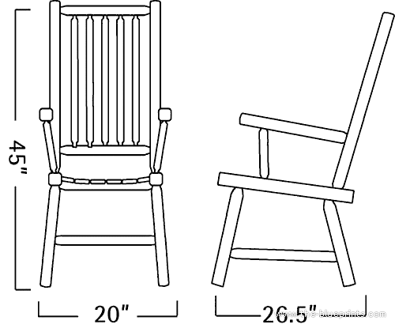

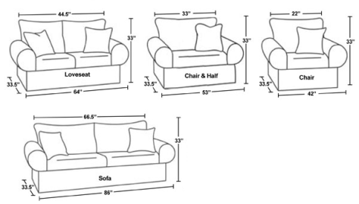

Share
How does your model compare with your design? If you were going to build it full size, what would you use? How is this perfect for the person you made it for?

