Social Emotional – Getting Ready for School/First Day of School – Sample Storytime Outline

Book 1: Nonfiction or other themed book

Rhyme: Back to School Fingerplay
Two little houses all closed up tight
(make fists)
Open up the window and let in the light
(open fist)
Ten little finger people tall and straight
(ten fingers)
Ready for school at half past eight
(walk with fingers)

Book 2: Story in rhyme
Song: Wheels on the Bus
Book 3: Interactive story

Science Center: Sink and Float
- Tub with water
- Objects that sink and float
- Papers with sink and float written on the top so that children can predict what will sink and float before they put it in the water
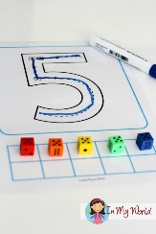
Math Center: Tracing numbers with dice counting
- Mats with numbers to trace 1 – 6
- Dice
Literacy Center: Writing Their Name
- Chalkboards (or White Boards)
- Colored Chalk (or White board markers)
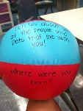
- Nameplates for each child
Game: Getting to Know You Game
- Beach ball
- Permanent marker

