Diversity and Inclusion – Sample Storytime Outline
Book 1: Nonfiction or other themed book
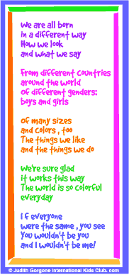
Rhyme:

Book 2: Story in Rhyme
Song: https://www.youtube.com/watch?v=MYXJlfcfFKU
“We all sing with the same voice”
My hair is black and red. My hair is yellow. My eyes are brown and green and blue. My name is Jack and Fred. My name’s Amanda Sue. I’m called Kareem Abdul. My name is you.
I live in southern France. I’m from a Texas ranch. I come from Mecca and Peru. I live across the street. In the mountains, on a beach. I come from everywhere. And my name is you.
We all sing with the same voice. The same song, the same voice. We all sing with the same voice. And we sing in harmony.
Sometimes I get mad and mean. Sometimes I feel happy. And when I want to cry, I do. When I’m by myself at night. I hold my teddy tight. Until the morning light. My name is you.
I have sisters one, two, three. In my family there’s just me. I’ve got one daddy. I’ve got two. Grandpa helps me cross the street. My cat walks on furry feet. I love my parakeet. My name is you.
We all sing with the same voice. The same song, the same voice. We all sing with the same voice. And we sing in harmony.
I like to run and climb. I like to sit and read. I like to watch my TV, too. And when it’s time for bed. I like my stories read. “Sweet dreams” and “Love you” said. My name is you.
We all sing with the same voice. The same song, the same voice. We all sing with the same voice. And we sing in harmony.

Book 3: Interactive story

Science Center: https://www.bonbonbreak.com/talking-about-diversity-using-playdough/#_a5y_p=1186921
Ingredients for playdough
Food color
Math Center: Graphing and charting hair color, eye color
Literacy Center: Making or cutting out letters with playdough
Game: Red Rover

