Kentucky Ghost Stories Resources

Although many of the crafts and programming ideas are Halloween related, they can be adapted for spirits and hauntings and other events throughout the year.

Programming Ideas
- Zombie or Monster Prom—have patrons dress as zombies or monsters, crown a Prom king and queen during the event—the event can feature make-up and hair styling artists
- Have a spirited book discussion! Pick one of KDLA’s horror book discussion kits, many to choose from including Abraham Lincoln, Vampire Hunter; Dracula; and Frankenstein
- Have a film discussion about horror movies from the 50s to today
- Pick a monster or zombie and have a book discussion and film festival starring your choice
- Have a good storyteller come to the library and tell the stories featured in the Kentucky Spirits kit
- Have an English or Literature teacher or professor speak on folklore and fairy tales through history or through geographic region
- Decorate a section of the library as a haunted house
- A recommendation from….The Ferndale (Wash.) Public Library hosted a Zombie Project Runway. Seven kids had an hour to get themselves zombied up before walking down a runway in the library and standing before the judges. Each zombie contestant had to have an infection story, which ranged from a motorcycle crash in zombie territory to a zombie homeless man asking for spare change and spare limbs.
- Have a local Spanish teacher or native of Mexico speak about the Day of the Dead celebrations
- Have a speaker or program on the origins of Halloween
- Have patrons discuss their personal or family ghost stories
- Have a local haunted house? Have the local tourism office or local history buff speak about it.
- Have an area paranormal society or ghost hunter speak about their interest in paranormal
- Have a display of monster books of all sorts, don’t forget modern day monsters like Hannibal Lector and old favorites from mythology
- Display “spirited” collectibles

Craft Ideas

Glittered Memory Ornaments
Remember those that went before….
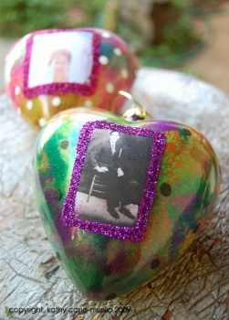

Supplies:
Clear glass ornaments
Clear water-based varnish
Microfine glitter or mica powders
Photo
White craft glue
Paint brush
Directions:
Remove the top of the glass ornament.
Pour in about a tablespoon of varnish and roll it around, so the inside of the ornament is fully coated. Turn upside down and drain out excess.
Pour in the glitter, put your finger over the hole and shake so all the inside of the bulb is coated with glitter. Leave top off to dry.
Replace top, glue picture on the front of the ornament, embellish with more and glitter if desired.

Sugar Skulls

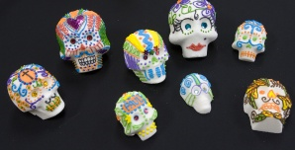
Supplies:
1 set of plastic skull molds
Mixing bowl and spoon
2 cups of granulated sugar
2 teaspoons of meringue powder
2 teaspoons of water
1 piece of cardboard, approximately 5" x 5"
Mix the dry ingredients together in the bowl. Sprinkle the water in and continue to mix until the sugar is completely moistened and becomes the consistency of moist sand. Scoop some of the mixture into the mold and pack it evenly and firmly. Place the piece of cardboard on top of the mold and quickly flip it over so the sugar skull pops out. Very carefully slide it onto a flat surface.
Continue making the rest of the skulls. Let them dry for 24 hours in a dry place.
Icing:
2/3 cup of water
1/2 cup meringue powder
2 pounds of powdered sugar
Electric mixer
Concentrated food coloring (the kind professional cake bakers use)
1 pastry or Ziploc bag
Plastic cups
Spoon
Blend the ingredients with an electric mixer until the peaks form in the icing. If using assorted colors, scoop the white icing into separate bowls and add a dab of different colored food coloring in each one. Mix again. Scoop the icing into the pastry or Ziploc bag (snip the corner for the latter). Continue until you have several bags of different colors. Keep sealed and refrigerated until use.
*Makes four small skulls.

Make Horror in a Jar
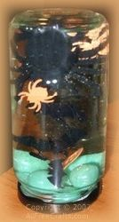

This Halloween craft project is similar to a Christmas snow globe, although the liquid used in the jar is clear Karo Corn Syrup.

You will need:
- clean empty jar (baby food or small jam jar size) with leakproof screwtop lid
- marbles, glass stones or small pebbles
- one plastic spider, ghost, witch or other Halloween figure (the largest you can find that will fit in the jar without touching the sides)
- Halloween confetti with bat, spider and pumpkin shapes
- optional: silicone caulking
Craft Project Instructions:
1. Add a layer of marbles to the bottom of the jar.
2. Add the large Halloween figure to the jar. Although it is not necessary, you may want to glue this to the center of the upside down jar lid so that it remains stationary while the other objects float around it. If so, use waterproof silicone caulking (the kind used for fish tanks is excellent) to cement the base of the figure in place. Let dry.
3. Add a selection of Halloween confetti pieces.
4. Pour in clear corn or heavy sugar syrup to fill the jar. If you are adding a figure glued to the lid, remember to allow space for this so the syrup doesn't overflow.
5. Screw on the lid and invert the jar. If desired, you can run a bead of silicone caulking around the lid to secure it permanently. Activate your Halloween scene by shaking or inverting the jar so you can see the confetti and marbles floating slowly around.
Tin Can Luminaries
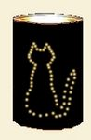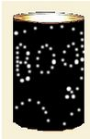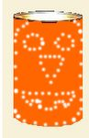
It's easy to make tin can luminaries to light your walkway or front steps. Add a coat hanger wire and you can hang them up, if you like. Just recycle those old tin cans and make a variety of designs.
There are two basic methods you can use for punching the designs. You can work directly on the tin can, using the ridges on the can as a measure to keep things evenly spaced. Or you can draw your design on paper first, then use the paper as a pattern by wrapping it around the tin can and punching directly through the dots on the paper.
You will need:
• clean tin cans
• votive candles or tea light candles
• pencil, crayon or permanent marker
• paper and scissors (optional, depending on method used)
• coat hanger or sturdy wire for hanging (also optional)
• towel and firm work surface
• hammer
• large nail
• freezer
• water
• spray paint
Instructions:
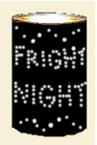1. Clean and dry the tin cans, fill with water, and freeze overnight. The ice provides support for the can as you drive in the nail holes.
2. It is possible to punch a design directly into the tin can. You can mark where you plan to punch the holes with a marker, because the lines will be covered by spray paint later.
- If you are using a paper pattern, cut paper to fit around the can, then draw your design on the paper.
- Remember that simple shapes are most effective for punched designs.
3. Lay a thick towel on your work surface to absorb the melting ice and to prevent the can from rolling as you work.
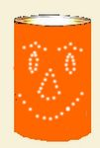4. Place a tin can on the towel. If using a paper pattern, wrap the can in the paper and tape the pattern in place. If drawing the pattern directly on the can, use a fine marker (in the same color that you have chosen for the spray paint) to draw the outline.
5. Use the hammer and a large nail to punch the holes. If you're making a hanging luminary, remember to punch two holes at the top, on either side of your design, to take the hanger.
6. Immerse the can in hot water to melt the remaining ice.
7. Make sure the can is perfectly dry before applying spray paint to the sides and bottom of the can.
8. If you want to hang the luminary, cut a length of sturdy wire, or use a length of wire from a coat hanger, and bend it into an arched hanger shape. Bend up the ends and insert them into the two holes that you placed at the top of the can.
9. Place a votive candle or tea candle inside the can. Light with a long fireplace matchstick, or a barbeque lighter.

Light Bulb Witch

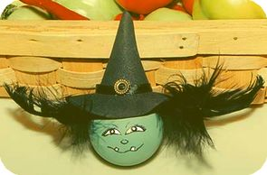
Material:
Burned out light bulb
Printable Witch's Hat Pattern
Acrylic Enamel Paints: sage green, black, white
Black Feathers
Black Craft Foam
Gold Bead or Button
Black String or ribbon
Hot Glue
Tacky Glue
Toothpick
Paint Brush
How to:
Paint your lightbulb using sage green paint. It's important to use an enamel paint for this project. If you use regular acrylic paints, the paint will scratch and peel. If you have glass paint, that will be even better. If you decide to use regular acrylic paints, do not expose your bulbs to the outdoors and be very careful not to scratch the surface. Allow your paint to dry.
Make the hat using craft foam, but you can purchase a ready made hat at craft shops. To make the hat, use the printable pattern pieces (but you will need to enlarge the pieces if using a regular light bulb). The best way to make the hat, is to draw your circles on a sheet of paper first and use the paper template, to cut from the foam.
To assemble your hat, roll the 1/3 circle to create a cone shape and using tacky glue, secure the seam. If you want to add a hanger for your witch, glue about a 5 inch strand of string or ribbon (2 cut ends) on what will be the inside of the cone. The ribbon will extend up and out of the top of the cone (see photo). Allow this glue to dry completely before you continue. Cut a hole in the centre of your full circle, this hole will need to be large enough, to insert over the socket end of your light bulb.
Once the glue on your cone section is dry, attach the cone to the bib section using tacky glue and allow the glue to dry.
To dress up the hat a little, glue a small strip of black ribbon around the seam between the cone and brim of the hat. Add a small gold bead or button to the centre (see photo for placement).
For the hair, I used feathers, but you can use raffia or doll hair or any other suitable product. Cut feathers to random lengths with longest length about 3 inches. I used 9 pieces of feather for this project. Using your finger nails or scissors, very gently pull the exposed ends of the feathers (soft section of the feathers only) to create a curl on the feather. Similar to curling ribbon. With your fingernails, you pinch the feather between 2 finger nails and pull gently, this will curl the ends. If using scissors, place the soft section of the feather ends along one blade of your scissors and your finger or thumb on top of the feather with the feather strands pinched between the scissor blade and your finger. Gently pull the feather through (very gently or you'll break the feather) to create a small curl. If your scissors are very sharp, you may cut through the feather, so be careful.
Hot glue your feathers to the lightbulb where the hair should be placed (see photo). Making sure the glue on your hat is dry, place the hat over the lightbulb and hot glue in place on the lightbulb. This will cover all the feather ends.
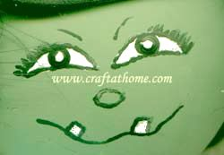
Painting the face:
To the left, is a clear diagram of the face and it is very easy to paint. The eyes are simply a 1/3 circle, painted white. Once the white paint is dry, paint the edge of your eye with black paint (a toothpick works great for painting the detail, just don't press with toothpick). Dip your toothpick in black paint and gently paint the outline.
Using a toothpick or very fine liner paint brush, paint an oval shape for the nose and crooked line for the mouth. Paint 2 squares with white paint to create the teeth and once that paint is dry, outline the teeth with black paint. Again, using a toothpick, draw eyelashes and small strokes for the eyebrows.

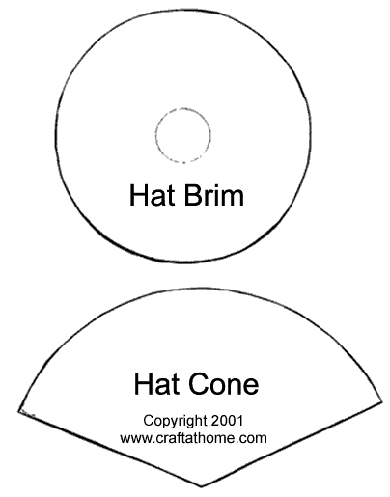

Online Resources


www.snopes.com
The definitive Internet reference source for urban legends, folklore, myths, rumors, and misinformation


www.americanfolklore.net/


http://www.louisvilleghs.com/home.html

Kentucky Paranormal Research
www.kyghosts.com/


ghosthunter.com

My Old Kentucky Ghosts
www.angelfire.com/ky3/myoldkentuckyghosts

Ghost Walking Tours of Louisville
www.louisvilleghostwalks.com/

Northern Kentucky Paranormal Society
www.nkyps.com

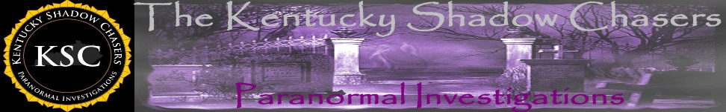
Kentuckyshadowchasers.com
Haunted Places in Kentucky
theshadowlands.net/places/kentucky.html
http://ghosthunter001.webs.com/hauntedplaces.htm

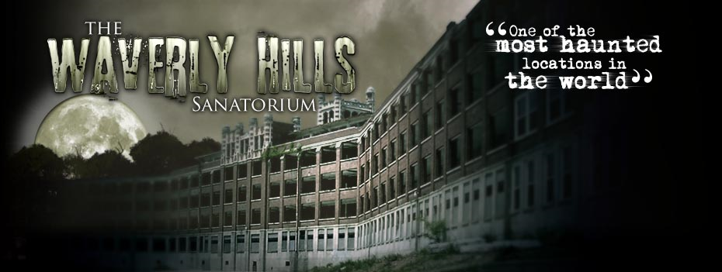
www.therealwaverlyhills.com/

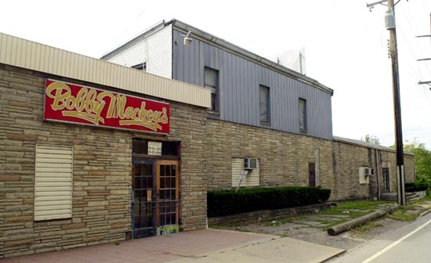

Bobby Mackey’s Music World
http://www.bobbymackey.com/hellsgate.html

Kentucky Area Paranormal Society
www.kentuckyareaparanormalsociety.info/

www.kygh2000.com/indexmain.html

Kentucky Paranormal Detectives
kentuckyparanormaldetectives.yolasite.com

The Haunting Investigators of Northern Kentucky
www.thinkparanormal.com

Paranormal Investigators of Northern Kentucky
www.paranormalinvestigatorsofnky.com

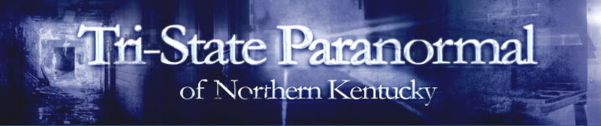
www.tspnorthernkentucky.com

Haunts of Owensboro
www.hauntsofowensboro.com
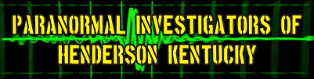
www.kyghosthunters.net

Commonwealth Paranormal
www.facebook.com/pages/Commonwealth-Paranormal/302790136603

Kentucky Baseline Paranormal Research
www.kentuckybaselineparanormalresearch.com

Eastern Kentucky Paranormal Investigations
www.easternkentuckyparanormal.com


www.angelfire.com/extreme2/freek29/ghosts.html

Kentucky Spirit Seekers
sites.google.com/site/kentuckyspiritseekers

Louisville Paranormal Investigations
www.louisvilleparanormalinvestigations.com

Bluegrass Ghost Chasers
http://bluegrassghostchasers.net/
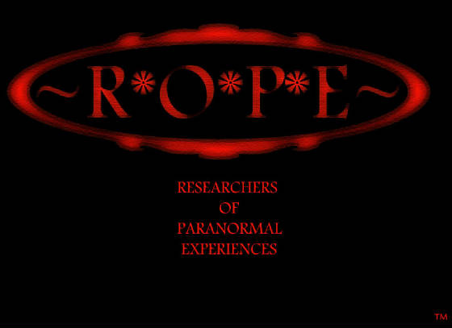
http://www.researchersofparanormalexperiences.net/
West Virginia Ghosts
www.wvghosts.com


www.appalachianghostwalks.com

Haunted Trivia & Fun Facts

Halloween Holiday Trivia
- Orange and black are Halloween colors because orange is associated with the Fall harvest and black is associated with darkness and death.
- Jack o’ Lanterns originated in Ireland where people placed candles in hollowed-out turnips to keep away spirits and ghosts on the Samhain holiday.
- Pumpkins also come in white, blue and green. Great for unique monster carvings!
- Halloween was brought to North America by immigrants from Europe who would celebrate the harvest around a bonfire, share ghost stories, sing, dance and tell fortunes.
- Tootsie Rolls were the first wrapped penny candy in America.
- The ancient Celts thought that spirits and ghosts roamed the countryside on Halloween night. They began wearing masks and costumes to avoid being recognized as human.
- Halloween candy sales average about 2 billion dollars annually in the United States.
- Chocolate candy bars top the list as the most popular candy for trick-or-treaters with Snickers #1.
- Halloween is the 2nd most commercially successful holiday, with Christmas being the first.
- Bobbing for apples is thought to have originated from the roman harvest festival that honors Pamona, the goddess of fruit trees.
- Black cats were once believed to be witch's familiars who protected their powers.

Monster Trivia & Folklore
- Signs of a werewolf are a unibrow, hair palms, tattoos, and a long middle finger.
- Vampires are mythical beings who defy death by sucking the blood of humans.
- In 1962, the Count Dracula Society was founded.
- To this day, there are vampire clubs and societies with people claiming to be real vampires.
- There really are so-called vampire bats, but they're not from Transylvania. They live in Central and South America and feed on the blood of cattle, horses and birds.
- Many people still believe that gargoyles were created by medieval architects and stone carvers to ward off evil spirits.

Creepy Tidbits
- If you see a spider on Halloween, it is the spirit of a loved on watching over you.
- Worldwide, bats are vital natural enemies of night-flying insects.
- The common little brown bat of North America has the longest life span for a mammal it's size, with a life span averaging 32 years.
- In about 1 in 4 autopsies, a major disease is discovered that was previously undetected.
- The Ouija Board ended up outselling the game of Monopoly in its first full year at Salem. Over two million copies of the Ouija Board were shipped.

What is the name of the monster in Mary Shelley's Frankenstein?
Answer: He does not have one. Although the monster is often referred to by other characters he is never actually given a proper name. He is only referred to as the creature, the beast or something similar.
According to many cultures how can you tell a werewolf from a normal wolf?
Answer: Werewolves have no tail. In human form werewolves were often described as having a single eyebrow and a very long middle finger. According to Russian folklore a person who was a werewolf had bristles under their tongue.
In the novel by Bram Stoker, where was Dracula killed?
Answer: Within his castle in Transylvania. The vampire hunters are forced to chase Dracula, as he flees back to his homeland. Dracula is defeated and turned to dust.
How did Victor Frankenstein's mother die, in the novel by Mary Shelley?
Answer: Disease. Victor's mother gets scarlet fever. Mary Shelley wrote this novel while vacationing with friends in the Alps.
According to Scandinavian culture, Werewolves have one ability that is very unique. What is it?
Answer: A paralyzing gaze. According to Scandinavians, werewolves for the most part were old women. Not only do they have a paralyzing gaze, but their claws are poisonous as well.
According to the Odyssey, Homer's epic from Greek mythology, what is the name of the Cyclops that Odysseus encounters?
Answer: Polyphemus. Polyphemus is the son of Poseidon and a Nereid named Thoosa. A Nereid is a sea nymph.
Who wrote the vampire thriller 'Interview with a Vampire'?
Answer: Anne Rice. Interview with a Vampire is one book within a series of books about vampires. It was later released as a movie in 1994 which starred Tom Cruise and Brad Pitt.
There are very few ways to counter the curse of being a werewolf. According to the Greeks which of these methods will work?
1 -- Do not eat human flesh for nine years
2 -- Eat wolf's Bane
3 -- Kill the person who turned you into a werewolf.
Answer: 1 -- Do not eat human flesh for nine years. The Greeks believed that you could be changed into a werewolf by eating meals prepared by certain priests that contained human flesh. If you wanted to break the curse you had to abstain from eating any human flesh for nine years.
In the past, what did some cultures do to prevent someone from rising out of their grave?
Answer: Decapitate the body If it was suspected that a person might become a vampire after death, people in the village would often decapitate the body. According to their beliefs, this would prevent the person from being able to become a vampire.
What is the most common method of killing a werewolf?
Answer: Silver bullet. Silver is said to be a 'pure' metal, which is why it is used in many rites and ceremonies. To kill a werewolf you can shoot him with a silver bullet or stab him with a silver object.

