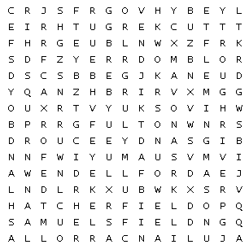

Find the word in the puzzle. Words can go in any direction. Words can share letters as they cross over each other.

AshlandBoyd Barkley BigSandy TuckerGuthrie SamuelsField
BlueGrass FlemingMason Fulton WendellFord Sturgis
HatcherField JulianCarroll NorthernKY Rough River

