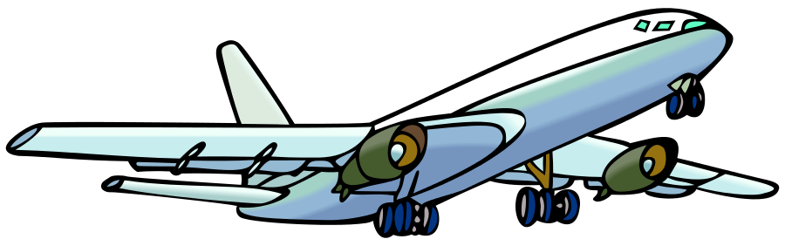

This file is licensed under the Creative Commons Attribution-Share Alike 3.0 Unported license.
Image created by Chris Martin on December 6, 2006. Retrieved from: https://commons.wikimedia.org/wiki/File:Airplane_clipart.svg

