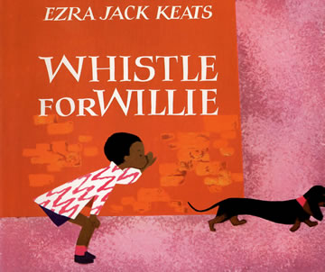
Critical Thinking
Ages 4-5
The books and activities in this kit are designed to encourage, teach and enhance critical thinking skills.

Whistle for Willie by Ezra Jack Keats
Supporting Books:
Bark, George by Jules Feiffer
The Magic Horse of Han Gan by Chen Jiang Hong
Iggy Peck Architect by Andrea Beaty
On Earth by Brian Karas

Explore
Questions:
- What is Peter's neighborhood like? How can you tell?
- How old do you think Peter is? Why?
- Why does Peter want to whistle? Why do you think it is so difficult for him?
- How do you think Peter feels the first time that he tries to trick Willie from inside the carton?
- Does Peter do anything that you have done before?
- Why do you think Peter's mother plays along when he pretends to be his father?
- How do you think Peter feels when he finally is able to whistle for Willie?
- How did you feel the first time you whistled? (Or mastered another similar skill?)
- What is something you want to do, but have not been able to …yet?

Manipulatives:
Not Provided:
- Boxes of all sizes and shapes from shoe to large packing crate
Let the children explore the boxes, build with them, sit in them, stack them, nest them inside each other. What else can a box be?
Create
Pick your favorite box(es). What can you make out of it (them)?
Supplies:
- Boxes from above
- Construction paper
- Paper Plates
- Foil
- Bottle caps
- Jar lids
- Hot Glue Guns
- Glue
- Colored and Patterned Duct Tape

Share
What did you make? What will you do with it? How did you decide what to make? What materials did you use? Why?

