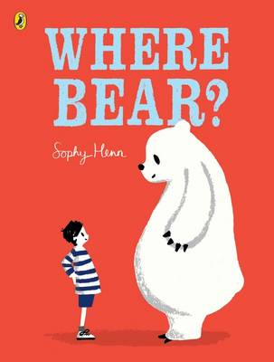

Linking Cause and Effect
Ages: 2-3
The books and activities in this kit are designed to explore why things happen, the causes and their reactions.

Informational Guide

Linking Cause and Effect
Ages: 2-3
The books and activities in this kit are designed to explore why things happen, the causes and their reactions.

Where Bear? by Sophy Henn

Supporting Books:
If You Give a Mouse a Cookie by Laura Numeroff
Because a Little Bug Went Ka-Choo by Rosetta Stone
Bob and Otto by Robert O. Bruel
Winter Bees and Other Poems of the Cold by Joyce Sidman

Explore
Questions:
- Where do you think the bear cub came from?
- What was happening to the bear?
- Are you bigger than you were last year? Why? Why do we grow?
- The bear getting bigger caused problems in the house. What problems can you think having a bear in your house would cause?
- With each place they try, ask: Why can’t he live there?
- Why was the arctic the best place for bear?
- How did the bear moving change his relationship with the boy?
- (Remember, with this age, you may not get answers, but still ask the questions, then talk through the answers with them)

Manipulatives:
- Magnifying glasses
- Sorting discovery stones

Not Provided:
- naturals objects like grass, leaves, shells and sticks, stones

Encourage the children to touch, smell, explore the objects with their senses. Add the magnifying glasses and show them how looking through the glass changes what they can see. Talk about what it is about the glass that causes it to magnify objects. What is the benefit of seeing more details?

Create
Invisible pictures: Draw with white crayons on white paper. You cannot see the picture!
Paint over your drawing with water colors. What happened?

Supplies:
- White paper
- White crayons
- Watercolor paints
- Brushes

Share
Talk about why the paint allowed you to see the white drawing.

