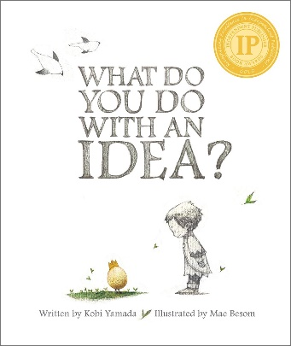
Wondering and Asking Questions
Family
The books and activities in this kit are designed to inspire wonder, curiosity and juicy questions.

What Do You Do With an Idea? by Kobi Yamada
Supporting Books:
Suddenly! By Colin McNaughton
I Ain’t Gonna Paint No More by Karen Beaumont
Only One You by Linda Kranz
Ada Lovelace, Poet of Science by Diane Stanley

Explore
Questions:
- What is an idea?
- Have you ever had one?
- Where do ideas come from?
- Can ideas follow you if you try to ignore them?
- What is magical about ideas?
- What does it mean to feed an idea and make it grow?
- If an idea spreads is it no longer yours? Does it matter?
- If you have an idea how do you make it real?
- What does it mean when an idea takes on a life of its own?
- How does an idea change the world?

Manipulatives:
- Marble magnets
- Bar magnets
- Fabric squares
Not Supplied:
Tubes (toilet, paper towel, wrapping paper, etc.)
Paper
Let the children explore the properties of the magnets. How do the magnets stick to one another? If you hold them apart, can you feel them tug at each other? How far away do you have to hold them before you don’t feel it anymore? How can they use the tubes to make a tunnel they can manipulate the marbles through? Do the magnets work on the paper and the fabric? Why? What about through the paper? The fabric? Combinations? How any layers of paper before the magnets no longer attract each other?

Create
Make an idea! Write your idea on a piece of paper. Put it inside the egg. Now make a little critter from your egg using the materials provided. Take it home and care for it.
Supplies:
- Plastic eggs
- Construction paper
- Chenille stems
- Gems, markers Scissors
- Glue

Share
Talk about their ideas, how they will care for them and ways they can use their ideas. How can you tell when an idea is ready to go out into the world?

