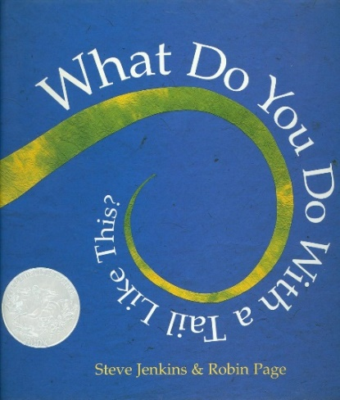
Imagining and Making Models
Family
The books and activities in this kit are designed to explore the part our imagination plays in the things we create.

What Do You Do With a Tail Like This? by Steve Jenkins and
Robin Page
Supporting Books:
Rosie Revere, Engineer by Andrea Beaty
What to Do With a Box by Jane Yolen
Mr. Biddles by Kristine A. Lombardi
Flight of the Honeybee by Raymond Huber

Explore
Questions:
- What kind of animal do you think this nose, ear, etc belongs to
- Why would they need their ____ to look like that, move like that, etc.
- If you could change your _____ what would you want your_____to do?
- What would it look like? Feel Like? Move like?
- If you were an animal that moves through trees and eats leaves, what would your nose, ears, etc look like?

Manipulatives:
- Scarves
- Hats
- Small paper cups
Not Provided:
- Ribbons
- Ties
Play dress up with the materials provided. How can they be tails and ears and noses and other body parts? Ask about what they are doing. What kind of animal are they being? Why do they need that tail, that nose, etc. Encourage imagination by asking questions like: what would happen if a dog had a monkey tail? or pig had a nose like a fox? How would that change their behavior?

Create
Create a creature! Make up an animal. Ask yourself, what it eats, where it lives, what kinds of things does it need to do. Make a nose, ears and tail for your creature that you can wear to pretend.
Supplies:
- Ribbons
- Small paper cups
- Large rubber bands
- Inexpensive plastic head bands
- Tape
- Construction paper
- Felt squares
- Paper plates (small and large)
- Scissors
- Glue
- Markers
- Crayons

Share
Put on your creations and be your animal. Answer questions about it.

