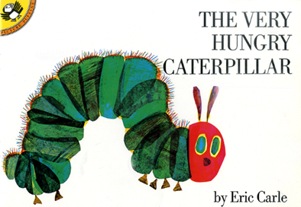
Seeing Patterns and Making Predictions
Ages 2-3
The books and activities in this kit are designed to explore the nature of patterns and how we use patterns to predict what comes next.
The Very Hungry Caterpillar by Eric Carle
Supporting books:
Brown Bear, Brown Bear by Bill Martin Jr
Pattern Bugs by Trudy Harris
Color Zoo by Lois Ehlert
Lots and Lots of Zebra Stripes by Stephen Swinburne

Explore
Questions: (Ask the questions as you read the story, giving time for answers and thought)
What do you think is in the egg?
Why is he hungry?
What do you think he will eat? How many?
When he eats too much: what do you think will happen?
Have you ever eaten too much?
How did you feel? Did you do it again?
What do you think is happening in the cocoon?
How do you know the caterpillar is changing in the cocoon?
(Remember, with this age, you may not get answers, but still ask the questions, then talk through the answers with them. Talk about how patterns are more than just an arrangement of items or designs on cloth, but are also patterns of behavior – things that act the same way every time, do the same things at set times…etc)
Manipulatives:
- Shapes
- Blocks
- Scarves

Let children explore the shapes. Observe how they sort them and ask questions – Why did you put that there? Have them sort by color, size, shape, texture…

Create
Make a hungry bug
Have children think about what kind of bug they want to make. Does it fly? Does it crawl? Wriggle? Jump?
What does it eat? Does it need pincers? Teeth? A stinger?
Have them gather the materials they need to make their bug.
Supplies: (Make an example of a hungry bug. Talk about why you chose to make your bug that way. This supplies a starting point for parents or caregivers that may not feel they are “crafty”.)
- Small paper plates
- Construction paper shapes including shapes that could be wings
- Plastic gems
- Glue sticks
- Googly eyes
- Chenille stems

Share
Share your creations!
Why did you make it that way?
Did you give him a name?
What does he like to eat?
Encourage them to tell you about their creation.

