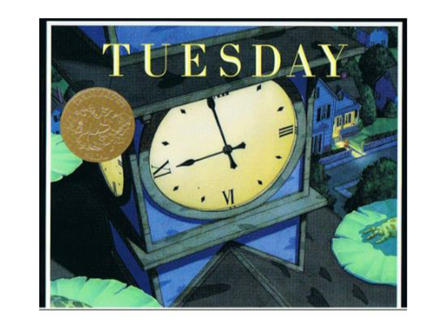

Wondering and Asking Questions
Ages 4-5
The books and activities in this kit are designed to inspire wonder, curiosity and juicy questions.

Informational Guide

Wondering and Asking Questions
Ages 4-5
The books and activities in this kit are designed to inspire wonder, curiosity and juicy questions.

Tuesday by David Wiesner

Supporting Books:
Du Iz Tak? By E.B. White
Touch the Brightest Star by Christie Matheson
Over the Ocean by Taro Gomi
Listen to the Wind: The Story of Dr. Gregg & Three Cups of Tea by Greg Mortenson

Explore
Questions:
- What do you notice on the front cover? Is there anything strange or puzzling? Turn the page and look at the three pictures of the frogs. What do you think is happening here?
- The three frames zoom in on the turtle sitting on a log. What information can we get from this close-up (e.g. emotions and reactions)?
- Can you tell what the frogs are thinking and feeling from the way they are drawn and painted?
- How would you describe the way the frogs are flying on the different pages?
- What do you think the people that see the frogs are saying and thinking?
- Tuesday has very few words. Why do you think the author decided to tell his story this way?
- Look at the few sentences in the book. Would it change the way we read the story if there were no words at all?
- What do you think the people are saying and thinking when they find lily pads everywhere?
- Why did the author choose pigs as the next animal to have an adventure? What kind of adventure do you think the pigs have?
- Would this story be different if it was set in the daytime?
- Why do you think this book is called Tuesday? Can you think of another good title for this book?

Manipulatives:
- Rubbing plates

Not Supplied:
- Paper of all kinds
- Rulers
- Crayons

Let the children create various textures with the rubbing plates. What happens if they use different colors? Different pressure? No color, just pressure? I wonder…

Create
Pick your favorite texture you created. Use it as the background for a collage.
Supplies:
Nature and animal magazines (Old Ranger Ricks or Zoo Books, etc)
- Scissors
- Glue
- Texture backgrounds created in the explore above.

Share
What is the story behind your collage?

