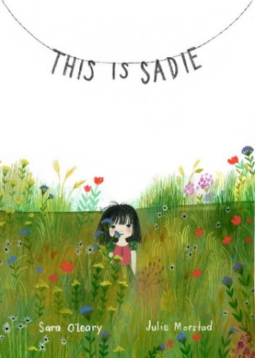

Wondering and Asking Questions
Ages 4-5
The books and activities in this kit are designed to inspire wonder, curiosity and juicy questions.

Informational Guide

Wondering and Asking Questions
Ages 4-5
The books and activities in this kit are designed to inspire wonder, curiosity and juicy questions.

This is Sadie by Sara O’Leary

Supporting Books:
Where Do Jet Plans Sleep at Night by Brianna Caplan Sayres
The Little Engine That Could by Watty Piper
Mr Wuffles! by David Wiesner
A Picture Book of Helen Keller by David A. Adler

Explore
Questions:
- Do you see Sadie? Have you ever climbed in a box or a laundry basket? Was it really a box or…?
- What do you do when you wake up before everyone else? Are you quiet? What do you think Sadie is building?
- What does it mean that some of her friends live in books? Do you have a book friend?
- Sadie puts herself into her favorite stories? Do you do that?
- Can you find Sadie in the tree?
- Do you have wings? Or a tail? What do you imagine?
- Are the days long enough for you?
- How can you make your own story, like Sadie?

Manipulatives: None

Not Provided:
- Boxes
- Papers
- Solo Cups
- Tissue paper
- String
- Bubble wrap
- Chenille stems
- Other Recyclables

Explore the materials, imagine what they can be.

Create
Build what you imagined. Where can it fit in your story?

Supplies: Same as above

Share
Tell the story that goes with what you made.

