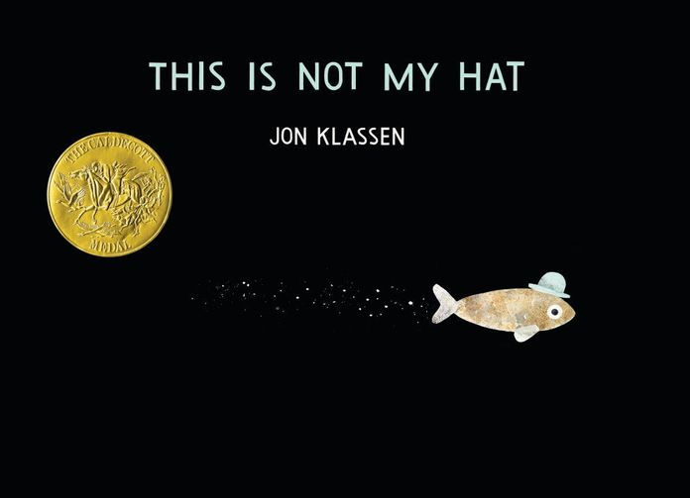

Investigation and Problem Solving
Ages 4-5
The books and activities in this kit are designed to encourage investigation and teach and enhance problem solving skills.

Informational Guide

Investigation and Problem Solving
Ages 4-5
The books and activities in this kit are designed to encourage investigation and teach and enhance problem solving skills.

This is Not My Hat by Jon Klassen

Supporting Books:
Hello, Mr. Dodo! By Nicholas John Frith
Sylvester and the Magic Pebble by William Steig
Lilly’s Purple Plastic Purse by Kevin Henkes
The Book Itch by Vaunda Micheaux Nelson

Explore
Questions:
- Wait a minute, should he have stolen that hat? Why?
- Do you think he is going to get away with it? Why?
- Why is he heading for the tall plants? Will he have to stay there?
- What do you think happened when the big fish found the little one with his hat?
- How do you think he found him in the plants?
- How do you know he found him?

Manipulatives: None

Not Provided:
- Hat
- Boxes
- String
- Chairs
- Blankets or sheets (all consumables)

Use these materials to make hiding places. Have children take turns wearing the hat and hiding while the others look for them.

Create
Think of your favorite hiding place at home. If you wanted someone to find you or something you have hidden, but don’t want to tell them exactly where your hiding place is, what clues would you use? Make a treasure map that leads to your hiding place. You can use word or picture clues or a combination of both. Don’t make it too easy.

Supplies:
- Paper
- Pencils
- Markers
- Crayons

Share
Take turns sharing each other’s maps. See if you can guess each other’s hiding places from the clues. When you get home, test your map with your parent, sibling or friends.

