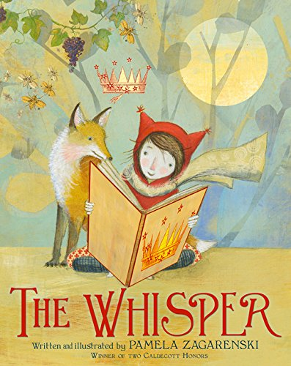

Imagining and Making Models
Family
The books and activities in this kit are designed to explore the part our imagination plays in the things we create.

Informational Guide

Imagining and Making Models
Family
The books and activities in this kit are designed to explore the part our imagination plays in the things we create.

The Whisper by Pamela Zagarenski

Supporting Books:
Seven Blind Mice by Ed Young
Benjamin Bear in Bright Ideas! By Philippe Coudray
Fort Building Time by Megan Wagner Lloyd
Tito Puente, Mambo King by Monica Brown

Explore
Questions:
- Do you like stories? What kinds are you favorite?
- What is happening to the words? What words can you see flying out of the book?
- What is the fox doing?
- Why is the little girl sad? Ca you have stories without words?
- What does the whisper tell her? What do you think will happen when she turns the page?
- What would be a good title for a story with this picture? The next? And the next?
- Where have you seen that crown before? Why do you think it is now over the little girl’s head?
- What as in the bag? What do you think the fox needs from the little girl?
- What do you think this book is trying to tell you?
(If time allows, go back through the book and ask the children to find the repeating elements: fox, rabbit, bees, crown)

Manipulatives:
- Tinker toys
- Blocks

Not Provided:
- Solo cups
- assorted (non-sharp) kitchen utensils (unpuppets)

Allow children to explore the building materials. Ask them to build a setting for a story. Using the kitchen utensils as puppets, tell the story.

Create
Using pictures from the magazines and old books, make a fantastic collage.

Supplies:
- nature magazines
- fashion magazines
- old storybooks
- scissors
- construction paper
- glue

Share
Find a cozy corner with your parent or caregiver and take turns telling a story about your fantastic collage.

