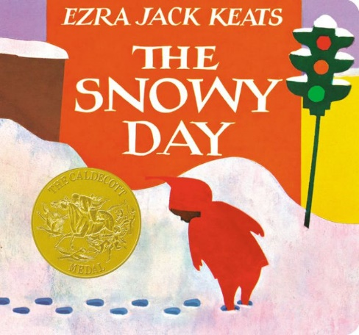

Wondering and Asking Questions
Ages 2-3
The books and activities in this kit are designed to inspire wonder, curiosity and juicy questions.

Informational Guide

Wondering and Asking Questions
Ages 2-3
The books and activities in this kit are designed to inspire wonder, curiosity and juicy questions.

The Snowy Day by Ezra Jack Keats

Supporting Books:
Beyond the Pond by Joseph Kuefler
Lost and Found by Oliver Jeffers
Mr Squirrel and the Moon by Sebastian Meschenmoser
Yucky Worms by Vivian French

Explore
Questions:
- Where do you think the story takes place? What are some clues?
- What are some ways you are like Peter?
- Do you remember waking up to a snowy world outside your window? What was it like? What did you do?
- Why do you think the snowball in Peter's pocket wasn't there when he checked before bed? Can you think of a way to save a snowball?
- What do you wonder about the world outside your window?
(Remember, with this age, you may not get answers, but still ask the questions, then talk through the answers with them)

Manipulatives:
- White tablecloth

Not Supplied:
- Common small objects of differing shapes and sizes

Place objects under the tablecloth and see if the children can tell what they are by feel. Let them take turns. Which shapes are hard? Easy? Why?

Create
Make a Snowy Day! Q-Tip painting on blue paper
Using the end of Q-tip, dip into the paint and make it snow on your paper. Make snowdrifts, snowmen snowballs fights. Let it dry. Using the markers, add color to your picture - sleds, animals…whatever you like to play with in the snow.

Supplies:
- Light Blue construction paper
- White tempera or acrylic paint
- Q-tips
- Markers

Share
Talk about your snowy day.

