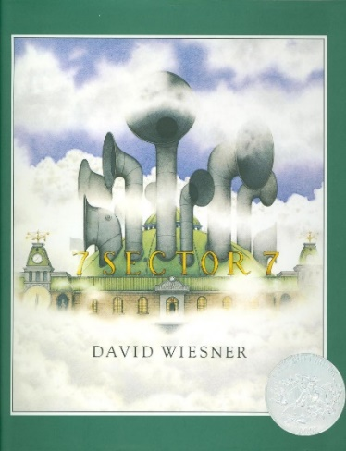

Investigation and Problem Solving
Ages 2-3
The books and activities in this kit are designed to encourage investigation and teach and enhance problem solving skills.

Informational Guide

Investigation and Problem Solving
Ages 2-3
The books and activities in this kit are designed to encourage investigation and teach and enhance problem solving skills.

Sector 7 by David Wiesner

Supporting Books:
Look-Alikes Jr by Joan Steiner
The Birthday Box by Leslie Patricelli
Green by Laura Vaccaro Seeger
Gingerbread for Liberty! by Mara Rockliff

Explore
Questions:
- The only words in the book are signs and labels. This gives you tremendous freedom to “read” this book in a way that speaks to your audience. You can talk about the Empire State Building – why people go there, what makes it special.
- Why would clouds be a problem here?
- Clouds can be anything you imagine. Do you make shapes from the clouds?
- When the cloud takes the boy to Sector 7, why is it a problem? What are the papers for? What does the boy do?
- Why are there different kinds of clouds?
- Why do they get in trouble?
- What happens next?
- Why do you think the clouds look like that now?
- What do you think those clouds do?
(Remember, with this age, you may not get answers, but still ask the questions, then talk through the answers with them)

Manipulatives:
- Fabric squares

Not supplied:
- Cotton balls
- Paper

Have some water in a cup. Wet some of the cotton balls. Talk about what clouds are made of – water droplets.
Make them rain on a fabric square– what happened? Wrap a wet cotton ball in a piece of fabric and squeeze. What happened? Why? Try it with a piece of paper. Did the same things happen? How was it different? Wad up the paper and make it rain on it. How did that change what happened?

Create
Make clouds with cotton balls. Stretch them, pull them, make them look like you want them to look.

Supplies:
- Construction paper
- Cotton balls
- Glue sticks

Share
What kind of cloud did you make? What shapes do you see when you look at your cloud?

