SEAL STEM Online Resources

NASA’s blog post on Getting Started with SEAL:

- Collection of resources for the SEAL programming kits

https://community.starnetlibraries.org/get-started-with-seal/

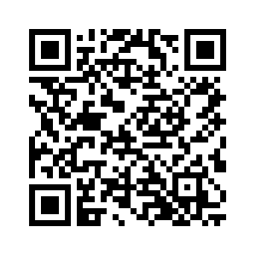

Solar Eclipse Activities for Libraries Training Videos – YouTube

- Recorded workshops that can be watched right now – they are updated on an ongoing basis so they follow what is happening right now with the changes in the sky and the upcoming eclipses

https://tinyurl.com/yc4pa5c4

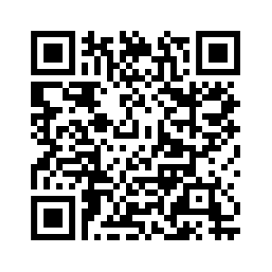

Solar Eclipses of 2023 and 2024: A North American "Double-Header" (starnetlibraries.org)

- Booklet sent out directly to public libraries that covers the eclipse and solar science programming for the 2023 and 2024 eclipses.

https://www.starnetlibraries.org/2020/wp-content/uploads/2022/11/SEAL-booklet-web-2.pdf

