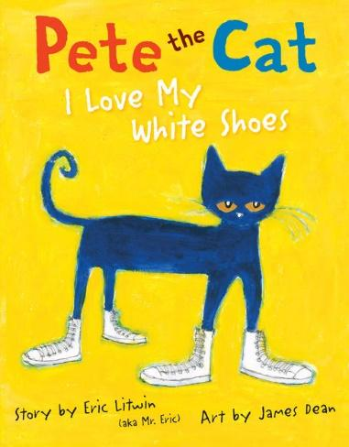

Seeing Patterns and Making Predictions

Ages 4-5
The books and activities in this kit are designed to explore the nature of patterns and how we use patterns to predict what comes next.

Informational Guide

Seeing Patterns and Making Predictions

Ages 4-5
The books and activities in this kit are designed to explore the nature of patterns and how we use patterns to predict what comes next.

Pete the Cat: I Love My White Shoes by Eric Litwin

Supporting Books:
I Want My Hat Back by Jon Klassen
Goodnight Moon by Margaret Wise Brown
Bear Has a Story to Tell by Philip C Stead
Bring on the Birds by Susan Stockdale

Explore
Questions:
Encourage the kids to sing Pete’s sing about his shoes.
- What do you do when you get new shoes?
- What song would you sing about your shoes? Or what dance would you do?
- What happens to Pete’s shoes?
- Does he get upset? (Encourage them to say “Goodness NO!” every time the book asks if Pete cries.)
- Why do you think Pete doesn’t get upset?
- What do you do if you get your new shoes dirty? Or you drop something on your new shirt or rip your new pants?
- How does Pete’s song change? How does it stay the same?
- What other things could Pete step in? What color would it change Pete’s shoes?
(Pete’s story follows a very predictable pattern. What other patterns can you see in the story?)

Manipulatives:
- Buttons
- Beads
- Gems

Not provided: Solo Cups
Place the materials on the table and let children examine them. Break them into groups. Give each group 4-6 cups and have them sort the objects into the cups. How will you sort them? By color? Texture? Size?....?

Create
Word patterns – patterns are more than color or shape sequences. Patterns can be behavior – the way Pete reacts each time to his shoes getting dirty. Patterns can also be with words – words that start with the same letter, have the same number of letters, same sounds, rhyme…
Make a pattern with the words on your paper.

Supplies:
- Construction paper
- Pages full of words printed in a variety of bold fonts

Share
What is your pattern? Why did you choose that pattern? What other patterns do you see in the world around you?

