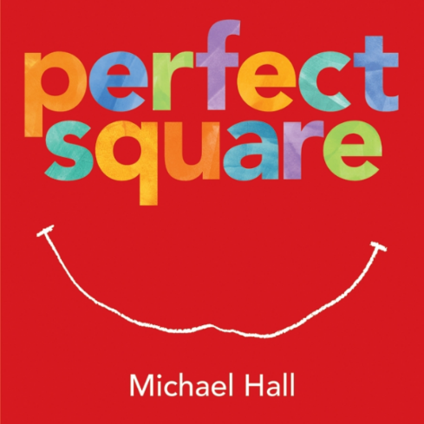

Imagining and Making Models
Ages 4-5
The books and activities in this kit are designed to explore the part our imagination plays in the things we create.

Informational Guide

Imagining and Making Models
Ages 4-5
The books and activities in this kit are designed to explore the part our imagination plays in the things we create.

Perfect Square by Michael Hall

Supporting Books:
Not a Box by Antoinette Portis
Little White Rabbit by Kevin Henkes
Dot by Patricia Intriago
A Boy and His Jaguar by Alan Rabinowitz

Explore
Questions:
During:
- What makes the square “perfect”?
- As each thing happened to the square, first ask what they would do, then what they think the square will do?
After:
- What was your favorite thing the square did when it was not “perfect”?
- Would you use a different shape? What shape? What would you make with it?

Manipulatives:
- Fabric squares

Not Provided:
- Paper cut into squares

Put out fabric and paper squares. Allow the children to explore the squares. How can they fold them into different shapes? Does the fabric fold differently than the paper? Why? What do they notice about the shapes they can make? What happens if they combine squares?

Create
Have the children choose a shape than fold, tear, manipulate the paper into something new. What did they make? How is it perfect? (see attached images of sample paper constructions)

Supplies:
- Large paper shapes including squares, triangles, rectangles, pentagons, circles...

Share
Talk about the possibilities of the different shapes. Why did they choose that shape? What were the limitations? The possibilities?

