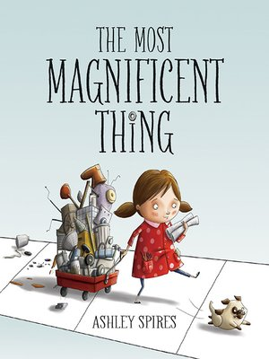
Imagining and Making Models
Ages 4-5
The books and activities in this kit are designed to explore the part our imagination plays in the things we create.

The Most Magnificent Thing by Ashley Spires
Supporting Books:
Beautiful Oops! By Barney Saltzberg
The Dot by Peter H Reynolds
Ish by Peter H Reynolds
Me…Jane by Patrick McDonnell

Explore
Questions:
- What do think the most magnificent thing should do?
- How does it become the most magnificent thing?
- Talk about the process of creativity.
- Does it always work the first time?
- Does it need to?
- What did she do when she couldn’t get it to do what she wanted?
- How did that help?
- Have you done that?

Manipulatives: All consumables
Not Provided:
- Boxes
- Bottles
- Containers
- Rubber bands
- Tape
- Clothes pins
- Paper
- Paper towel and toilet paper rolls
- Cans and other recyclables
These same items will be what they use to create their magnificent thing. Let them explore the materials, try different configurations, experiment with how to make moving parts. Encourage brainstorming and experimentation with construction and movement. Refer to the story and the struggles she had in creating her magnificent thing. Stress it does not have to be perfect to be MAGNIFICENT.
After they have explored, then have them choose the parts they need and move on to the create. They can work separately or in groups.

Create
Using the materials provided, make a magnificent thing. What do you want your “thing” to do? What makes it magnificent?
Supplies:
Same as the manipulatives.

Share
Tell about your magnificent thing. Did it turn out the way you wanted it? What would you change about it? What did you learn while you were building it?

