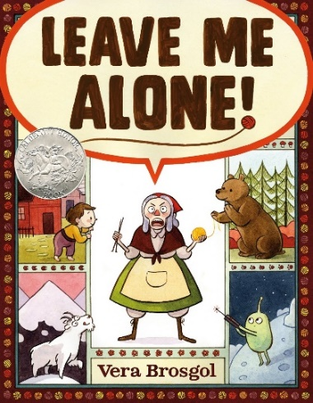

Investigation and Problem Solving
Family
The books and activities in this kit are designed to encourage investigation and teach and enhance problem solving skills.

Informational Guide

Investigation and Problem Solving
Family
The books and activities in this kit are designed to encourage investigation and teach and enhance problem solving skills.

Leave Me Alone by Vera Brosgol

Supporting Books:
It’s Only Stanley by Jon Agee
Enemy Pie by Derek Munson
The Hungry Lion by Lucy Ruth Cummins
On A Beam Of Light by Jennifer Berne

Explore
Questions:
- Why does she want to be alone?
- Do you ever have that problem? Where do you go?
- What happens everywhere she goes?
- How does she solve her problem?
- Can you climb to the moon from the top of a mountain?
- What is a void?
- Do you think she was glad to be back at the end?

Manipulatives:
- Keva planks

Not Supplied:
- Solo cups
How high would you have to climb to reach the moon? How high can you build with the cups and planks before your tower falls? Have the children work together to build the tallest tower they can. As problems arise, encourage them to think through the solutions.

Create
The old woman wants to be left alone, but everywhere she goes has its own distractions. Break up into four groups. Assign each group a location and have them create ways to get rid of the distractions:

Home: kids taking and playing with her yarn
Woods: bears interested in fire and wanting to eat her (remember bears do not speak English)
Mountains: goats eating her yarn
Moon: Moon men examining her (remember they have no ears).

Supplies:
- Copy the corresponding pages from the book
- Pen and paper

Share
Come together and discuss the various solutions. Do you think they would have worked? Why or why not?

