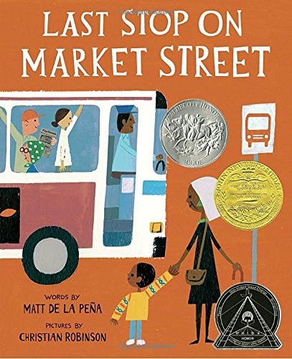
Wondering and Asking Questions
Family
The books and activities in this kit are designed to inspire wonder, curiosity and juicy questions.

Last Stop on Market Street by Matt De La Pena
Supporting Books:

The World in a Second by Isabel Minhos Martins
The Heart and the Bottle by Oliver Jeffers
The Adventures of Sparrowboy by Brian Pinkney
The Noisy Paint Box: The Colors and Sounds of Kandinsky’s Abstract Art by Barb Rosenstock

Explore
Questions:
- CJ says it smells like freedom. What does freedom smell like?
- How does a tree drink through a straw?
- A bus breathe fire?
- Have you ever ridden a bus? Where did you go? What did you see?
- Why was CJ feeling sorry for himself?
- How can you “see” with your ears? Your nose? How else can you “see” without using your eyes?
- Do you close your eyes when you listen to music? What happens when CJ closes his eyes and listens?
- Where do you find beautiful? How do you know something is beautiful?
- What is a soup kitchen? What are they doing there?

Manipulatives:
- Binoculars
- Color paddles
- Prisms
CJ’s grandmother encouraged him to look at things in a different way. Explore the way these items can help you look at things in a new way. What happens when you combine binoculars with a color paddle? With a prism?

Create
Treasure from trash: using these items that you would normally throw away, make something beautiful.
Supplies:
- Jar lids
- Bottle caps
- Buttons
- Pieces of string
- Wrappers
- Old pictures
- Egg cartons
- Cereal boxes
- Juice cartons
- Bits of ribbon
- Toilet paper rolls
- Paper towel rolls
- Rubber bands
- Corks
- Tape
- Hot glue guns and glue sticks (supervision required)

Share
Talk about the supplies that were chosen. What makes your creation beautiful?

