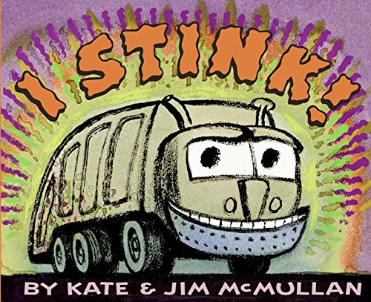

Linking Cause and Effect
Ages 4-5
The books and activities in this kit are designed to explore why things happen, the causes and their reactions.

Informational Guide

Linking Cause and Effect
Ages 4-5
The books and activities in this kit are designed to explore why things happen, the causes and their reactions.

I Stink! by Kate and Jim McMullan
Supporting Books:
Egg by Kevin Henkes
If You Take a Mouse to School by Laura Numeroff
Where Are You by Sarah Williamson
Goodnight, Goodnight Construction Site by Sherri Duskey Rinker

Explore
Questions:
- Who do you think it is?
- What clues is he giving you to use to guess who he is?
- Have you seen a truck like this?
- Why do we need trucks to collect the trash?
- Where does trash come from?
- Why do they crush the trash?
- Is his alphabet soup something you would want to eat?
- What do you think all that stuff smells like?
- What’s in your trash?
- Where does all the trash go?

Manipulatives:
- Marbles
- Blocks

Not Provided:
- paper towel rolls
- toilet paper rolls
- wrapping paper tubes
- tape
- solo cups

Talk about how a lot of these things are trash. Let the children explore the materials and, working in groups of 4-6 with a parent or helper, design a marble maze. What works? What doesn’t? Why?

Create
Box trucks
Cover boxes with wrapping paper, using the materials provided, design a truck.

Supplies:
- Shoe
- tissue and other small boxes
- TP rolls
- wrapping paper
- markers
- buttons

Share
What kind of truck did you make? What does it sound like? Smell like? Where will it go?

