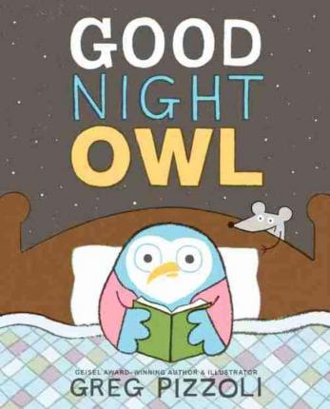

Critical Thinking
Ages 2-3
The books and activities in this kit are designed to encourage, teach and enhance critical thinking skills.

Informational Guide

Critical Thinking
Ages 2-3
The books and activities in this kit are designed to encourage, teach and enhance critical thinking skills.

Good Night Owl by Greg Pizzoli

Supporting Books:
Shh! We Have a Plan by Chris Haughton
Stuck by Oliver Jeffers
Beetle Bop by Denise Fleming
Raindrops Roll by April Pulley Sayre

Explore
Questions:
- What do think the noise is?
- What can you see that Owl cannot?
- Have you ever heard a noise at night and got scared?
- What do you do? Do you call your parents?
- What does Owl do?
- Why can’t Owl get to sleep after he tears down the roof?
- Has that ever happened to you?
- How could Owl have figured out what the noise was without tearing down his house?
- Why was he able to sleep after he saw what the noise was?
- What was it?

Manipulatives:
- Color paddles
- Magnifying glasses

Not Provided:
- Random objects

Explore how the color paddles and magnifying glasses change what you see and how you see it. How does looking at things in different ways, change the way we react to them? Change our understanding of what they are?

Create
Create something from the materials provided. Have a clear idea of what it is for before you build it., but don’t tell anybody what you are building.

Supplies:
- Construction paper
- Glue
- Scissors
- Chenille stems
- Toilet paper rolls
- Paper towel rolls
- Small boxes
- Plastic bottles
- Crayons
- Markers
- String
- Tape

Share
Take turns looking at each other’s creations. Talk about what they could be. Why is it hard to guess what something is if you have never seen it before?

