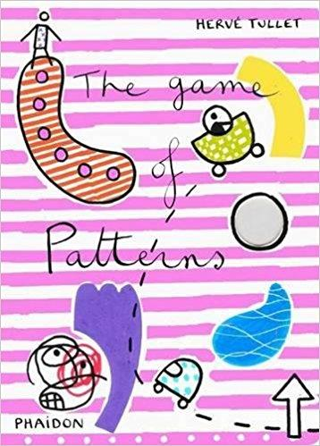
Seeing Patterns and Making Predictions
Ages 2-3
The books and activities in this kit are designed to explore the nature of patterns and how we use patterns to predict what comes next.

The Game of Patterns by Herve Tullet
Supporting Books:
The Mixed Up Chameleon by Eric Carle
Shapes, Shapes, Shapes by Tana Hoban
Bees, Snails &Peacock Tails by Betsy Franco and Steve Jenkins
Fabulous Frogs by Martin Jenkins

Explore
Questions: (Ask the questions as you read the story, giving time for answers and thought)
- How many patterns can you see?
- Many of them look the same, but what if you look closer? What do you see?
- Ask these after the story:
- Look around the room. Do you see any patterns?
(Point out patterns in the room, on their clothes, talk about what makes a pattern. Remember, with this age, you may not get answers, but still ask the questions, then talk through the answers with them.)

Manipulatives:
- Shapes
- Blocks
- Fabric squares
Allow the children to explore the materials while talking about what a pattern is and making a few simple ones for them to mimic and explore. Talk about the different colors, shapes and textures of the objects. Talk about how many ways could you sort these objects, how many ways there are to make a pattern.

Create
Create a pattern chain. Take strips of paper and connect them to make a chain. Let the child pick the colors and patterns, talk about how to arrange them in a pattern.
Supplies:
- Paper solid colors and simple patterns (stripes, polka dots), cut into 1” x 8” strips
- Glue sticks

Share
Talk about their chain, why they picked those colors, those patterns, how often does their pattern repeat, etc.

