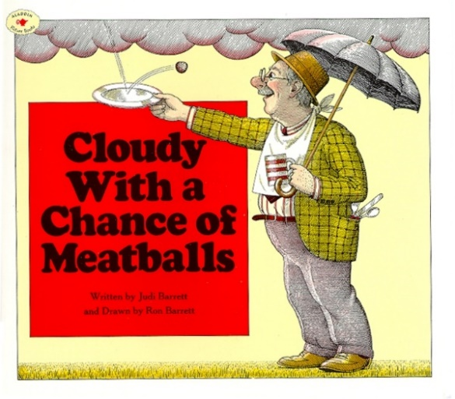

Investigation and Problem Solving
Ages 4-5
The books and activities in this kit are designed to encourage investigation and teach and enhance problem solving skills.

Informational Guide

Investigation and Problem Solving
Ages 4-5
The books and activities in this kit are designed to encourage investigation and teach and enhance problem solving skills.

Cloudy With a Chance of Meatballs by Judi Barrett

Supporting Books:
Puddle by Hyewon Yum
The Cow Who Climbed a Tree by Gemma Merino
Once Upon an Alphabet by Oliver Jeffers
Star Stuff: Carl Sagan and the Mysteries of the Cosmos by Stephanie Roth Sisson

Explore
Questions:
- What would it be like to live in Chewandswallow?
- What kind of “rain” would be your favorite?
- Do you think it would hurt to get hit by a meatball?
- Why was the food getting bigger a problem?
- Do you think bread makes a good raft?
- What else could they have used to get away?
- The grandfather made up a story based on something that happened at breakfast. Have you ever had something happen that made you think of a story? A memory? What was it?

Manipulatives:
- Mirrors
- Flashlights
- Scarves

Play with the flashlights, mirrors and scarves. What happens when you shine the light through a scarf? I wonder if you can bounce the light off a mirror? What if you put a scarf over the mirror? Be careful not to shine the light in anyone’s eyes. Can you make up a story about a town where the sun is a flashlight and ...?

Create
What kind of weather would you like if you could make it do whatever you wanted. Using the materials provided, create a rainstorm in your town.

Supplies:
- Construction paper
- Ribbon
- Q-tips
- Cotton balls
- Pompoms
- Tissue paper squares
- Leaves, sticks
- Paper plates

Share
What does it rain in your town? Tell about your rain

