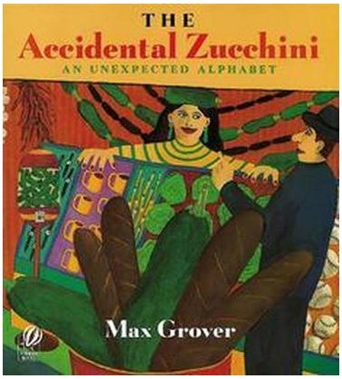

Imagining and Making Models
Ages 2-3
The books and activities in this kit are designed to explore the part our imagination plays in the things we create.

Informational Guide

Imagining and Making Models
Ages 2-3
The books and activities in this kit are designed to explore the part our imagination plays in the things we create.

The Accidental Zucchini by Max Grover

Supporting Books:
Work, An Occupational ABC by Kellen Hatanaka
The ABC Bunny by Wanda Gag
Take Away the A by Michael Escoffier
Z is for Moose by Kelly Bingham

Explore
Questions: (Ask the questions as you read the story, giving time for answers and thought)
Encourage them to imagine the amazing creations on each page.
- What kind of sound do you think apple cars would make?
- Would you wear clothes in a bathtub boat?
- How big would an elephant elevator have to be? Etc…
- What would you make out of each letter?
(Remember, with this age, you may not get answers, but still ask the questions, then talk through the answers with them)

Manipulatives:
- Keva Planks
- Blocks
- Linen napkins

Not provided:
- Random objects of different shapes

Divide into two groups;
Group 1: Play and build with the Keva planks. Ask: How many can you balance on top of each other? What would make it more stable so they can build higher? What if you work together?
Group 2: Place an object under a napkin and allow the children to feel it. Can they guess what it is just by touch? Ask: What does it feel like? Hard? Soft? Straight sides or curved?
After about 10 minutes, switch places.

Create
Pick a letter and decide what you would make that begins with that letter. Using the materials provided, build your creation.

Supplies:
- Construction paper cut into letters of the alphabet, squares, circles, triangles and other shapes
- Small boxes
- Craft sticks
- Water bottles
- Toilet and paper towel rolls
- Glue
- Crayons
- Markers.

Share
Talk about what you made. What would it sound like? Move like? Do? Where would you find it?

