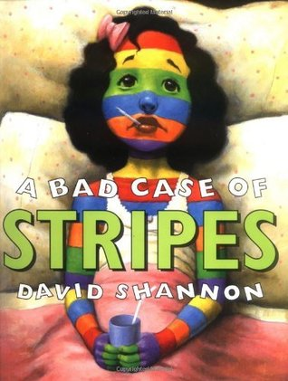
Linking Cause and Effect
Family
The books and activities in this kit are designed to explore why things happen, the causes and their reactions.

A Bad Case of Stripes by David Shannon
Supporting Books:
Edward the Emu by Sheena Knowles
The Girl Who Never Makes Mistakes by Mark Pett
I Like Myself by Karen Beaumont
Coyote Moon by Maria Gianferrari

Explore
Questions:
- What can you tell about Camilla right away?
- Is there a food you like that others do not? Do you eat it anyway?
- Why would Camilla care if other people do not like lima beans? If she likes them, why doesn’t she just eat them?
- Why do you think causes Camilla to break out in stripes? Why does she keep changing? What does this tell you about Camilla?
- Do the things people say make you change? How?
- Why does eating lima beans cure Camilla?

Manipulatives:
- Maracas
- Cow Bells
Not provided:
- Other instruments
Because Camilla tries to please everyone, she begins to change. Her behavior causes what happens next. Let the children explore the materials. See how the instruments do not make noise unless something is done to them, that how you play them changes the sounds they make.

Create
Working in teams of two, have one lay down on the paper and the other mark top of head, neck, shoulders, elbows, wrists, hands, fingers (optional), waist (each side), hips, knees, ankles, feet, toes (optional). Once each has their sheets, have them connect the dots with straight lines, then cover the dots with star stickers – this is the constellation of you! (This can be as detailed or simple as you wish. See image below for general idea.) Using pictures from the magazines, crayons and markers, fill your constellation with things that you like, that make you who you are.

Supplies:
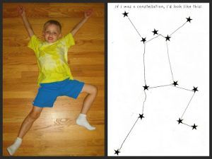
- Butcher paper
- Markers
- star stickers of all sizes and colors
- crayons
- magazines
- scissors

Share
Talk about the things you filled your constellation with. Are there things you like your friends do not? Why is it okay to be yourself? Like what you like?

