Sorting and Patterning – Sample Storytime Outline
Book 1: Nonfiction or other themed book
Rhyme:
Pattern Rhyme-MMM Kids Early Math Concepts
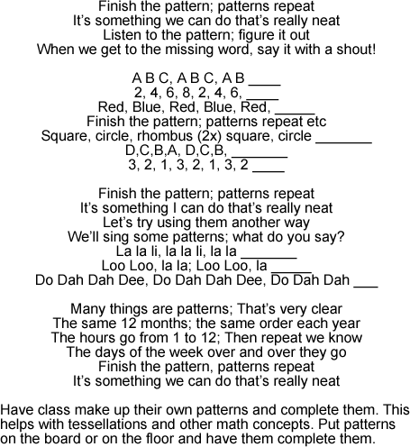

Book 2: Story in Rhyme
Song: This is the way we sort our colors, sort our colors, sort our colors
This is the way we sort our colors so early in the morning.
We want to put the red right here, the green right there and the blue right here.
This is the way we sort our colors so early in the morning.

Book 3: Interactive Story

Science Center: Patterns in nature search
Magnifying glasses or binoculars
Math Center: Creating block patterns
Blocks
Literacy Center: Patterns in print
Words with repeating letters
Game: https://www.kaplanco.com/product/16323/pattern-blocks-and-activity-cards-set?c=8%7CNU1050

