Baby Storytime

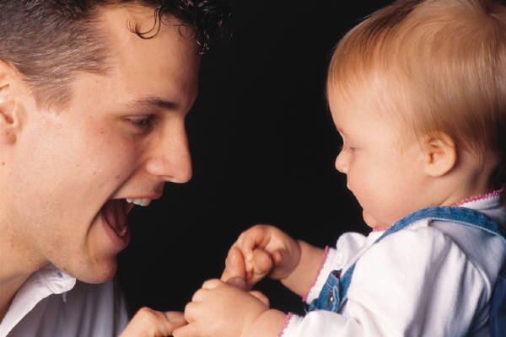
Welcome
Welcome, welcome, everyone,
Now you’re here. we’ll have some fun.
First we’ll clap out hands just so,
Then we’ll bend and touch our toes.
Welcome, welcome, everyone,
Now you’re here, we’ll have some fun.

Rickety, Rickety Rocking Horse
Rickety, rickety rocking horse, “Ride” baby on knees
Over the hills we go.
Rickety, rickety rocking horse, Gently rock baby back in lap
Giddy-up, giddy-up, whoa! And hug baby.

The Moon is Round
The moon is round, make circle with fingers
As round can be. circle baby’s face with fingers
Two eyes, Point to each part on baby, and then to self
A nose,
And a mouth like me!
Story
I Kissed the Baby
by Mary Murphy

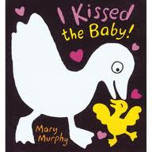

This is the Way the Farmer Rides
This is the way the farmer rides,
Jiggety-jog, jiggety jog. Rock baby side to side on knees.
This is the way the lady rides.
A-prance, a-prance, Bounce baby gently on knees.
This is the way the gentlemen ride.
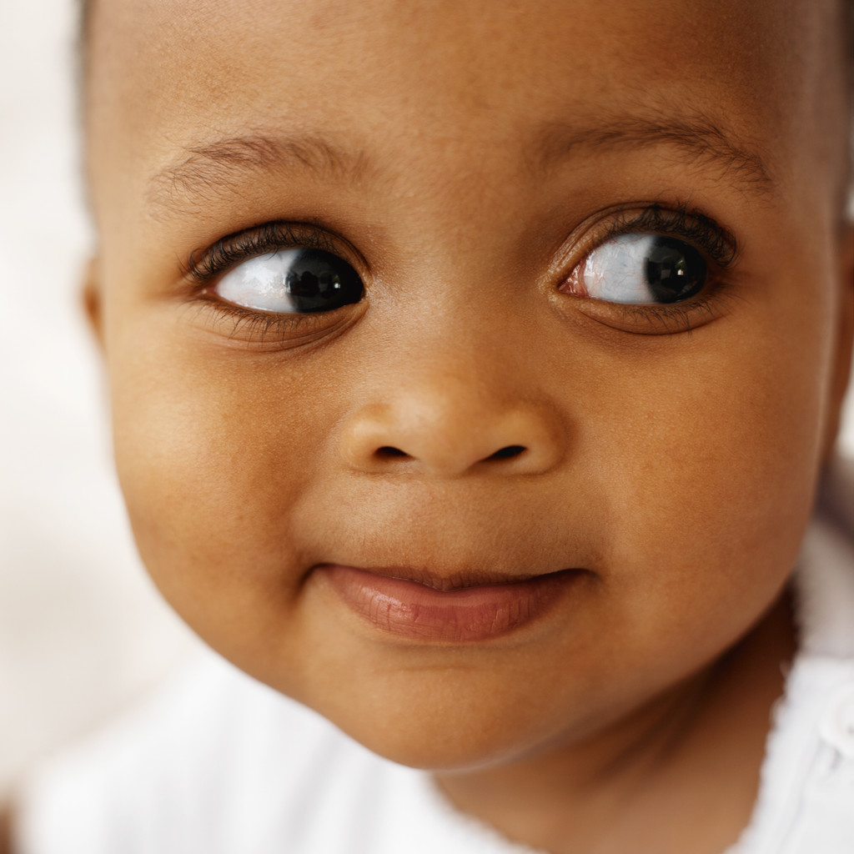
A-gallop, gallop, gallop! Bounce baby quickly on knees.

Fuzzy Bumblebee
Who’s Afraid of the Big Bad Wolf
Fuzzy, fuzzy, fuzzy bumblebee,
bumblebee, bumblebee,
Fuzzy, fuzzy, fuzzy bumblebee,
Landing on my toes.


Fuzzy, fuzzy, fuzzy bumblebee,
bumblebee, bumblebee,
Fuzzy, fuzzy, fuzzy bumblebee,
Landing on my nose.

Landing on my tum…bum
Landing on my ear…hair

Round and Round the Garden
Round and round the garden
Goes the teddy bear.
One step, two step,
Tickle under there.
More, More, More Said the Baby by Vera
Williams

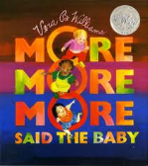

I Can Make My Hands Go Clap, Clap, Clap
To “The Wheels on the Bus”
I can make my hands go clap, clap, clap,
Clap, clap, clap,
Clap, clap, clap,
I can make my hands go clap, clap, clap,
They’re a part of me.
My eyes go blink, fingers go snap, feet go stomp, legs go jump,
tongue go click, hips go wiggle, lips go kiss.
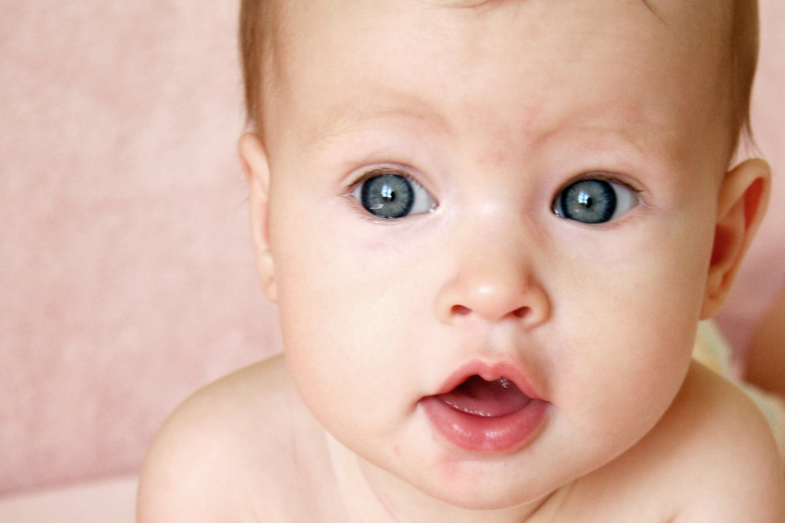

Goodbye
On my face, I have a nose,
And way down here I have ten toes.
I have two eyes that I can blink,
I have a head to help me think,
I have a chin and very near,
I have two ears so I can hear.
Here are my arms to hold up high,
And here is my hand to wave goodbye.

Tracking
In a darkened room, perhaps at bedtime, turn on a flashlight and encourage your little one to track the light moving around the room. This can be a bit hypnotizing and can be a good way to soothe and relax your baby. Make it part of your own sound and light show with soft background music.
--6-9 months, Games Babies Play: From Birth to 12 Months by Vicki Lansky; Publishers Group West 1993

