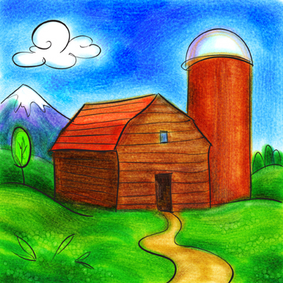
Baby Farm Storytime

Welcome
Bingo
There was a storytime that had a girl
And Jenny was her name-o.
Jump, jump, Jenny jump,
Jump, jump, Jenny jump,
Jump, jump, Jenny jump,
We’re glad you’re here today.

Old MacDonald Had a Farm
Old MacDonald had a farm, Ee i ee i oh!
And on his farm he had some chicks, Ee i ee i oh!
With a cluck-cluck here,
And a cluck-cluck there
Here a cluck, there a cluck,
Everywhere a cluck-cluck
Cow, pig, horse, sheep, etc.

This Little Cow
This little cow eats grass.
This little cow eats hay.
This little cow looks over the fence
This little cow runs away
But this big cow does nothing at all
But lie in the field all day.

Story
Hello, Day! By Anita Lobel

Baa, Baa, Black Sheep
Baa, baa, black sheep,
Have you any wool?
Yes sir, yes sir,
Three bags full.
One for the master,
And one for the dame,
And one for the little boy
Who lives down the lane.

This is the Way the Farmer Rides
This is the way the farmer rides
Jiggety-jog, jiggety jog.
Rock baby side to side on knees.
This is the way the lady rides
A-prance, a-prance,
Bounce baby gently on knees
This is the way the gentlemen ride.
A-gallop, gallop, gallop!
Bounce baby quickly on knees

You’re My Little Baby
I’m a Little Teapot
You’re my little baby,
So soft and sweet
Here are your hands,
Here are your feet.
I’ll watch you clap your hands
And tap your feet.
I love you baby
So soft and sweet! Tickle tummy

Story
Peek-a-Moo!
By Marie Torres Cimarusti

I Can Make My Baby Smile
The Muffin Man
I can make my baby smile,
My baby smile, my baby smile,
I can make my baby smile,
When I tickle her toes.

I can make my baby laugh,
Baby laugh, baby laugh,
I can make my baby laugh,
When I tickle her nose.
Tickle his tummy, Tickle his feet.

All Around the Farm
The cows on the farm go moo, moo, moo,
Moo, moo, moo,
Moo, moo, moo.”
The cows on the farm go moo, moo, moo,
All around the farm.

The horses…Neigh, neigh, neigh.
The pigs…Oink, oink, oink.
The chicks…peep, peep, peep.
The sheep…baa, baa, baa.

Little Red Wagon
Bumping up and down in my little red wagon
Bumping up and down in my little red wagon
Bumping up and down in my little red wagon
Won’t you be my darling?
Swaying side to side, rocking back and forth, picking up treasures, hey ho

Story
Barnyard Banter by Denise Fleming

When Ducks Get Up in the Morning
When ducks get up in the morning
They always say good day.
When ducks get up in the morning
They always say good day.
“Quack, quack! Quack, quack!”
That is what they say.
“Quack, quack! Quack, quack!”
That is what they say.
Cows, horses, dogs, sheep, pigs, etc.

Yum, Yum
Develop your baby’s language skills when you prepare a meal or snack by chanting the following verse or singing it to the tune of “The Farmer in the Dell.”
It’s time to find the milk
It’s time to find the milk
Hi, ho, the derry oh
It’s time to find the milk
Walk to the refrigerator and take out the milk carton. Say, “Oh boy, I love milk. Yum, yum.” Use the chant with other foods or household items. Expressing pleasant emotions with you baby is very good for brain development. In addition, games such as this one develop language skills. Tone and facial expressions are understood before words. Emotional learning is intertwined with all domains of learning.
6m & Up
From 125 Brain Games for Toddlers and Twos: Simple Games to Promote Early Brain Development by Jackie Silberg; Gryphon House, 1999

