Appalachian Culture in Kentucky Resource Guide
Table of Contents:
Introduction…………………………………………………………….1
Discussion questions………………………………………………1-2
Keywords and phrases…………………………………………….2-3
Oral history interviews……………………………………………..3-4
Information about Appalachia……………………………………4-31
Programming ideas………………………………………………31-32
Craft project………………………………………………………33-42
Articles…………………………………………………………….42-61

Introduction
This resource guide is designed to provide you with tools to help people engage with the past and connect with others. There are many print and audio resources included with the kit that can be shared with your group. There are also oral history interviews with Kentuckians that can be played and shared, information about Appalachian history, and articles about Appalachia and Kentucky. Play music from some of the CDs included in the kit and encourage your participants to talk about the hand-held items that are included in the kit as well.

Discussion questions
1. What does Appalachia and Appalachian culture mean to you?
2. What do you wish folks outside of Appalachia and outside of Kentucky knew and understood about Appalachia?
3. What recipes do you associate with Appalachia?
4. What traditions do you associate with Appalachia?

Keywords and phrases
Alice Lloyd College
Appalachian Regional Commission
Apple stack cake
Harriet Arnow
Beans and cornbread
Black lung
Mary Breckinridge
Harry Caudill
Church meetings
Billy Curtis Clark
Coal
Company store
Community
Corn husk dolls
Cumberland Gap
Ed McClanahan
Faith
John Fox, Jr.
Frontier Nursing School
Janice Holt Giles
Hard-working
George Ella Lyon
Mining
Music
Oral traditions
Pack horse librarians
Singing
Storytelling

Oral history interviews
Shared with permission from the Louie B. Nunn Center for Oral History, University of Kentucky Libraries.
All rights to the interviews, including but not restricted to legal title, copyrights and literary property rights, have been transferred to the University of Kentucky Libraries. Interviews may only be reproduced with permission from Louie B. Nunn Center for Oral History, Special Collections and Digital Programs, University of Kentucky Libraries.

**You may come across language in UK Libraries Special Collections Research Center collections and online resources that you find harmful or offensive. SCRC collects materials from different cultures and time periods to preserve and make available the historical record. These materials document the time period when they were created and the view of their creator. As a result, some may demonstrate racist and offensive views that do not reflect the values of UK Libraries.

Interview with Joseph A. Scopa, July 24, 1986
Project: Appalachia: Immigrants in the Coal Fields Oral History Project
Interview Accession: 1986oh263_app074
Link to the interview: https://kentuckyoralhistory.org/ark:/16417/xt7j6q1sh24r
Time stamps for relevant clips to share: 27:43-28:51; 53:29-54:02

Interview with Opal Goble, July 19, 1988
Project: Appalachia: Family and Gender in the Coal Community Oral History Project
Interview Accession: 1988oh125_app143
Link to the interview: https://kentuckyoralhistory.org/ark:/16417/xt7bcc0tt74w
Time stamps for relevant clips to share: 13:06-14:52; 17:15-20:33

Information about Appalachia
Appalachian Studies Association. (2022). ASA Timeline. Retrieved from: http://appalachianstudies.org/resources/timeline3.phpASA

ASA Timeline
1900-1920 Overview
Coal Industry developed, builds towns and camps, imports labor-diverse populations-union organizing-mine, disasters-coal mine wars-railroads -massive timbering and development of national forests-early tourism-large resort hotels and mansions-settlement schools-missionaries-council of mountain workers- WWI-textile strikes in Elizabethtown, TN, Gastonia and Marion, NC (20’3 and 30’s)-prohibition and moon shining- radio and hillbilly music-beginning of chemical industry-Scopes Monkey trial
1900: Mountain Workers Conferences, Maryville College, Tennessee
1902: Hindman Settlement School Founded by Katherine Pettit and May Stone (known as the WTCU School until 1915); “Report of the Secretary of Agriculture in Relation to the Forests, Rivers, and Mountains of the Southern Appalachian Mountains” is issued by the Government Printing Office
1905: H.B. Ayres and W.W. Ashe, The Southern Appalachian Forests
1908: Russell Sage Foundation funded John C. Campbell to survey social and economic conditions of the Southern Mountains
1913: Council of Southern Mountain Workers and Southern Mountain Workers Conference organized; Pine Mountain Settlement School Founded by Katherine Pettit; Horace Kephart, Our Southern Highlands
1914: Berea College’s Mountain Collection (Weatherford-Hammond Collection since 1964) was founded
1921: John C. Campbell, The Southern Highlander and his Homeland
1925: Council of Southern Mountains Workers move office to Berea; John C. Campbell Folk School founded by Olive Dame Campbell; Mountain Life & Work commences publication
1929: Council of Southern Mountains hosts a conference of missionaries and educators calling for a “cooperative survey of the mountains”

1930 Overview
The Great Depression - New Deal, Welfare programs - CCC camps - WPA builds schools and public buildings - Smoky Mountain National Park - Tennessee Valley Authority - Government Surveys of Region - UMWA organizes coal mines - Prohibition ends - Folk Revival
1930: Southern Highland Handicraft Guild organized; Elizabeth Hooker, Religion in the Highlands
1932: Highlander Folk School founded by Miles Horton and Don West
1935: U.S. Dept. of Agriculture survey: Economic and Social Problems and Conditions of the Southern Appalachians. Helen Dingman of Berea College encouraged the project.
1935: Everett E. Edwards. References on the Mountaineers of the Southern Appalachians (USDA)
1937: Allen Eaton, Handicrafts of the Southern Highlands; Grace Leybourne, “Urban Adjustments of Migrants from the Southern Appalachian Plateaus”
1938: Morris G. Caldwell, “The Adjustments of Mountain Families in Urban Environments”

1940 Overview
World War II - migrations to north to work in defense plants - Manhattan Project - Oak Ridge - Lil Abner. Mechanization of coal - beginning of strip mining and migration to urban areas. UMWA Health and Welfare Fund - Blue Ridge Parkway - Second Home Recreation Development - Commercial Tourism
1940: Frank Smith moves from John C. Campbell Folk School to Berea and founds the Country Dancers; James Still, River of Earth
1943: Cratis Williams teaches Appalachian Ballads and Songs course at Appalachian State Teachers College
1948: Richard Chase, The Grandfather Tales

1950 Overview
Appalachian Studies for Urban Teachers, Social Service Workers by Loyal Jones and Council of Southern Mountains
1950: James Brown’s Harvard dissertation on the Beech Creek Community; Richard Drake teaches Appalachian history course at Berea College
1951: Perley F. Ayers became president of Council of Southern Mountains
1955: Wilma Dykeman, The French Broad
1954: Harriet Arnow, The Dollmaker (about urban migration); Roscoe Griffin leads the first “Workshop on the Southern Mountaineer” in Cincinnati.
1955: Wilma Dykeman, The French Broad
1956: Cratis Williams and Beulah Campbell organized workshop on Living Folk Arts of the Southern Mountain Peoples; Ford Foundation meets with President Weatherford Berea to plan a study of the Southern Appalachian Region
1957: Tom and Pat Gish buy and begin publishing The Mountain Eagle in Whitesburg, Ky.; Ford Foundation grants $250,000 to Berea College to fund an Appalachian regional survey. The survey is organized under the name of “Southern Appalachian Studies,” and W.D. Weatherford is named Director of Administration.
1959: Berea College begins summer workshop, The Urban Adjustment of Sothern Appalachian Migrants”

1960 Overview
John F. Kennedy campaigns in West Virginia - War on Poverty - Appalachian Volunteers and Vista workers - Community Action - Welfare Rights - Appalachian Regional Commission - Civil Rights Movement - Mannington Mine Disaster - Coal Mine Safety and Black Lung Movement - Strip Mining and Anti-Strip Mining Movement – Vietnam
1960: Conference of Appalachian Governors formed (precursor to ARC)
1961: Cratis Williams dissertation, The Southern Mountaineer in Fact and Fiction; Robert F. Munn, The Southern Appalachians: A Bibliography and Guide to Studies
1962: The Ford Foundation report The Southern Appalachian Region: A Survey published. Thomas Ford, University of Kentucky and regional scholars developed the survey.
1963: Harry Caudill, Night Comes to the Cumberlands; Appalachian Volunteers formed at Berea College and Eastern Kentucky University; Council of Southern Mountains opened office in Uptown Chicago; John F. Kennedy appoints the President’s Appalachian Regional Commission
1964: First issue of Appalachian Outlook: New Sources of Regional Information was published
1964-5: Appalachian Regional Commission established
1965: Jack Weller, Yesterday’s People; Appalachian Regional Development Act passed by Congress institutin the Appalachain Regional Commission
1966: Elliot Wigginton and high school students at Rabun Gap, Georgia, begin publication of Foxfire; Congress for Appalachian Development formed
1968: W.L. Eury Appalachian Collection at Appalachian State University founded; United Appalachians Cincinnati (UAC) founded
1969: Appalachian Film Workshop (Appalshop) begins in Whitesburg, Kentucky; Helen Lewis at Clinch Valley College and Mike Smathers at Lees College develop early Appalachian Studies classes; Fontana Meeting of Council of Southern Mountains; First Conference on the Southern Appalachian in Cincinnati is hosted by Xavier University. Myles Horton gives keynote address

1970 Overview - Part I
Economic Development Programs - Fast Foods - Road Building - Oil companies buy coal companies - Brookside Coal Strike - Floods (Buffalo Creek and 1977 floods) - Coal Mine Disasters and Federal Regulations of Strip Mining and Mine Safety - Council of Southern Mountains ends. Foxfire - Appalshop - Appalachian Music Festivals, Blue Grass Festivals, Hillbilly Days - Oral history projects - Community Colleges.
1970: Bill Best organizes an Appalachian Studies Conference with Council of Southern Mountains Committee at Clinch Valley College, Wise, Virginia; Berea College Appalachian Center developed with Loyal Jones as Director; People’s Appalachia published in Morgantown, West Virginia; Appalachian People’s Old Timey Folk-Rock Camp Meeting Music Fair, High Knob Recreation Area, Norton, Virginia; James Dickey, Deliverance, movie released in 1972; Appalachian Identity Center opens in Cincinnati with Ernie Mynatt as director; Annual Appalachian Festival (an exhibition of arts, crafts, and music) begun in Cincinnati; Second conference on the Southern Appalachian in Cincinnati is hosted by Xavier University. Michael Maloney gives keynote address; Lewis M. Killian, White Southerners
1971: Appalachian Consortium founded; Appalachian March for Survival Against Unfulfilled Promises (Welfare March on Washington); Appalachian People’s History Book, Southern Conference Education Fund; People’s Hearing on Strip Mining, Wise, Virginia; James Branscome’s article "Annihilating the Hillbilly"; Gurney Norman, Divine Rights Trip was published as part of The Last Whole Earth Catalog, published as a separate book first in 1972; People’s Appalachian Research Collective, Morgantown, West Virginia, published Appalachia’s People, Problems, Alternatives, An Introductory Social Science Reader; Schwarzweller, Brown, and Mangalam, Mountain Families in Transition: A Case Study of Appalachian Migration; Third Conference on Southern Appalachian in Cincinnati is hosted by Xavier University; Course entitled “Southern Appalachians in an Urban Environment” is taught at Xavier University by Frank Foster
1972: Appalachian Journal begins publication; Urban Appalachian Council founded in Cincinnati; Our Common Heritage founded in Dayton and immediately begins to sponsor a Mountain Days festival
1973: Appalachian Heritage was published by Alice Lloyd College from 1973-1982, then by Hindman, then at Bereap; Appalachian Notes published at Berea
1974: Appalshop begin publication of Mountain Review
1976: Cratis Williams Symposium in Boone, North Carolina; Charlotte Ross published
Bibliography of Southern Appalachia
APPALACHIAN STUDIES CONFERENCE ORGANIZED
1977: "A Guide to Appalachian Studies" published by Appalachian Journal; Laurel Shackelford and Bill Weinberg, Our Appalachia: An Oral History, Alice Lloyd College Oral History Archives; University of Kentucky Appalachian Center developed with Doug Arnett as Acting Director; Founding Meeting of Appalachian Studies Conference convened by Richard Drake at Berea; Gurney Norman, Kinfolks, The Wilgus Stories
1970s Overview - Part II
1978 1st Appalachian Studies Conference held at Berea. Convener: Stephen Fisher
Address by Bob Scott, Federal Co-Chairman, Appalachian Regional Commission
Theme: Where Do We Go From Here? John Gaventa, Archie Green and Jim Wayne Miller speak on Which Side Are We On? Opening the debate between the Activists and the Academic Scholars;
Center for Appalachian Studies developed at Appalachian State University, Patricia Beaver, Director; Helen Lewis, Linda Johnson and Don Askins, Colonialism in Modern America, The Appalachian Case; Appalachian Consortium acted as office base for Appalachian Studies Conference and co-sponsored the conference; Henry Shapiro, Appalachia on our Mind: the Southern Mountains and Mountaineers in the American Consciousness, 1870-1920; Archives of Appalachia founded at ETSU, Richard M. Kesner, Director

1979 2nd Conference - Jackson’s Mill State 4-H Camp, West Virginia. Sharon Lord, Chairperson

Theme: Land Use - Leaving the Land and the Land Ownership Study featured. Gordon Ebersole spoke on Dams, Kilowatts and the Corps. Mike Kline sang songs about the land; 1st Appalachian Writers Workshop at Hindman; David Whisnant publishes Modernizing the Mountaineer

1980s Overview
Land Ownership Study - KFTC and Broadform Deed battle - New River Dam Controversy - Coal Strikes: A.T. Massey and Pittston - Mine Closures - U.S. Steel leaves Lynch, Kentucky and Gary, West Virginia - Fast Foods and Strip Malls - Big Road Corridors

1980: 3rd Conference - Johnson City, Tennessee. Joan Moser, Chair. Theme: Appalachia America. More than 300 persons attended. Reception at Down Home Picking Parlor honoring Jim Wayne Miller and book publication: The Mountains Have Come Closer. Myles Horton and Helen Lewis present paper on The Roles of Transnational Corporations. Robert Higgs read Sut Lovingood: Appalachian Super Star; Appalachia/America, the first published proceedings of the Appalachian Studies Conference (3rd conference); Appalachian Land Ownership Study completed; John Gaventa, Power and Powerlessness; Appalachian Writers Association formed; First Appalachian Studies Proceedings published

1981: 4th Conference - Blue Ridge Assembly, Black Mountain, North Carolina. John Stephenson, Chairperson. Appalshop reception announcing film history of Appalachia. Sidney Farr read Appalachian Women in Literature. Film: Coal Mining Women

1982: Ron Eller, Miners, Millhands and Mountaineers; "Assessing Appalachian Studies" published by Appalachian Journal; 5th Conference - Virginia Tech, Blacksburg, Virginia. Pat Beaver, Chairperson. Keynote speaker: Sue Thrasher on Highlander Center. Harry Caudill and the Burden of Mountain Liberalism. Citizens for the Preservation of Floyd County made presentation.

1983: 6th Conference - Pipestem Resort State Park, West Virginia. Jim Wayne Miller, Chairperson. Keynote speaker: Don West, Appalachian South Folklife Center. Music by Jane Sapp, Etta Baker, Sparky Rucker and Reel World String Band. John Inscoe paper on Mountain Masters and Grassroots Poetry Project by Gurney Norman and George Ella Lyons.

1984: Center for Appalachian Studies & Services founded at ETSU, Richard Blaustein, Director; 7th Conference - Unicoi State Park, Georgia. Charlotte Ross, Chairperson. Welcome by Lt. Governor Zell Miller. Music by the Eller Brothers. Carl Ross paper on 20th Century Politics in North Georgia; Now and Then magazine published by ETSU-CASS

1985: 8th Conference - Berea College, Berea, Kentucky. Richard Drake, Chairperson. Keynote by Loyal Jones: A Tribute to Cratis Williams. Bill Best and Jim Wayne Miller present Dick and Jane Revisited. Discussion of David Whisnant’s All That is Native and Fine. Mary Beth Pudup paper: Beyond the "Traditional" Mountain Subculture; William Turner and Edward Cabbell, Blacks in Appalachia

1986: 9th Conference - Appalachian State University, Boone, North Carolina. Chairperson Ron Eller spoke on "The Search for Community in Appalachia." Music by Clint Howard Band and the Frank Proffitt family. Steve Fisher paper on The Nicaraguan Revolution. Appalachian Film and Drama panel: Jerry Williamson, Sharon McCrumb, Jean Speer and Gerald Wood; Appalachian Studies Conference becomes Appalachian Studies Association; Patricia Beaver, Rural Community in the Appalachian South

1987: 10th Conference - East Tennessee State University celebrating a decade of Appalachian Studies. Music by ETSU bluegrass band. Poetry by Bettie Sellers, Rita Quillen and Don Johnson. Howard Dorgan and Marshall Family program on Old Regular Baptists. Sandra Ballard presents interview with Harriet Arnow; Denise Giardina, Storming Heaven; Howard Dorgan, Giving Glory to God in Appalachia; Rodger Cunningham, Apples on the Flood: The Southern Mountain Experience; Mountain Heritage Center at Western Carolina holds first Ulster-American Heritage Symposium

1988 11th Conference - Radford University, Virginia. President Grace Edwards and Keynote speaker, Marilou Awiakta. First year of the Appalachian Youth Conference. Presentations by AppalKids of Pulaski High School. Joan Moser paper on Appalachian Folk Medicine and Mary Anglin paper on The Rise and Fall of Mica. Gospel singing; Susan Keefe, Appalachian Mental Health

1989 Journal of the Appalachian Studies Association begins publication; 12th Conference - West Virginia University. President Loyal Jones and Keynote speaker Jim Comstock, editor of West Virginia Hillbilly (newspaper). Paper by Kate Black on Roving Pickets. Andrena Belcher storyteller and film Powerhouse for God by Jeff Titon.

1990 Overview
Mountain Top Removal - Hispanic Immigration to Region - Mine Closures - Globalization - Industries Moving to Mexico and other Developing Countries. Population Decline.

1990: 13th Conference - Unicoi State Park, Georgia. Doyle Bickers, President. Keynote by Eliot Wigginton, The Foxfire Experience. Music by the Foxfire Boys and Norman and Nancy Blake. Papers by John Hennen, Sandra Ballard, Clyde McCoy and Benita Howell.

1991: 14th Conference - Berea College. President Wilburn Hayden and Keynote speaker Wilma Dykeman. Discussion of David Fischer’s Albion’s Seed. Appalshop film, Gurney Norman’s story Fat Monroe. Paper: Don’t Let it Acid Rain on our Appalachian Parade.

1992: 15th Conference - Asheville, North Carolina. President Roberta Herrin. Keynote speaker David Whisnant. Sally Maggard paper Will the Real Daisy Mae Please Stand Up. Jewel Ridge Theater Group. Jean Speer, From Stereotype to Regional Hype; ASA office management taken over by ETSU - Center for Appalachian Studies

1993: Steve Fisher, Fighting Back in Appalachia; 16th Conference - Johnson City, Tennessee. President Rebecca Hancock. First Annual Cratis D. Williams Service Award and Sixth Annual Youth Conference. Keynote by Noah Adams. Howard Dorgan paper on The No-Heller Baptists. ETSU Bluegrass Band; First Ohio Appalachian Conference

1994: Appalachian Studies Association granted 501c3 status retroactive to 1977. Organization office moved to West Virginia University linked to Regional Research Institute; 17th Conference - Virginia Tech. Theme: Appalachia and the Politics of Culture. Alice Brown, President and Keynote speaker: Archie Green. Discussion of The Kentucky Cycle. Talk by Congressman Rick Boucher. Papers on gender roles and the Celtic Connection; Loyal Jones, Appalachian Values

1995: 18th Conference - West Virginia University. President Ron Lewis and Welcome by Jesse White, Appalachian Regional Commission. Herby Smith. Appalshop film: Beyond Measure. Papers on women’s health care, tobacco economy and visit to Arthurdale. Keynote by Denise Giardina and music by Carl Rutherford, Kate Long and Melvin Wine. The last Youth Conference; First issue of ASA’s Journal of Appalachian Studies published; Jerry Williamson, Hillbillyland: What the Movies Did to the Mountains and What the Mountains Did to the Movies

1996: 19th Conference - Unicoi State Park, Helen, Georgia. President John Inscoe - Keynote by Helen Lewis and George Reynolds - Foxfire Tour. Discussion Deborah McCauley’s Appalachian Mountain Religion; Jim Wayne Miller died, August; Wilma Dunaway, The First American Frontier: Transition to Capitalism in Southern Appalachia, 1700-1860

1997: 20th Conference - Ft. Mitchell, Kentucky. Co-sponsored by Urban Appalachian Council, Cincinnati, Ohio. Dwight Billings, President. Jean Ritchie concert in Ohio. Honoring James S. Brown. Affrilachian poets. Emphasis on urban history and migration.

1998: 21st Conference - Appalachian State University, Boone, North Carolina. President, Howard Dorgan and Keynote, Lee Smith. Over 500 in attendance. Ron Rash read poetry From Mountain to Mill. First Silent Auction; Marshall University establishes Center for the Study of Ethnicity and Gender in Appalachia; Appalachian Studies Association Website Committee was established.

1999: 22nd Conference - Southwest Virginia Center for Higher Education, Abingdon, Virginia. President Steve Fisher. Keynote speaker Jo Carson. Concert by Hazel Dickens. Attendance tops 700. Papers on Women, Place and Social Justice. Big Creek People in Action and other community groups participate.

2000 Overview
Mine Disasters; Reality Television Comes to Appalachia; “Clean Coal” Debate; Mine Politics; Mountain Top Removal Debate, Living Healthy Initiatives

2000: 23rd Conference - University of Tennessee, Knoxville. President Jim Lloyd. Theme: Regional Stewardship for the Millennium. Laurel Theater Music. Visit to Highlander Center. Papers on Oak Ridge and Collaborative and Participatory Research; Dwight Billings and Kathleen Blee’s The Road to Poverty; Ferrum College’s AppLit goes online

2001: 24th Conference - Snowshoe, West Virginia Ski Resort. President Sally Maggard. Keynote Rachel Thompkins. Book Forum The Road to Poverty by Billings and Blee. Jesse White, ARC Federal Co-Chair. Not so Silent Auction and first T-Shirts of Appalachian Pioneers with fashion show; John O. Brien’s At Home in the Heart of Appalachia; Appalachian Studies Association moved office to Marshall University, Huntington, West Virginia

2002: 25th Conference - Unicoi State Park, Helen, Georgia; John A. Williams’ Appalachia: A History

2003: 26th Annual Appalachian Studies Conference held in Richmond, KY on March 28-30. Theme: “Building a Healthy Region: Environment, Culture, Community”; Wilma A. Dunaway’s Slavery in the American Mountain South; Gretchen Moran Laskas’ The Midwife’s Tale

2004: 27th Annual Appalachian Studies Conference held at Cherokee High School in Cherokee, NC on March 26-28. Theme: “Building a Healthy Region: From Historical Trauma to Hope and Healing”; Robert Salyer’s “Sludge”; Michael Montgomery’s Dictionary of Smoky Mountain English; Ron Rash’s Saints at the River

2005: 28th Annual Appalachian Studies Conference held at Radford University in Radford, VA on March 18-20. Theme: “Vital Words and Vital Actions: Partnerships to Build a Healthy Place”; Sharon Hatfield’s Never Seen the Moon; Darnell Arnoult’s What Travels With Us: Poems

2006: 29th Annual Appalachian Studies Conference held at Sinclair Community College in Dayton, OH on March 17-19. Theme: “Both Ends of the Road: Making the Appalachian Connection”; Sago Mine Disaster in Sago, WV; Catherine Pancake’s “Black Diamonds”; The Encyclopedia of Appalachia (edited by Rudy Abramson and Jean Haskell); Dot Jackson’s Refuge

2007: 30th Annual Appalachian Studies Conference held at Maryville College in Maryville, TN on March 23-25. Theme: “Piecing the Appalachian Experience”; Anne Lewis’s Documentary “Morristown”; James J. Lorence’s A Hard Journey: The Life of Don West; Ann Pancake’s Strange as the Weather Has Been

2008: 31st Annual Appalachian Studies Conference held at Marshall University in Huntington, WV on March 29-30. Theme: “The Road Ahead: The Next Thirty Years of Appalachian Studies” Ronald D. Eller’s Uneven Ground; Ron Rash’s Serena

2009: 32nd Annual Appalachian Studies Conference held at Shawnee State University in Portsmouth, OH on March 27-29. Theme: “Connecting Appalachia through Traditional and Contemporary Arts, Crafts, and Music”; Chris Green’s The Social Life of Poetry; C.E. Morgan’s All the Living

2010: 33rd Annual Appalachian Studies Conference held at North Georgia College and State University in Dahlonega, GA on March 19-21. Theme: “Engaging Communities”; Upper Big Branch Mine Disaster in Raleigh County, WV; “Bonecrusher” Documentary; Alessandro Portelli’s They Say in Harlan County; Bloodroot by Amy Greene; This Gone Place by Lisa J. Parker; Virtual Coal Mining Site developed on Second Life as an educational resource; Helen Lewis receives honorary Doctorate from Berea College in KY

2011: 34th Annual Appalachian Studies Conference held at Eastern Kentucky University in Richmond, KY on March 11-13. Theme: “River of Earth: Action, Scholarship, Reflection, and Renewal”; Death of Judy Bonds, Appalachian Activist; “Coal” (Reality Show set in Westchester, WV); March on Blair Mountain

KENTUCKY COAL HERITAGE
Kentucky Coal Education. (2016). Kentucky History-Coal. Retrieved from: http://www.coaleducation.org/coalhistory/default_H.htm

Kentucky History - Coal
Around April 13, 1750 Dr. Thomas Walker was the first recorded person to discover and use coal in Kentucky. In 1820 the first commercial mine, known as the "McLean drift bank" opened in Kentucky, near the Green River and Paradise in Muhlenberg County; and we have been mining coal ever since.
Coal has been used in Kentucky for over 250 years and probably longer if you count the native American Indians. The Kentucky Coal Heritage section is just a small part of the Kentucky Coal Education site, here you will find information related to and about Kentucky Coal through pictures, articles, and other various sources as we dig up the past.

Kentucky Coal Museum: About Us

Kentucky Coal Museum. (2022). About Us. Retrieved from: https://kycoalmuseum.southeast.kctcs.edu/about_us/index.aspx

They have come from all over, according to AAA’s national travel magazine Journals. Visitors from as far away as Australia, Scandinavia, and Hong Kong, have come to Eastern Kentucky to visit the Kentucky Coal Museum, the nation s best coal museum. When they leave, they are invariably singing the praises of this one-of-a-kind experience that tells the story of coal mining in Kentucky.

The Kentucky Coal Museum represent one of Kentucky's most valuable assets in educating the public about coal mining. Located in the picturesque mining community of Benham and near the U.S. Steel coal camp of Lynch, both of which are unique reservoirs of coal mining history, the museum is fast becoming one of the state s must-see destinations. In addition to national magazines like Journals and Southern Living, newspapers from around the country Ohio to California have run feature stories on the museum and its exhibits. When visitors leave, they often say they intend to come back and to tell others about this jewel in the mountains.

The Museum offers the public the opportunity to learn about coal mining through its presentation of perhaps the most comprehensive collection of mining memorabilia in the nation. The product of study and painstaking research, the Museum's collection uniquely portrays life in a coal camp. The Museum's founders were very much aware that a large majority of mining communities around Appalachia and, indeed, around the state and nation no longer exist. Many individuals who grew up in these coal camp communities now have sons, daughters, and grandchildren who have grown up hearing the stories about what life was like in the coal camps. However, for many of those people who want to share that coal camp experience with their own children and grandchildren they cannot go home again, because so many of the state's mining communities have been abandoned and torn down. It was with this thought in mind that the Museum's collection was assembled and is housed in the wonderfully-restored Benham company store.

The goal in the development of the Museum, was to tell the story. It is the story of coal in Kentucky, and the story of the thousands of workers, most of who came from the Deep South and Eastern Europe to escape poverty and build a better life for their families. Their stories are told at the Kentucky Coal Museum, perhaps as well as they are told anywhere in the world.

History of the Kentucky Coal Museum
Kentucky Coal Museum. (2022). History of the Kentucky Coal Museum. Retrieved from: https://kycoalmuseum.southeast.kctcs.edu/about_us/history.aspx

Almost one hundred years ago, the company commissary was the bustling center of life in the Benham coal camp. Clerks measured fabric for homemakers, weighed sacks of sugar and coffee, and even sold caskets to grieving families. Friends met to chat, old men played checkers, and neighbors shared the latest gossip. The primary folding money taken here was scrip, credit against the wages of the miners.

Today, the renovated Benham Commissary is the Kentucky Coal Museum dedicated to preserving and exhibiting the artifacts and experiences that tell the story of coal mining in eastern Kentucky. The idea for a coal museum first developed during the 1970s but did not see action until 1990 when the Tri-City Chamber of Commerce purchased the Commissary. Several grants allowed for the overhaul of the property, and by 1993, a Board of Directors was installed, and a Curator was hired.

The Kentucky Coal Museum has continued to develop and grow in many different areas:

1997 Loretta Lynn, Coal Miner’s Daughter exhibit
2003 Mock Coal Mine exhibit
2010 Coal history weekly radio program and podcast
Genesis of Harlan County Coal Camps

Coal mining is indelibly woven into the fabric of daily life in the mountains of southeast Kentucky. It is hard to imagine a time when this was not so. As recently as 80 years ago, however, the vast coal resources of this region lay largely undisturbed beneath the rugged mountains. The land was sparsely populated by farmers who used the mountain streams, the forests, and what tillable land was available to feed and clothe their families. This way of life was drastically changed in the early years of this century. At this time the large coal companies moved in to exploit the rich mineral deposits found beneath the mountains of Harlan County.

At the extreme eastern end of Harlan County, two companies, United States Steel and International Harvester, each developed captive mines to feed their large steel mills in Gary, Indiana and Chicago, Illinois. These companies literally created almost overnight, small industrial cities in the midst of a mountain wilderness that had, until that time, remained relatively isolated from the rest of the nation.

In 1910, the Wisconsin Steel Company, a subsidiary of International Harvester, purchased about 6000 acres on Looney Creek near the small trading center of Poor Fork (later called Cumberland). Here they began construction of the town of Benham and simultaneously drove mine entries into the sides of the mountains. By the end of the summer of 1911 the L & N Railroad had extended a spur from Pineville, Kentucky to Benham and the first train car of coal was shipped directly from Benham to Chicago on September 1, 1911.

In 1917 the U.S. Coal and Coke Company, a subsidiary of U.S. Steel, purchased nearly 19,000 acres of land just upstream from Benham. Construction of the town of Lynch, which was in its day described as the largest coal camp in the world, was begun in August of that year. By January 1, 1918, there were nearly 1500 men on the payroll and 12,000 tons of coal had been shipped to U.S. Steel s mills in Gary, Indiana.

It is this rich history that the Kentucky Coal Museum and Portal 31 are striving to preserve and share with the world.

Hatfield-McCoy Trail
Kentucky Department of Tourism. Hatfield & McCoy Trail. (2022). Retrieved from: https://www.kentuckytourism.com/culture/history-heritage/heritage-trails/hatfield-mccoy-trail

The bitter feud between the Hatfield & McCoy families is one of the most infamous and endlessly fascinating chapters of American history.

Involving land disputes, doomed love affairs, courtroom drama and violent clashes, the conflict raged for more than five decades on both sides of the Tug River, which carves out the border between Kentucky and West Virginia.

This deeply tangled story takes many twists and turns throughout Pike County in scenic Southeastern Kentucky. Stop by the Pike County Tourism Office in Pikeville to pick up free self-guided Hatfield & McCoy Driving Tour materials, which point out flashpoints in the feud and paint a vivid picture of the many colorful characters from both families.

Perry Cline Gravesite
Perry Cline was a prominent Pikeville citizen and Kentucky State Representative who became embroiled in the feud when his niece, Mary McCoy Daniels, suffered brutal violence at the hands of the Hatfield gang. Cline used his political influence to get Kentucky’s then-governor involved in the family war, and issued a bounty on the Hatfields that so angered West Virginia’s governor that he threatened a civil war between the states.

Ellison “Cottontop” Mounts Historical Marker (UPIKE)
On New Year’s night 1888, several Hatfields raided the cabin of Randolph McCoy, wounding his wife and killing two of his children, Alifair and Calvin. Ellison “Cotton Top” Mounts was sentenced to death, and this site marks the site of his execution by hanging.

Old Courthouse
This historic courthouse is where the Hatfield family members involved in the attack on Randolph McCoy’s house stood trial.

Dils Cemetery Gazebo
Visit this cemetery to see the gravesites of Randolph McCoy, his wife, Sally, and his daughter, Roseanna. Several Hatfields are also buried here.

Old McCoy House (Chirico’s)
After two of his children were killed and his cabin was burned to the ground in a raid by the Hatfields, Randolph McCoy spent the remainder of his days in this home, at the end of Main Street in Pikeville.

Roseanna’s Baby’s Gravesite / Aunt Betty’s House
Roseanna McCoy, daughter of Randolph, was once involved in a star-crossed love affair with Johnse Hatfield, son of Hatfield patriarch William Anderson “Devil Anse” Hatfield. Pregnant and cast out by her father, Roseanna went to live with her Aunt Betty, where she gave birth to baby Sarah Elizabeth, who died just eight months later of measles.

Paw Paw Tree Incident
It was here that Tolbert, Pharmer and Bud McCoy were killed in retribution for murdering Ellison Hatfield, the brother of Devil Anse Hatfield.

Randolph McCoy Homeplace
This is the site of the former McCoy family home, which the Hatfield gang burned to the ground on New Year’s night 1888. Keep your eyes peeled while you’re there; National Geographic’s “Diggers” have found many Hatfield-McCoy artifacts here.

Hatfield Cemetery (Wash Stand)
Visit the gravesite of Ephraim Hatfield and other Hatfield family members, and see an authentic wash stand used by the Hatfields that dates to the early 1800s.

“Preacher Anse” Hatfield Hog Trial Cabin
Some say it was the infamous Hog Trial that caused the bad blood between the Hatfields and McCoys. It was here that the trial took place between Randolph McCoy and Floyd Hatfield.

Asa Harmon McCoy Historic Marker
Another crucial event in the feud’s beginnings was the murder of Asa Harmon McCoy, a Union soldier who died at the hands of the Logan Wildcats – a Confederate militia that comprised several members of the Hatfield family.

Hatfield McCoy Monument (Blackberry)
This monument in Blackberry, Kentucky, depicts a timeline of the Hatfield-McCoy feud. The circular granite plaza features a winding stone wall, which depicts the Tug River, with markers that commemorate flashpoints in the conflict.

“Bad” Frank & Nancy McCoy Phillips Gravesite
Frank Phillips was a lawman who was commissioned by the Kentucky government to capture Hatfield posse members. An equally fascinating figure was his wife, Nancy; the daughter of Asa Harmon McCoy, Nancy was married to Johnse Hatfield before marrying Phillips.

Frontier Nursing Service
McKenzie Martin. (2022). Frontier Nursing Service. Kentucky Historical Society. Retrieved from: https://explorekyhistory.ky.gov/items/show/583

Historical Marker #558 in Leslie County commemorates the Frontier Nursing Service. Founded in 1925 by Mary Breckinridge, the Frontier Nursing Service provided medical services to remote areas of southeastern Kentucky. The organization eventually evolved into a hospital and a graduate school of midwifery.

Mary Breckinridge’s heartache over the loss of her two young children and her “strong sense of social justice” caused her to devote her life to the wellbeing of mothers and children. Beginning in 1925, the Frontier Nursing Service provided midwifery and general nursing care to people in a seven-hundred-square-mile area of isolated mountain communities, where childbirth mortality rates were the highest. Relying almost solely on community support and outside philanthropy, the program was staffed by “Mrs. Breckinridge’s nurses,” who often traveled on horseback to tend to the birth of thousands of children and countless other ailments.

In 1928, the Hyden Hospital and Health Center, staffed by professional nurse-midwives, was dedicated, offering additional services to the people of southeastern Kentucky. At the outbreak of World War II, Mary Breckinridge lost most of her British nursing staff to the war effort. To fill the need, Breckinridge founded the Frontier Graduate School of Midwifery at Hyden, which expanded in 1970 to include a training program in primary-care nursing.

The granddaughter of U.S. Vice President John C. Breckinridge, Mary was educated in Switzerland and Connecticut before receiving a nursing degree from St. Luke's Hospital in New York. She took graduate courses in midwifery in the United Kingdom, earning a certification as a nurse-midwife. Breckinridge was the recipient of numerous awards for her contribution to nursing and midwifery in America, including a posthumous election to the American Nurses Association Hall of Fame in 1982. The significance of the Frontier Nursing Service was further cemented when Wendover, the headquarters and home of Mary Breckinridge, was selected as a National Historic Landmark in 1991.

Programming ideas
-Invite a performer from the Kentucky Humanities Council’s Chautauqua to present. https://www.kyhumanities.org/programs/chautauqua

Here are some of the relevant presenters as of 2022.
Daniel Boone
Jemima Boone
Mary Carson Breckinridge
Lilley Cornett
Aunt Molly Jackson
Alice Lloyd
Jean Ritchie
Harland Sanders

-Host a storyteller who tells Appalachian stories and folk tales

-Invite a musician to play the dulcimer, mandolin, guitar, and/or violin and to talk about music traditions from the area.

-Invite a Cooperative Extension Agent to talk about food and preservation traditions.

-Host a book discussion. The following book discussion kits are available from KDLA. You can request them by going to this link: https://kdla.ky.gov/librarians/askalibrarian/Pages/KitRequest.aspx

Along a Storied Trail by Ann Gabhart
Big Stone Gap: A Novel by Adriana Trigiani
Bloodroot: A Novel by Amy Green
The Devil Amongst the Lawyers by Sharyn McCrumb
The Dollmaker by Harriet Arnow
The Enduring Hills by Janice Holt Giles
Hell and Ohio: Stories of Southern Appalachia by Chris Holbrook
Hill Women: Finding Family and a Way Forward in the Appalachian Mountains by Cassie Chambers
A Parchment of Leaves by Silas House
River of Earth by James Still

Craft idea
How to Make a Corn Husk Doll
WikiHow. September 9, 2019. Retrieved from: https://www.wikihow.com/Make-a-Corn-Husk-Doll
Corn husk dolls or corn dollies have been a part of harvest festivals in many parts of the world for centuries. They began with the notion that people would gain good luck and a successful harvest the following year if dollies were woven from this year's harvested corn. While we're less superstitious than the olden times, we can still enjoy reviving old crafts for the sake of making something pretty to display.

Method 1
1. Assemble the items needed for this project.
Dry corn husk method:
Dry corn husks
Strong string
Water
Paper towels/newspaper
Scissors

You can dry the corn husks off purchased corn. Alternatively, buy husks from an ethnic grocery store or farmer's markets. Some regular supermarkets might also stock them. During sweet corn season, many grocery stores allow customers to husk their corn in the store, and they are more than happy to allow you to bring away some husks for free. Just ask the produce manager nicely first!

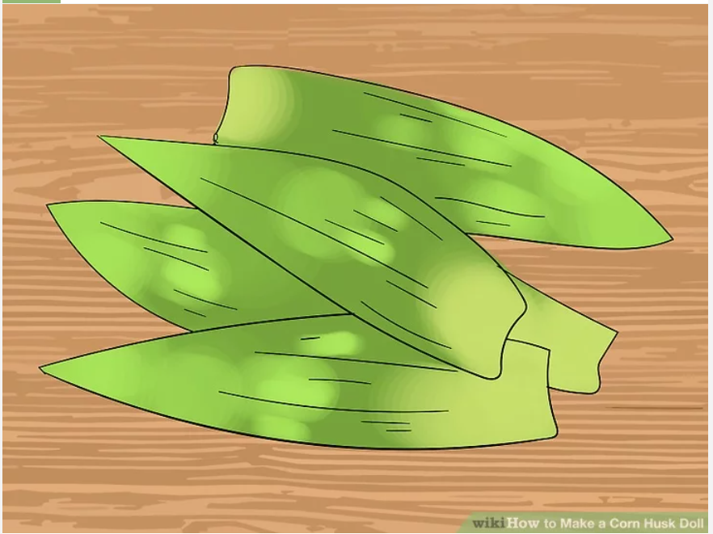

2. Soak the corn husks in warm water for a few hours. This will make them much more pliable and easier to work with.

3. Lay down paper or cloth on a flat work surface. This tends to be a wet and messy project.

4. Select four of the soaked husks. If you have one or two that have holes or brown spots on them, put them on the outside.
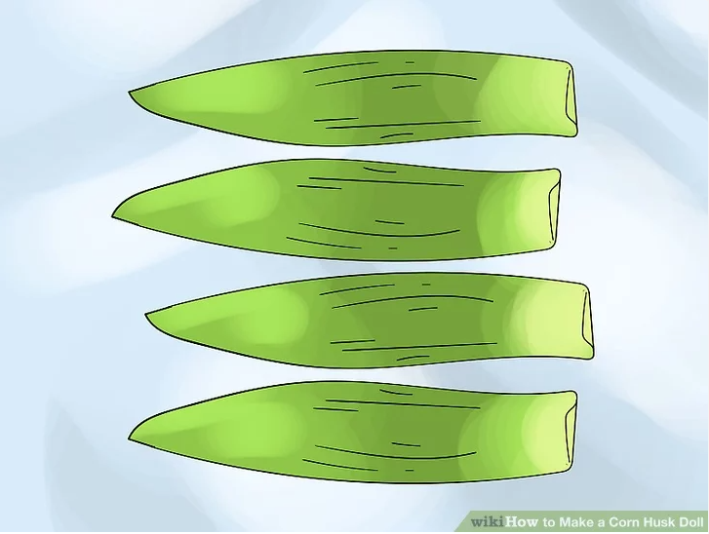

5. Tie the husks together with some strong string. You could also use thick, strong rubber bands if you want.

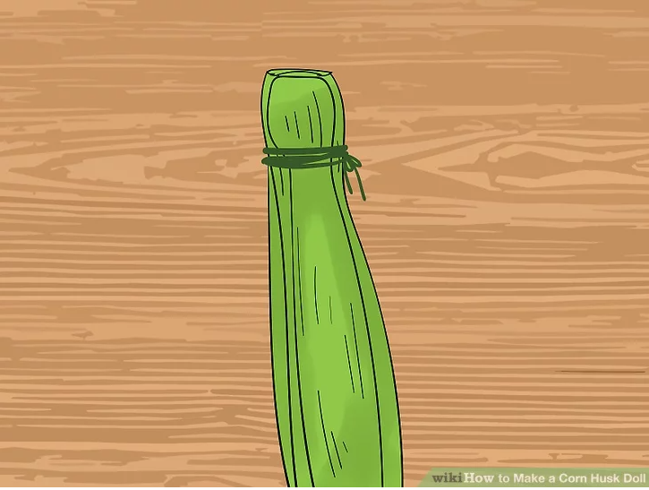

6. Flip two husks over so that the outside husks are now on the inside.
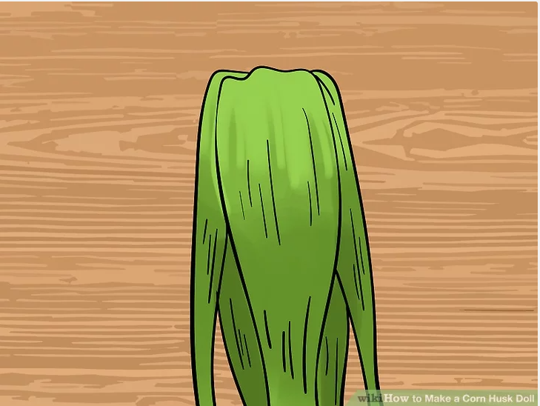

7. Make the head. Take two small pieces of soaked husk. Wad each piece into a ball, and stuff it in between a larger husk to cover it like a ball. Tie some string under the ball. Attach to the body with the rubber band or string.
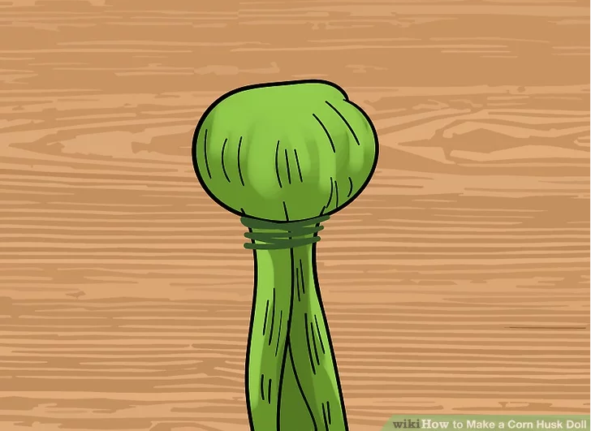

8. Make arms by braiding three thin strands of husk together. Tie on both ends to stop the braid from unraveling. Slip each arm in between the husks and tie into place.
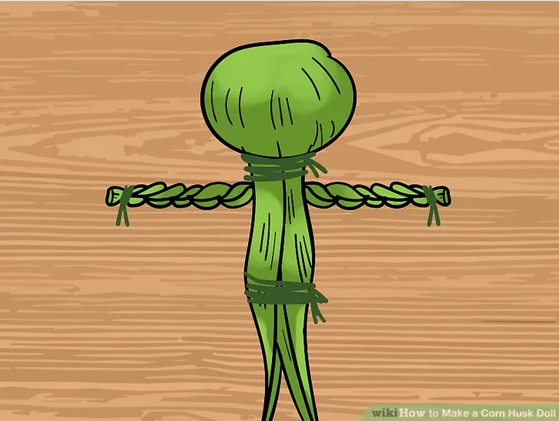

Method 2
Raffia "corn" dolly

1. Assemble the items needed for this project.
Raffia corn dolly method:
Raffia
Ornamental grasses and dried flowers
Scissors
Thread, yarn or string for tying (or just use raffia strands)
Ribbon for decoration
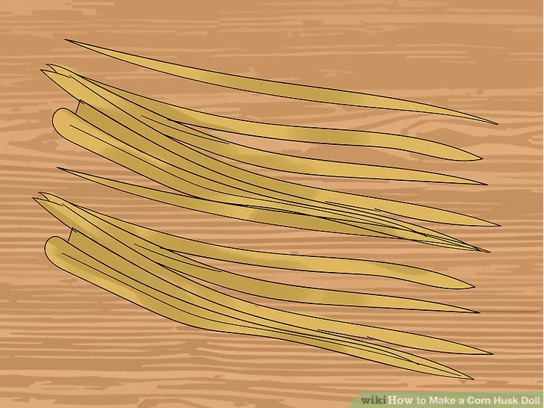
2. Fold the bundle of raffia in half. It should be about 45 centimeter (17.7 in) in length.
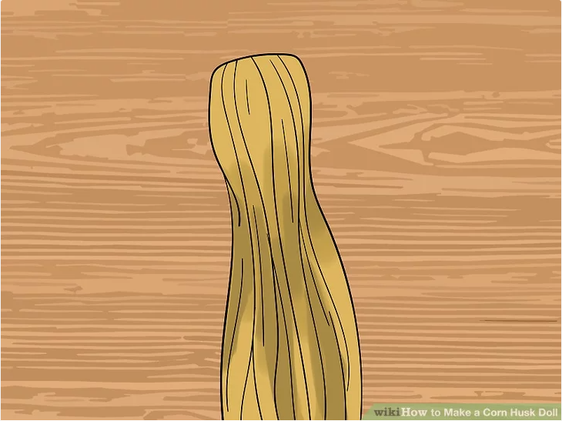

3. At the top of this folded raffia (the non-open end), tie a length of raffia around it. This should create a round, ball shape, which becomes the dolly's head.
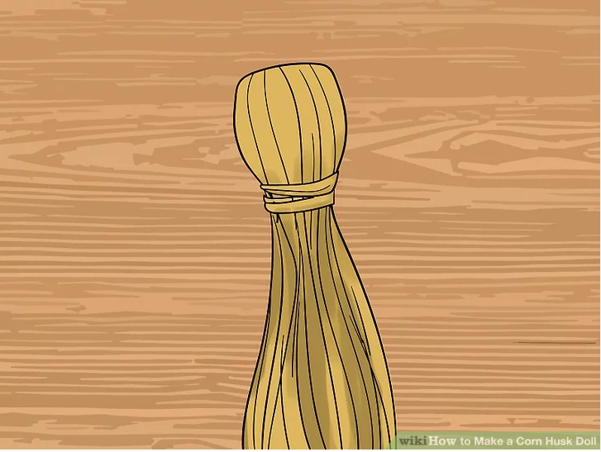

4. Make the arms from a new bundle of raffia. Cut a small bundle to about 12 centimeter (4.7 in) in length. Push this through the body, just under the head. Tie a piece of raffia directly under the arms on the body to keep them in place. This also form's the corn dolly's torso.

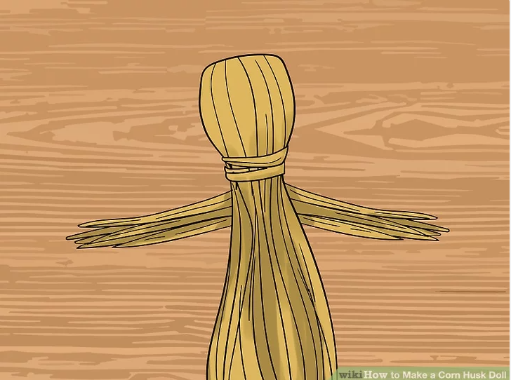

5. Wrap the arms and torso with raffia, going around and around until a smooth, totally covered look appears.
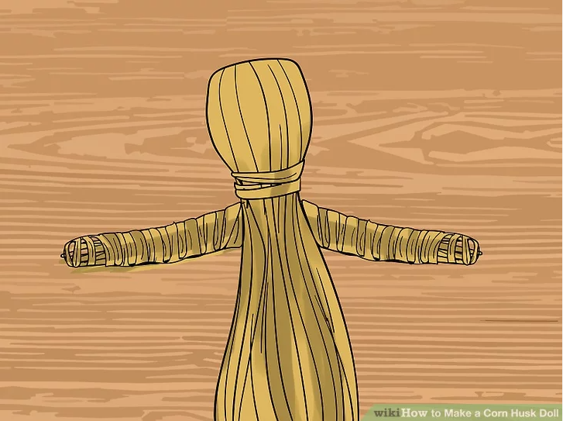

6. Make the dolly's hair. Braid a long length of raffia. Tie little knots each end to prevent unraveling. Then, fold each end of the braid to meet at the middle, creating loops that look like little braids hanging down.

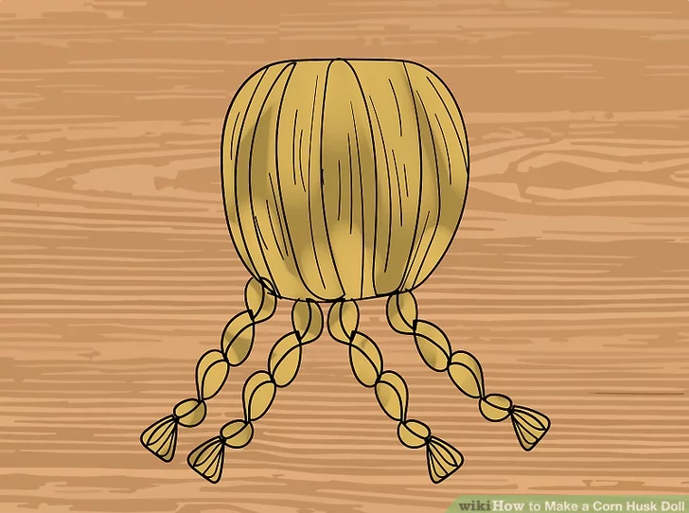

7. Tie the braid to the dolly's head. Use raffia or string.
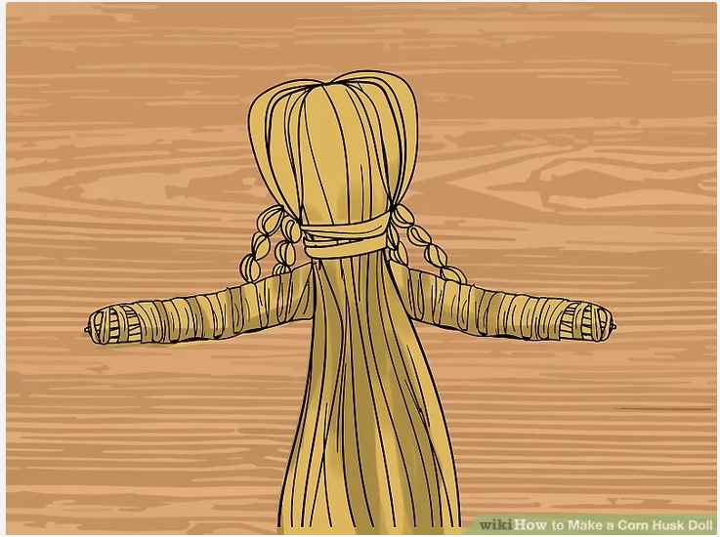

8. Make a hat. Measure the dolly's head and make a doughnut shaped ring that would just fit around her head. Wrap raffia around and around this to make a well-covered ring. Place on the dolly's head.
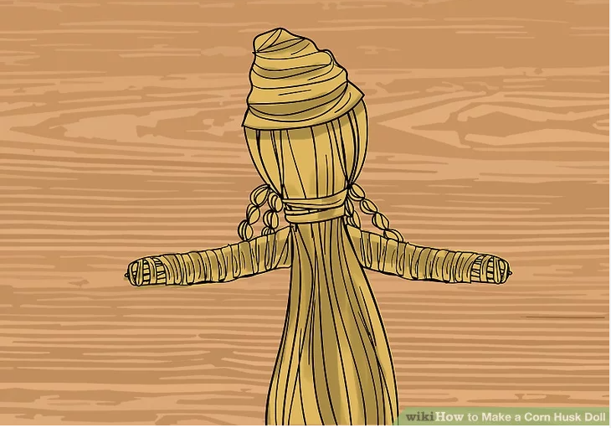

9. Decorate the dolly. You can display the dolly as she is now or add ornamental grasses and dried flowers through her skirt and on top of her head to improve her overall appearance. Use ribbon to prettify the corn dolly too.
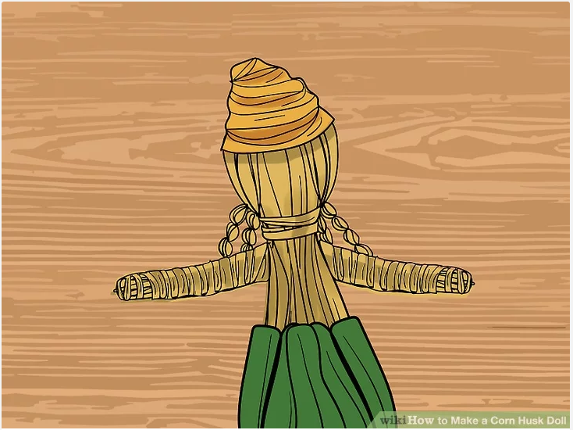

Articles
Read some or all of the following articles with your group, and then discuss the articles with the group members.
Discussion questions can include the following:
-Did you grow up in eastern Kentucky? What are your memories of your life there?
-What songs or stories did you learn from your family or friends?
-What is special to you about eastern Kentucky?
-What do you find interesting about the O Tucks, people from Kentucky who moved to Ohio?

Articles

Article 1:

Group Still Preserves OHIO-KY Connection. By Associated Press. August 29, 1993. Lexington Herald-Leader (KY). Retrieved from the NewsBank database.
OWENTON -- Stanley Dezarn has spent years preserving Kentucky's rich heritage for many people who migrated to Ohio in search of work.
Dezarn, who left his native southeastern Kentucky years ago for a teaching job in Butler County, Ohio, founded and leads an organization called the O'Tucks -- O for Ohioans and Tucks for Kentuckians.
He never tried to hide his heritage, despite having to endure being called "briarhopper" and "hillbilly." Besides maintaining a link between the transplanted Kentuckians and their past, Dezarn wanted the group to build a greater understanding with people of other backgrounds.
"It has given us a sense of pride, and we're respected," Dezarn said.
Although the group is non-partisan, a lobbying movement inspired the O'Tucks' founding. In the late 1950s, when Kentucky was considering a bonus for military veterans, Dezarn and others pushed to include Kentuckians living out of state.
Bert T. Combs, like Dezarn a Clay County native, became a supporter, and the transplanted Kentuckians got their bonus. With the bonus effort making him a familiar figure with Kentuckians living in southwestern Ohio, Dezarn was asked to organize a Clay County picnic.
It quickly expanded to include people from other Kentucky counties, and then it grew into the O'Tucks. At times, several thousand people attended the group's festivals and 350 still turn out for an annual banquet, usually held in early November.
Dezarn has much of the music and storytelling from the banquets on tapes that he plans to donate to Berea College.

Article 2:
Ohio makes hearts fonder-of Kentucky. By Jack Hicks. July 23, 1993 | The Kentucky Post (Covington, KY). Retrieved from the NewsBank database.
Stanley Dezarn grew up in a two-room log cabin in Appalachia, so after he moved north to Ohio years later he endured his share of being called "briar hopper" and "hillbilly."

But he didn't try to hide his heritage. The way he figures, you can leave Kentucky, but Kentucky doesn't leave you.

That's why Dezarn founded and leads an organization called the O'Tucks. It stands for Ohioans who come from Kentucky, or if you prefer, Kentuckians living in Ohio.

Dezarn, now 71, earned a college degree and taught in the mountains before moving to Butler County, Ohio, to teach. He founded O'Tucks to keep a Kentuckian's heritage from being swallowed up - and to build bridges of understanding with people of other backgrounds.

Or, in the words of the organization's stated purpose, "to promote the acquaintance, fellowship and understanding among the people of the community, and to preserve the rich qualities of folklore and lifestyles of the Appalachian highlands."

The O'Tucks have helped develop understanding by bringing people together for annual events like a festival and banquet.

"It has given us a sense of pride, and we're respected," Dezarn believes.

Dezarn has much of the music and light-hearted storytelling from the banquets on tapes that he plans to donate to Berea College. The speaker at this fall's banquet will be former Gov. Louie Nunn. He has been on the program previously, as were now deceased Govs. Bert Combs and A.B. "Happy" Chandler.

Combs and Chandler were political enemies, but Dezarn thought a great deal of both. He feels he was instrumental as a peacemaker in their later years.

Although the group is non-partisan, it was a political movement that inspired the O'Tucks' founding. In the late 1950s, when Kentucky was considering a bonus for military veterans, Dezarn and others pushed to include Kentuckians living out of state. Combs, like Dezarn a Clay County native, became a supporter, and the transplanted Kentuckians got their bonus. With the bonus effort making him a familiar figure with Kentuckians living in Southwestern Ohio, Dezarn was asked to organize a Clay County picnic. It quickly expanded to include people from other Kentucky counties, and then it grew into the O'Tucks.

At times, several thousand people attended the festivals, and 350 still turn out for the annual banquet, usually held in early November.

Dezarn and his first wife, Icea, were both teachers, and he ultimately became an elementary school principal. After her death he again encountered Gladys, whom he had known in school in Clay County.

The widow of a doctor, she lives in Owenton. Dezarn now splits his time between Hamilton and Owenton.

The traveling doesn't bother him much - traveling, after all, is his business nowadays.

While teaching summers in South Dakota, Dezarn got into the travel business. He stayed with it part time - now full time - and has led tours throughout the United States and over much of the world.

Despite the splendor of places like Hawaii, he always delighted in taking tourists back to the Kentucky hills he knows so well.

Dezarn recalls what Combs told him about the effort to reform Kentucky's schools, "so a Kentuckian will never have to leave Kentucky, or apologize for where he came from."

Dezarn had to leave to make a living, but he never apologized for his roots.

Article 3:
More to late bluegrass great Osborne than 'Rocky Top'. By Walter Tunis. October 29, 2021. Lexington Herald-Leader (KY). Retrieved from the NewsBank database.

When the news broke earlier this week informing us of Sonny Osborne's passing, my mind raced back to when I first heard him and sibling Bobby - bluegrass music's indomitable Osborne Brothers - on a record.

It was in high school when a friend well-versed in the traditions of string music played me a record that had been cut two decades earlier. The tune was "Ruby, Are You Mad?" Hearing it was like listening to a bomb go off.

Along with Bobby Osborne's high tenor singing, which sounded like it was being beamed in from outer space as opposed to the siblings' Hyden homestead, there was the banjo charge. That was Sonny's endlessly joyous work. Sure, the playing was fast, but it wasn't the speed that shook me. It was that pure, assured jubilation that made the Osborne Brothers freight train roar.

Sonny Osborne died Oct. 24 at 83.

I must sheepishly admit that I hadn't thought much about that awakening or the Osborne Brothers in general of late, despite the fact that their songs "Rocky Top" and "Kentucky" have long been monuments of bluegrass form and tradition, as well as figurehead tunes for two states. The brothers' split in 2005 with Sonny's retirement. Absence from the big bluegrass touring picture for close to two decades makes a few memories fade. But when I listened to "Ruby" again yesterday, the effect was just as jarring as when I was introduced to it so many years ago.

Just three players - Sonny, Bobby and co-guitarist Red Allen - made the record. But with a killer mountain tenor, some sterling harmonies and that atomic banjo drive igniting the Osborne Brothers' commanding sound, nothing else was needed.

Central Kentucky audiences know a thing or two about bluegrass banjo, especially with a musical titan like J.D. Crowe living here. In a stylistic context, Osborne and Crowe were different players, but their fearlessness proved a common bond. Their tone and technical command were immaculate, as was their understanding of musical tradition. But their sound was made all the more scholarly by being open enough to roll with the times, especially in terms of incorporating country music dialects into their sound. The Osbornes famously flew against the traditional wind a time or two by incorporating electric instrumentation into their sound during the 1960s and then taking to stages other than outdoor festivals - namely, college campuses.

That didn't stop the accolades, of course. They were inducted into the Grand Ole Opry in 1964 with membership in the much-later-formed Bluegrass Music Hall of Fame and Kentucky Music Hall of Fame following in the decades to come. There was glorious music along the way, too, from the famed trio's recordings with Allen to adventurous journeys incorporating drums and dobro with later, larger groups.

Bobby carried on after Sonny's retirement. But once that mighty banjo locomotive was retired following the Osborne Brothers' 52-year long run, a major chapter in bluegrass history was complete.

Of course, for many fans, the Osborne's legacy boils down to two words - "Rocky Top." It is as recognizable as any song in the bluegrass canon, which likely unsettles those in their home state, given its close affiliation with all things Tennessee - especially their storied sports rival, the University of Tennessee.

But the brothers were continually respectful of their Kentucky heritage, whether it was through Karl Davis' namesake tune, which the Osbornes popularized in 1965, or the bluegrass festival bearing the brothers' name that has been staged in Hyden for the last 28 years.

Kentucky gave something to Sonny Osborne, too - his name.

"When I was born, I was supposed to be named Roland," wrote Osborne is his popular "Ask Sonny Anything" column for Bluegrass Today magazine in 2020. "But at the Hyden hospital ... they might not have known how to spell Roland, so someone might have said, 'Just put Sonny on the paper till someone straightens it out.'

"Guess what? No one ever straightened it out."

Article 4:
Excerpt from 'Harlan Renaissance,' about Black Appalachians during, after coal boom. By William H. Turner. October 10, 2021. Lexington Herald-Leader (KY). Retrieved from the NewsBank database.
Over the years, when someone would squinch their face and wrinkle their brow when I told them that I was born in 1946 and stayed in Harlan County, Kentucky until I was twenty, I have, lightheartedly, of course, responded by saying, "I would not have chosen to be born in Harlan County, Kentucky, a year after World War II ended, except that is where my mother was." Our mother was born in Harlan County, in Benham, two decades earlier and was fixed firmly there to her parents, both of whom were among the first group of Black people to migrate in great numbers to the county in the Roaring Twenties. Mama's two older sisters were also born in Benham, Kentucky.

A critical mass of us African Americans lived throughout the span of the twentieth century in the heart of Appalachian coal country. Our sense of belonging in Harlan County was realized over almost a century, and the ties remain unbreakable. Our connections to this land attached us to it like chocolate-colored railroad crossties atop crushed white gravel. We were spiked down and anchored in place, able to carry heavy loads and perform a balancing act on life's narrow steel rails, our arms outstretched the way an acrobat holds a stabilizing pole while on a high wire, looking up and moving forward, one step at a time, gingerly. That said, we never went around humming the state song, "My Old Kentucky Home," as though Harlan County was that charming, picturesque, and serene; that idyllic. We knew that our Appalachian coal-town hollow was not Plymouth Rock. We knew we landed in Harlan County by coincidence of the global economy as America emerged as a world industrial power during WWI, the production of coal a major factor. After all, my grandparents' generation - sharecroppers, mainly - was but one generation removed from enslavement.

Within the blink of an industrial eye, between 1917 and 1920 - during which time my maternal grandparents migrated to Lynch from rural Macon, Georgia - the population of Lynch increased dramatically to seventy-two hundred. The first nonnative residents in Lynch were Italian and Hungarian stonemasons brought directly from Ellis Island by United States Steel Corporation, then the largest, most highly capitalized company in America ($1.5 billion in 1901), founded by J. P. Morgan. These robust souls were the first line of laborers who carved out what became a colossal coal camp, carved into the wilderness. By 1940, Harlan County's population (75,275) was exceeded in Kentucky only by the counties of Jefferson (Louisville) and Fayette (Lexington). Lynch and towns like Harlan, Hazard, Jenkins, and Wheelwright (in eastern Kentucky); Big Stone Gap, Grundy, and Stonega (in southwest Virginia); and Gary, Keystone, and Beckley (in southern West Virginia) were as racially and ethnically diverse-each group living in their neighborhoods and with traditions openly displayed-and as booming and blooming as New York City (Harlem). Harlan County was to Kentucky Black coal-mining families in the 1920s through the 1940s what Harlem was to Black New Yorkers in the same period. It was the cultural and social epicenter of the region for Blacks, and as "the blackest town for mountains around," Lynch was equivalent to 125th Street in Harlem-the school was our Schomburg Center for Research in Black Culture, and the Pool Room was our Apollo Theater.

When I went away to college in Lexington to the University of Kentucky at the age of twenty, in 1966, my initial observation, my version of cultural shock, was made by phone to my parents: "Mama, I've never understood why they say there are no Black people in our neck of the woods. I have never seen this high a concentration of White people in my whole life!"

The demise of the coal towns of central Appalachia never caused a collective sense of future shock. After all, the changes did not come like the COVID-19 crisis of 2020. There were plenty of signals, spread over the decades since 1940, as mining mechanized. Losing work was one thing, but the loss, the destruction of entire communities-physically and psychologically-was yet another. If indeed light is to photography and filmmaking what sound is to music, I have tried to cast light, mining down into those dark and blurred and concealed regions of a culture known only to, and noticeable only by, those with the lived experiences of it. I move between specific contexts-which are both fixed and past tense-and dynamic memory, and I tried to steady the images, freeze the frames, so to speak, and when fitting, I sought to concentrate on the foreground, then blur the background, and vice versa. At heart, from my heart, this book is a series stories that are personal, narratives that were told to me, and things I heard and observed, as well as participated in, personally, and studied as a sociologist. These stories and tales merge as a community cultural identity narrative, blended well enough, I hope, to paint pictures of the unique, yet universal, souls of Black Appalachian coal town folks.

-An excerpt from "The Harlan Renaissance" by William H. Turner. West Virginia University Press.

Article 5:
Jim Gifford: What My Heart Wants to Tell. By Dr. James Gifford. April 16, 2021. The Daily Independent. (Ashland, KY). Retrieved from the NewsBank database.

Tell about the South. What's it like there. What do they do there? Why do they live there?" These haunting questions posed by William Faulkner in "Absalom, Absalom!" could just as easily be applied to Appalachia.

Where is Appalachia? On its surface, that seems like an easy question to answer. Geographically, Appalachia is a mountain chain that stretches from southern New York to the northern parts of Alabama, Mississippi and Georgia. Appalachia includes all of West Virginia, and parts of 12 other states: Alabama, Georgia, Kentucky, Maryland, Mississippi, New York, North Carolina, Ohio, Pennsylvania, South Carolina, Tennessee and Virginia. These mountains are called the Alleghenies in western Maryland, the Cumberlands in eastern Kentucky and Tennessee, the Smokies in Georgia, the Blue Ridge in Virginia, the Catskills in New York and the White Mountains in New Hampshire. They are all part of an impressive mountain chain — collectively known as the Appalachians — that parallels the eastern seaboard of the United States.

European settlers moved into Appalachia in the 18th Century and eventually drove out most of the original inhabitants, the Indians. Small groups of Scotch-Irish, Anglo Saxons, and Germans settled the region, cleared land and built log cabins on their small farms. They lived a resolute, independent and isolated life, and became known as "hillbillies," Williams from the hills, with their own language, culture and religion. The descendants of these people lived on the same poor land when the Great Depression arrived in the 1930s.

Appalachia is home to more than 25 million people; about half of them are rural people, and many of them are poor. Historically, the Appalachian economy developed mostly from agricultural pursuits, the forest products industries, and coal mining. Today, the economy is more diverse because of relatively new manufacturing concerns, service industries and cultural tourism. The overall economy of the region is better, but there are still large pockets of intense poverty. When I pose the question, "Where is Appalachia" to people living in the region, many have responded, as did one Ashland resident, by saying that it was "south of here, a place where poor people have poor ways."

"Who lives in Appalachia" is a tougher question to answer. From the colonial beginnings of American history, until the present, outsiders have defined Appalachian people and Appalachian ways in negative terms. As early as the 1720s and 1730s, William Byrd's travel writings defined a back country where lazy people lived a primitive lifestyle. Generations of novelists, scholars, politicians and journalists wrote about Appalachia with the same analytical success enjoyed by three blind men who went to see the elephant.

In 1935, in the midst of the depression, the cruelest assessment of all was rendered by the great English historian Arnold Toynbee who compared the people of the southern mountains to the "barbarians of the old world," calling them a people "who had acquired civilization and then lost it."

The people who lived in the mountains of eastern Kentucky — along with all other Appalachians — suffered from the incorrect assessment of who they were (and who we are). Shakespeare lamented "the evil that men do lives after them; the good is oft interred with their bones." In Appalachia, that translates to "after truth dies, lies and misconceptions live on."

Those misrepresentations "about our mountain folk" prompted Knott County's Verna Mae Slone to write a simple memoir, "What My Heart Wants to Tell," because these lies and half-truths have done our children more damage than anything else. They have taken more from us than the large coal and gas companies did by cheating our forefathers out of their minerals, for that was just money. These writers (like Toynbee) have taken our pride and our dignity and disgraced us in the eyes of the outside world.

And so, at age 65, Slone sat down in her mountain cabin on Caney Creek in Knott County and began writing in her notebook. She was the 10th generation of Slones to live in Pippa Passes, Kentucky — within 2 miles of the place they had settled in 1790 — where she continued to follow family customs and traditions. The youngest of seven daughters, her mother died just after she was born, and she was raised by her father, "Kitteneye" Slone, who promised his dying wife to raise his daughter "with never a whopping." Verna Mae loved her father and "was not willing for him to die," so she wrote a memoir about him, never thinking it would be published, for her children and grandchildren.

In writing about her father's life, she captured the people and culture of Knott County and southeastern Kentucky. A small, sturdy man, Kitteneye made barrels and split rails; he delivered mail, herbal medicine, and occasionally moonshine. He enjoyed hard work and reveled in the beauty of the land that surrounded him. Kitteneye Slone represented the independent, versatile, self-sufficient Appalachian people who for generations built their own homes, made their own furniture and tools, farmed their lands and kept their herds, cut and machined timber, made herbal medicine, wove their own clothes and devised recipes unique to their own resources.

One of the truths about life is that even when we know something is wrong, we still don't know what is right. That's the purpose of many of the books published and sold by the Jesse Stuart Foundation. I invite you to read books like "What My Hearts Wants to Tell" or "Hidden Heroes of the Big Sandy Valley" and discover the reality of a great regional people.

Article 6:
Keeping our culture: Letcher County native performs Appalachian traditions. Lee Ward. January 29, 2021. The Daily Independent (Ashland, KY). Retrieved from the NewsBank database.

Dancing, strumming and singing are all in her bailiwick, in an effort to preserve Appalachian culture and educate others about it, whether they are Appalachian or those barely aware of the region.

Carla Gover, a Letcher County native, said she learned much of her subject simply by living it. Her musical family exposed her to hymn and ballads and there was singing at family reunions and other celebrations, funerals and even during work in the garden or the kitchen.

An eighth-generation Kentuckian, Gover said many of her family played string instruments, but her grandmother's religion — Holiness — didn't allow dancing.

"I was able to sneak and learn to dance," she said. "My mother was supportive."

As a young teen, she made a friend from the Philippines, who was in eastern Kentucky as a daughter of a physician. It was eye-opening.

"(Our friendship) caused me to reflect on my culture and to realize we have a culture here in Appalachian," she said.

"When you really start to go to other states, not only do they have different cultures, you learn there are strong and special things about Appalachian culture," she said, noting her grandmother who lived in Clay County was a big influence on her.

"We would go visit and stay with her and she moved in with us after my grandfather died," she continued. "She was a whole library of cooking, canning, sewing, all of it."

Gover shares her knowledge of Appalachia in various ways:

She's offering an Appalachian Flatfooting and Clogging Workshop online, in which she breaks down a fiddle tun and offers a formula for improvising the dance.

"I've worked for three years with KET designing digital curriculum for them and now I'm applying it to what I do," she said, noting there has been a lot of interest.

"Two-hundred fifty signed up in three weeks from all over the world," she said, noting the class is great exercise, something many have lacked throughout the pandemic. "I like to eat cornbread every day, and I like to dance so I can eat cornbread every day," she said.

Her song, "Me and the Redbird River," is being turned into a children's book.

"It's based on things my grandmother taught me when I was little," Gover said. The book will be illustrated by Kentucky artist Jeff Chapman Crane.

"My son, who was 9, was letting his hair grow during the pandemic," she said. "He posed as me and a friend posed as my granny."

Gover's feminist Appalachian ballad "Dangerous Women" can be seen on YouTube. She performs with her daughter; the song reverses roles of men and women and the challenges they face.

She plans to release a bilingual song "Home," featuring Kentuckians from Appalachia and Latin Americans from her Cornbread and Tortillas Collective. Cornbread and Tortillas is a bilingual folk opera for which she is the artistic director.

"It's important now because immigrants really have suffered during (the last administration) with hate speech, more depression and legal challenges to their standing here," Gover said. "I feel like it's really important as a way to make change you want to see in the world. If you're having a big party with music and dancing and food, it affects their hearts and it heals them to see really all alike."

She also performs in Zoe Speaks, a contemporary folk group whose music can be seen on YouTube.

Despite negative stereotypes of Appalachia, boosted by the recent release of the movie version of "Hillbilly Elegy," Gover said she believes the culture might be experiencing one of its occasional renaissances.

"A lot of those who perform and teach about Appalachian culture aren't from here," she said. "That's OK. I'm happy to share our culture, but some who are from here get left out of it and others aren't as respectful as they should be."

She said she understands. "As a kid in eastern Kentucky ... there was a lot of shame and damaging stereotypes we internalize," she said. "Appalachians have been defined by our problems instead of being seen for the nuanced and complex people we are."

Some paint a general picture of pills, violence and suicide, and while it exists in Appalachia, she said, it's missing something.

"It's OK if you're trying to create social chance of illuminate something," she said. "One of the things I've wanted to do is to help through my work and supporting others to have our narrative about what it means to be here to come to the front. I want to tell our story and not let other tell our story."

